**Season Outlook:**

**December 2nd First day of practice**

**December 12th first day of scrimmage**

**December 29th first day for games**

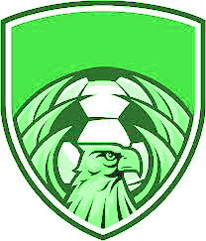

**December 5th Alumni Game**

**December 12th @Westwood**

**December 16th** Liberty FC 6:00pm

**December 18th @Brownsboro** GV 5:00pm BV 6:45

January 2nd @Sabine tournament TBD

January 3rd @Sabine tournament TBD

January 3rd @Sabine tournament TBD

January 5th New summerfield BV 5:00pm

January 9th Grand Saline 6:00pm

January 12th Central Heights 6:00pm

January 16th @Diboll GV 5:00pm BV 6:45pm

January 20th Carthage GV 5:00pm BV 7:00pm

January 23rd @Henderson GV 5:00pm BV 7:00pm

January 27th Pine Tree GV 5:00pm BV 7:00pm

January 30th Sabine GV 5:00pm BV 7:00pm

February 2nd (mon) @Center GV 5:00pm BV 7:00pm

February 7th (sat) Kilgore GV 11:00am BV 1:00pm

February 10th bye

February 13th @Carthage GV 5:00pm BV 7:00pm

February 17th Henderson GV 5:00pm BV 7:00pm

February 20th @Pine Tree GV 5:00pm BV 7:00pm

February 24th @Sabine GV 5:00pm BV 7:00pm

February 27th Center GV 5:00pm BV 7:00pm

March 3rd @kilgore GV 5:00pm BV 7:00pm

March 6th bye