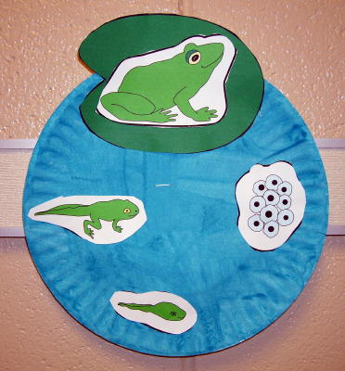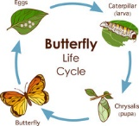

CLASS NEWS
Mrs. Williams
Date: April 13, 2026

Math: continue fractions

Science/Social Studies: continue lifecycles

Upcoming Events:
April 22 – We will visit Atlantic Union Bank as part of Family Futures enrichment activity (this will be less than an hour)

May 15 – Luray Caverns Field Trip

Look for the permission forms for both events in your child’s blue Friday folder

