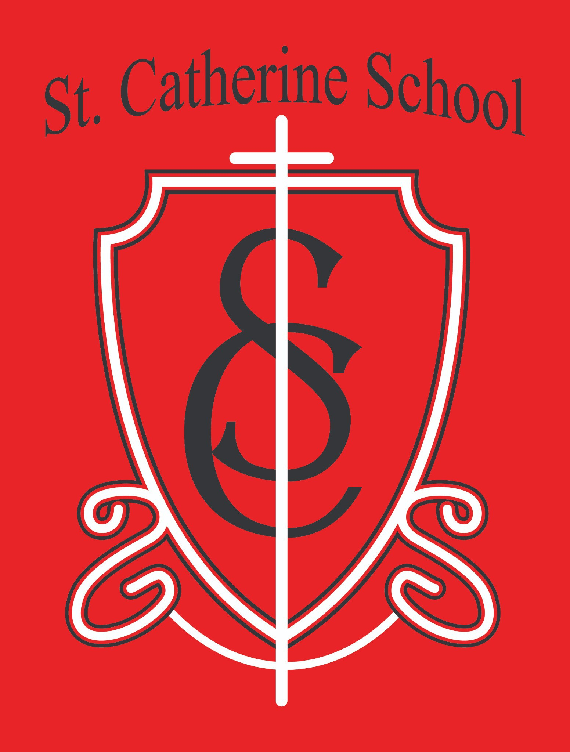

**St. Catherine School Weekly Newsletter (March 24-28th)** [**https://www.stcatherine.k12.nd.us/parents**](https://nam02.safelinks.protection.outlook.com/?url=https%3A%2F%2Fwww.stcatherine.k12.nd.us%2Fparents&amp;data=05%7C02%7CTerra.Giesen%40k12.nd.us%7C40ac4c648b21418020f008dd6ed4570b%7Cdbbf782acef14af186c81f9201061db6%7C0%7C0%7C638788580472808579%7CUnknown%7CTWFpbGZsb3d8eyJFbXB0eU1hcGkiOnRydWUsIlYiOiIwLjAuMDAwMCIsIlAiOiJXaW4zMiIsIkFOIjoiTWFpbCIsIldUIjoyfQ%3D%3D%7C0%7C%7C%7C&amp;sdata=kRgHXDJgL4Gb5l36rge%2Fw0YMdXP3CxOU6kbJNvchTi8%3D&amp;reserved=0)

# Principal's Message

St. Catherine School is entering an exciting new chapter with the upcoming launch of **St. Catherine Little Saints Child Care**. Seeing this vision come to life reminds me of the incredible **support and trust** that our families, parish, and community place in our mission.

We are thrilled to welcome **Beth Nadelin** as the **Director of Little Saints Child Care**. With her deep commitment to **faith-based early childhood education** and years of experience, she will help build a nurturing, Christ-centered environment for the youngest members of our community.

This project reflects **our dedication to growth and service**. With facility renovations— including **new restrooms, expanded space, and updated learning areas**—we are preparing a **safe, enriching environment** that honors the **dignity of every child**.

If you are interested in **enrollment**, please **contact the school office** to be added to our interest list. When official enrollment opens, our director or a staff member will reach out with details. **All families are welcome**—you do not need to be Catholic to attend or enroll.

This is **a community effort**, and I am incredibly grateful to everyone helping make **Little Saints Child Care a reality**. From volunteers to donors, teachers to contractors—**your support truly makes a difference.** Thank you for your trust as we continue to grow in faith, learning, and service together.

# Reminders

* **5th & 6th Grade Band Performance at REACH Banquet – April 3rd** 🎶

An email was sent to **5th and 6th grade parents** from **Mrs. Ihry** regarding the **band performance at the REACH banquet on April 3rd**.

If you have any **questions**, please reach out to **Mrs. Ihry, Mr. Kjelland, or myself**. **Thank you for your support!**

* **No Toys, Trinkets, or Fidget Toys at School**

🚫

Please do **not allow students to bring toys, trinkets, or fidget toys** to school **unless it is for Show and Tell or has been specifically approved** by a teacher or administration. These items have become a **major distraction in the classroom**, and students are getting in trouble for not following directions to put them away. Thank you for helping us maintain a focused learning environment!

* **March Reading Calendar Reminder** 📅

**Students must return their March reading calendar sheet to Mrs. Gulka by Wednesday, April 2nd** to receive credit for their reading progress!

* **Early Dismissal – April 2nd** ⏰

School will dismiss at 12:15 PM.

Lunch will be served, and buses will run as usual.

* **No Bishop’s Chess Club Next Week!** ♟

There will **not** be **Bishop’s Chess Club next week**. Please plan accordingly!

* **Easter Break – April 17–21** 🐣

No school in observance of Easter.

* **Save the Date – Spring Music Program** 🎼

Thursday, May 8th at 6:30 PM.

* **Tuition Assistance – TAP Application Reminder** 💰

Tuition assistance applications for the **2025–2026** school year are now open. Applications must be submitted through **FACTS Grant & Aid**.

**Deadline: May 15, 2025** (Early applications encouraged for faster award decisions).

📅

Apply here: [FACTS Sign-In](https://nam02.safelinks.protection.outlook.com/?url=https%3A%2F%2Fonline.factsmgt.com%2Fsignin%2F414FV&amp;data=05%7C02%7CTerra.Giesen%40k12.nd.us%7C40ac4c648b21418020f008dd6ed4570b%7Cdbbf782acef14af186c81f9201061db6%7C0%7C0%7C638788580472832154%7CUnknown%7CTWFpbGZsb3d8eyJFbXB0eU1hcGkiOnRydWUsIlYiOiIwLjAuMDAwMCIsIlAiOiJXaW4zMiIsIkFOIjoiTWFpbCIsIldUIjoyfQ%3D%3D%7C0%7C%7C%7C&amp;sdata=nfeIvy8p2VG2MGG28fAEmjCZQp8k4bZkx3Y%2Fj1Zg2ik%3D&amp;reserved=0)

If you have any questions, please **contact the school office for assistance.**

* **Virtue of the Week – Fortitude: Perseverance (March 17–28)** 💪

**Focus:** Completing tasks despite difficulties.

**Saint:** St. Monica

**Scripture:** *"Daughter, your faith has saved you."* (Mark 5:25–34) **Application:** Encouraging students to **push through challenges** and track progress on **long-term goals**.

**St. Catherine Spotlight**

**Sharing Joy Through Reading** 📚✨

A heartfelt **thank you** to our **1st & 2nd graders** and **5th & 6th graders** for **reading with the residents at St. Raphael's Care Center**. They were a **light to so many**, and it was a beautiful example of how **academics and service to**

**others intersect**—one of the many things that make **Catholic schools so special**.



Kindergarten Celebrity Readers

⭐

A **big thank you** to all of the **guest "celebrities"** who have read to our **Kindergarten class** so far! Your time and enthusiasm have made reading even more special for our youngest learners.

A Gift from the Heart

❤

A **generous donation** was made in **memory of a parishioner’s son** who passed away. Even in the sadness of loss, her **love for St. Catherine School** was deeply moving. We are incredibly grateful for her generosity and for the lasting impact her son’s memory will have on our school community.

Thank you to everyone who helps make **St. Catherine School a place of faith, service, and learning!**

Stay Connected with St. Catherine School

📍 **Address:** 540 3rd Ave. NE, Valley City, ND 58072

**Email:** [nicholas.lee1@k12.nd.us](mailto:nicholas.lee1@k12.nd.us)

📧

**Phone:** 1-701-845-1453

📞

**Website:** [www.stcatherine.k12.nd.us](https://nam02.safelinks.protection.outlook.com/?url=https%3A%2F%2Fwww.stcatherine.k12.nd.us%2F&amp;data=05%7C02%7CTerra.Giesen%40k12.nd.us%7C40ac4c648b21418020f008dd6ed4570b%7Cdbbf782acef14af186c81f9201061db6%7C0%7C0%7C638788580472847238%7CUnknown%7CTWFpbGZsb3d8eyJFbXB0eU1hcGkiOnRydWUsIlYiOiIwLjAuMDAwMCIsIlAiOiJXaW4zMiIsIkFOIjoiTWFpbCIsIldUIjoyfQ%3D%3D%7C0%7C%7C%7C&amp;sdata=hECEmNHUHyd2%2BjGxsQRAgSnZfFEjE8QxCfj1w2PEKog%3D&amp;reserved=0)

🌐

📘 **Follow Us on Facebook:** [St. Catherine School on Facebook](https://nam02.safelinks.protection.outlook.com/?url=https%3A%2F%2Fwww.facebook.com%2Fst.catherineschoolvc%2F&amp;data=05%7C02%7CTerra.Giesen%40k12.nd.us%7C40ac4c648b21418020f008dd6ed4570b%7Cdbbf782acef14af186c81f9201061db6%7C0%7C0%7C638788580472861811%7CUnknown%7CTWFpbGZsb3d8eyJFbXB0eU1hcGkiOnRydWUsIlYiOiIwLjAuMDAwMCIsIlAiOiJXaW4zMiIsIkFOIjoiTWFpbCIsIldUIjoyfQ%3D%3D%7C0%7C%7C%7C&amp;sdata=tGoRMS9Y64Wr85s9VJE4ie1VX%2Bpyk8wHpX4RcB%2FQbCA%3D&amp;reserved=0)

*“Inspiring excellence through faith, learning, and service.”*