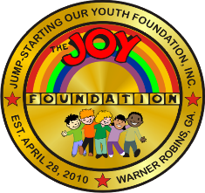
JUMPSTARTING OUR YOUTH (JOY) FOUNDATION,
INCORPORATED
Post Office Box 6228
Warner Robins, Georgia 31095

February 02, 2026

2026 Scholarship

To: All Applicants

RE: Scholarship Application Process

The JOY Foundation, a non-profit organization incorporated to empower the middle Georgia community through cultural awareness and educational enrichment, is pleased to announce it will award a $1000.00 fine arts scholarship to a deserving student.

Students with special talents and interests are recognized each year through scholarships in the visual or performing arts. The JOY Foundation scholarship will be awarded to a qualified Houston County 2026 graduating senior who plans to further their education at a college or university pursuing studies in the field of visual arts (such as painting, drawing, crafting, graphics, sculpture, photography, decorative arts, etc.). Enclosed you will find the necessary information to complete the application process.

Again, thank you for your interest and we look forward to receiving your application!
For additional information, please contact 478-442-4163 or 478-951-2037.

Sincerely,

Yvonne King

Yvonne King
Board Chair

