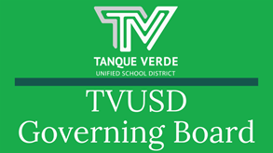


Governiing Board Meetiing Summary October 20, 2021

At the October 20, 2021 Governing Board meeting, Board Action Items included: SY22-23 Calendar Approval, Governing Board Meeting Date Change, Announcement of the first ever TVUSD Raytheon Leaders in Education Award Winner, Kristen Kvaran, and approval of the Board Letter to the Community. A detailed discussion of the school construction projects was presented by Superintendent Hagerman.

SY 2022-23 Callendar

The Governing Board discussed two possible calendar options for the 2022-23 school year at the September 22nd Regular Board Meeting. Both options were sent to Site Councils for review and feedback.

The Governing Board has approved the following changes in the 2022-23 School Year Calendar:
Grading Day - December 23, 2022

Planning Days - Three (3) added at the beginning of school year, and one (1) extra paid day at end of the school year.
K-12 Interim Grading Day Plan - Early Release for all grades K-12.

The 2022-23 School Year Calendar may be foundhere.

Raytheon Leaders iin Educatiion Award Wiinner!

We are excited to announceKristen Kvaran, PreK Teacher and Director of the Tanque Verde Community Preschool, is one of only four 2021 Raytheon Leaders in Education Award winners! She is the first to win in this new category, and the first TVUSD award winner! Ms. Kavaran will be honored at the Stand Up 4 Teachers celebration
event on November 3, 2021. Please read the full article here.

Stand Up 4 Teachersis a celebration of education champions featuring the

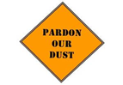

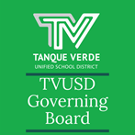
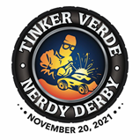
experiencing breakthrough infections, the board felt it was important to send a letter to the community. The Board Letter was also sent in a separate newsletter from the district and all schools.
presentation of the Spirit of Education Award, honoring businesses that make significant investments in education, along with the Raytheon Leaders in Education Award, honoring exceptional preK-12 teachers.2021-22 Projjects Update - Pardon our Dust!Superintendent Hagerman presented information including an update on the current construction projects, project timeline, and how the schools and district are navigating the logistical challenges of having projects on all campuses. Approximately 85% of the construction projects are being funded by the Arizona School Facilities Board.Once the project approvals have been obtained, it is critical that the projects are started and completed within the required timelines, so that funding is not lost. Funding is usually distributed through a two year cycle. However, because state funds have been held and are now accessible, all of our projects are taking place at the same time. The timeline and completion dates for the following projects may be seen in the October 20, 2021 - Project Updates and Timing PresentationTVHSNew Construction -Administration Building Remodel 12/20/21 Completion Date Science Labs/Classrooms 5/10/22 Completion Date Student Commons 8/17/22 Completion DateRoofing Project Weatherization Grading and DrainageEGJHNew Construction - New Fine Arts Building 6/23/22 Completion Date ACESNew Construction - Kindergarten Wing 6/06/22 Completion Date HVACWeatherization Door Hardware Nature TrailTVESNew Construction - Kindergarten Wing 6/30/22 Completion Date RoofingGrading and Drainage ITInteractive Screens Network Update WiFi UpdateChromebooks - E-Rate Emergency Connectivity FundingThe additional chromebooks will allow us to go to 1:1 devices for the 22-23 school year
Governiing Board Letter to the TVUSD CommuniityThe Governing Board approved a letter to the community addressing keeping students in classes and extracurricular activities. Based on other districts

Governing Board Letter - October 22, 2021

Important Dates & Informatiion

November Events Calendar -November 2021

The CURRENT 21-22 SCHOOL YEAR CALENDAR may be found here:

TVUSD School Year Calendar 2021-22 K-12th.

The Tanque Verde Foundattiion is hosting the Tinker Verde Nerdy Derby on November 20, 2021 at the Forty Niner Country Club. This
family oriented event replaces the Tech Trek and our TVUSD schools will benefit from technology investment. For more information click on the event logo, or visit: https://tanqueverde.org/2021/08/30/2nd-annual-tinker-verde-nerdy-derby/

Next Governiing Board Meetiing Date:

The Board approved a meeting date change. The next Governing Board Meeting will be held on *Tuesday, November 2, 2021, allowing leadership to attend the Stand Up 4 Teachers Awards Event. (see below)

The next Regular Meeting of the TVUSD Governing Board will be held on *Tuesday, November 6th.

A Call to the Public will be held at the first meeting of each month.
Board Meeting Agendas and Minutes

TVUSD Board Meeting Livestream Link

TVUSD Virtual Call to the Public Form

Student, Staff & Communiity Acknowlledgements
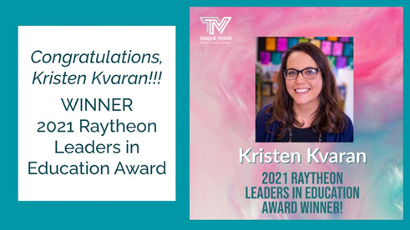
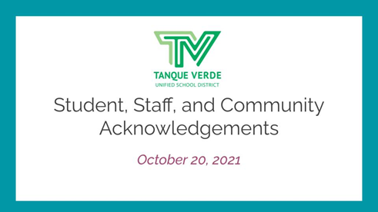
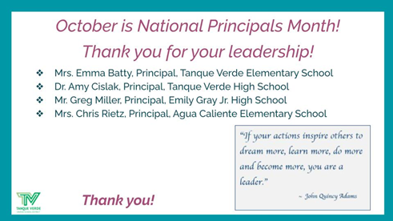
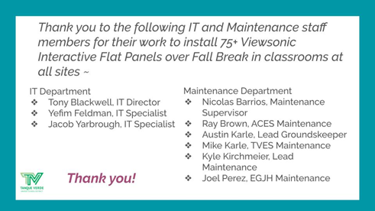
Connect wiith us
Visit our website

