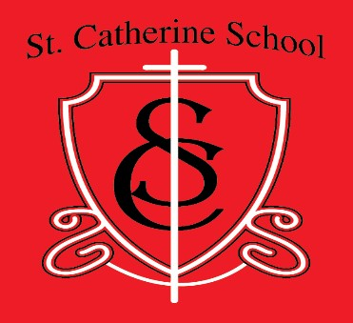
ST. CATHERINE SCHOOL
www.stcatherine.k12.nd.us
TUITION AGREEMENT FORM
2025 – 2026
PART I: Family Information
Parent’s Name:

Part II: Tuition Information
The total 2025/2026 estimated school budget is $664,332. The approximate number of students is 53. This puts the cost per student at approx. $13,200. With that in mind, the Parish Education Board has set tuition at the following levels:
Parish Families
$2320 for students in grades K – 6.
$1620 for each additional student enrolled.
Non-Parish Families
$3400 for students in grades K – 6.
$2200 for each additional student.
There is a 5% cash discount for tuition paid in full at fall registration. This discount only applies for families who are paying full tuition. (Approved at the February 2018 Education Board meeting. Effective July 1, 2018)

Part III: Cost
Cost for first student: $
Additional students: x per student= Less 5% Paid in Full Discount (if applicable, see above):
Total Amount Due: $

Part IV: Method of payment. Please check one.
One- time, full payment in August
Semi-annually (August and February)
Quarterly (August, November, February, May)
Monthly (10 payments August through May)
*12 Month payment option available upon request to principal

Part V: Parent/Guardian Signature(s)
Signature: Date: Signature: Date:

