Mrs. Daniel’s Messages
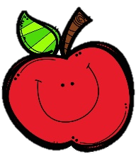
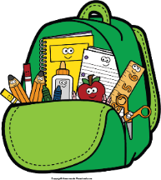
November 29-December 3, 2021
Reading Skills and Grammar (verbs for past, present, and future) Tests: Thursday
Spelling (compound words) and Vocabulary Tests: Friday

Please check your child’s binder each night.

Monday, December 13: Dress like candy cane
Tuesday, December 14: Wear flannel shirt
Wednesday, December 15: Beanie, scarf, socks
Thursday, December 16: Wear pajamas
Friday, December 17: 2nd 9 Weeks ends

Reading Story and Skills:  Story:  Anansi Goes Fishing  by Eric A. Kimmel  Phonics/Fluency:  compound words  Text-Based Comprehension:  compare and contrast, summarize  Grammar:  verbs for past,  present, and  future |  | Selection Vocabulary Words:  - weave – to form threads into cloth, a net, or web  - lazy – not liking to work or be active  - delicious – something that tastes really good  - justice – something that is fair and right  Vocabulary Words  (these words will be tested each week):  - been – to stay or wait  - believe – to think something is real or true  - caught – to take hold or trap someone or something  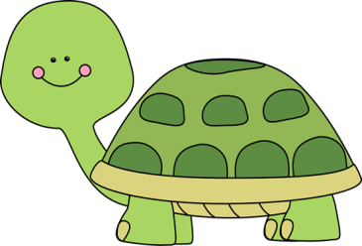  - finally – at the end  - today – this day  - tomorrow – the day after today  - whatever – anything that
Math  Topic 5 – Subtract Within 100 Using Strategies  Lesson 2: Count Back to Subtract on an Open Number Line  Lesson 3: Add Up to Subtract Using an Open Number Line  Lesson 4: Break Apart Numbers to Subtract  Lesson 5: Subtract Using Compensation |  |  |  |  | Social Studies/Science  We are finishing  our study of  American symbols.  We will also talk  about Native Americans.
Spelling Words: Students who correctly spell the bonus words get a small prize.
- basketball  - someone  - weekend | - riverbank  - something  - birthday |  | - bathtub  - backyard  - driveway | - raindrop  - mailbox  - bedtime |  | ***BONUS***  13. backstage  14. overflow  15. raindrop

