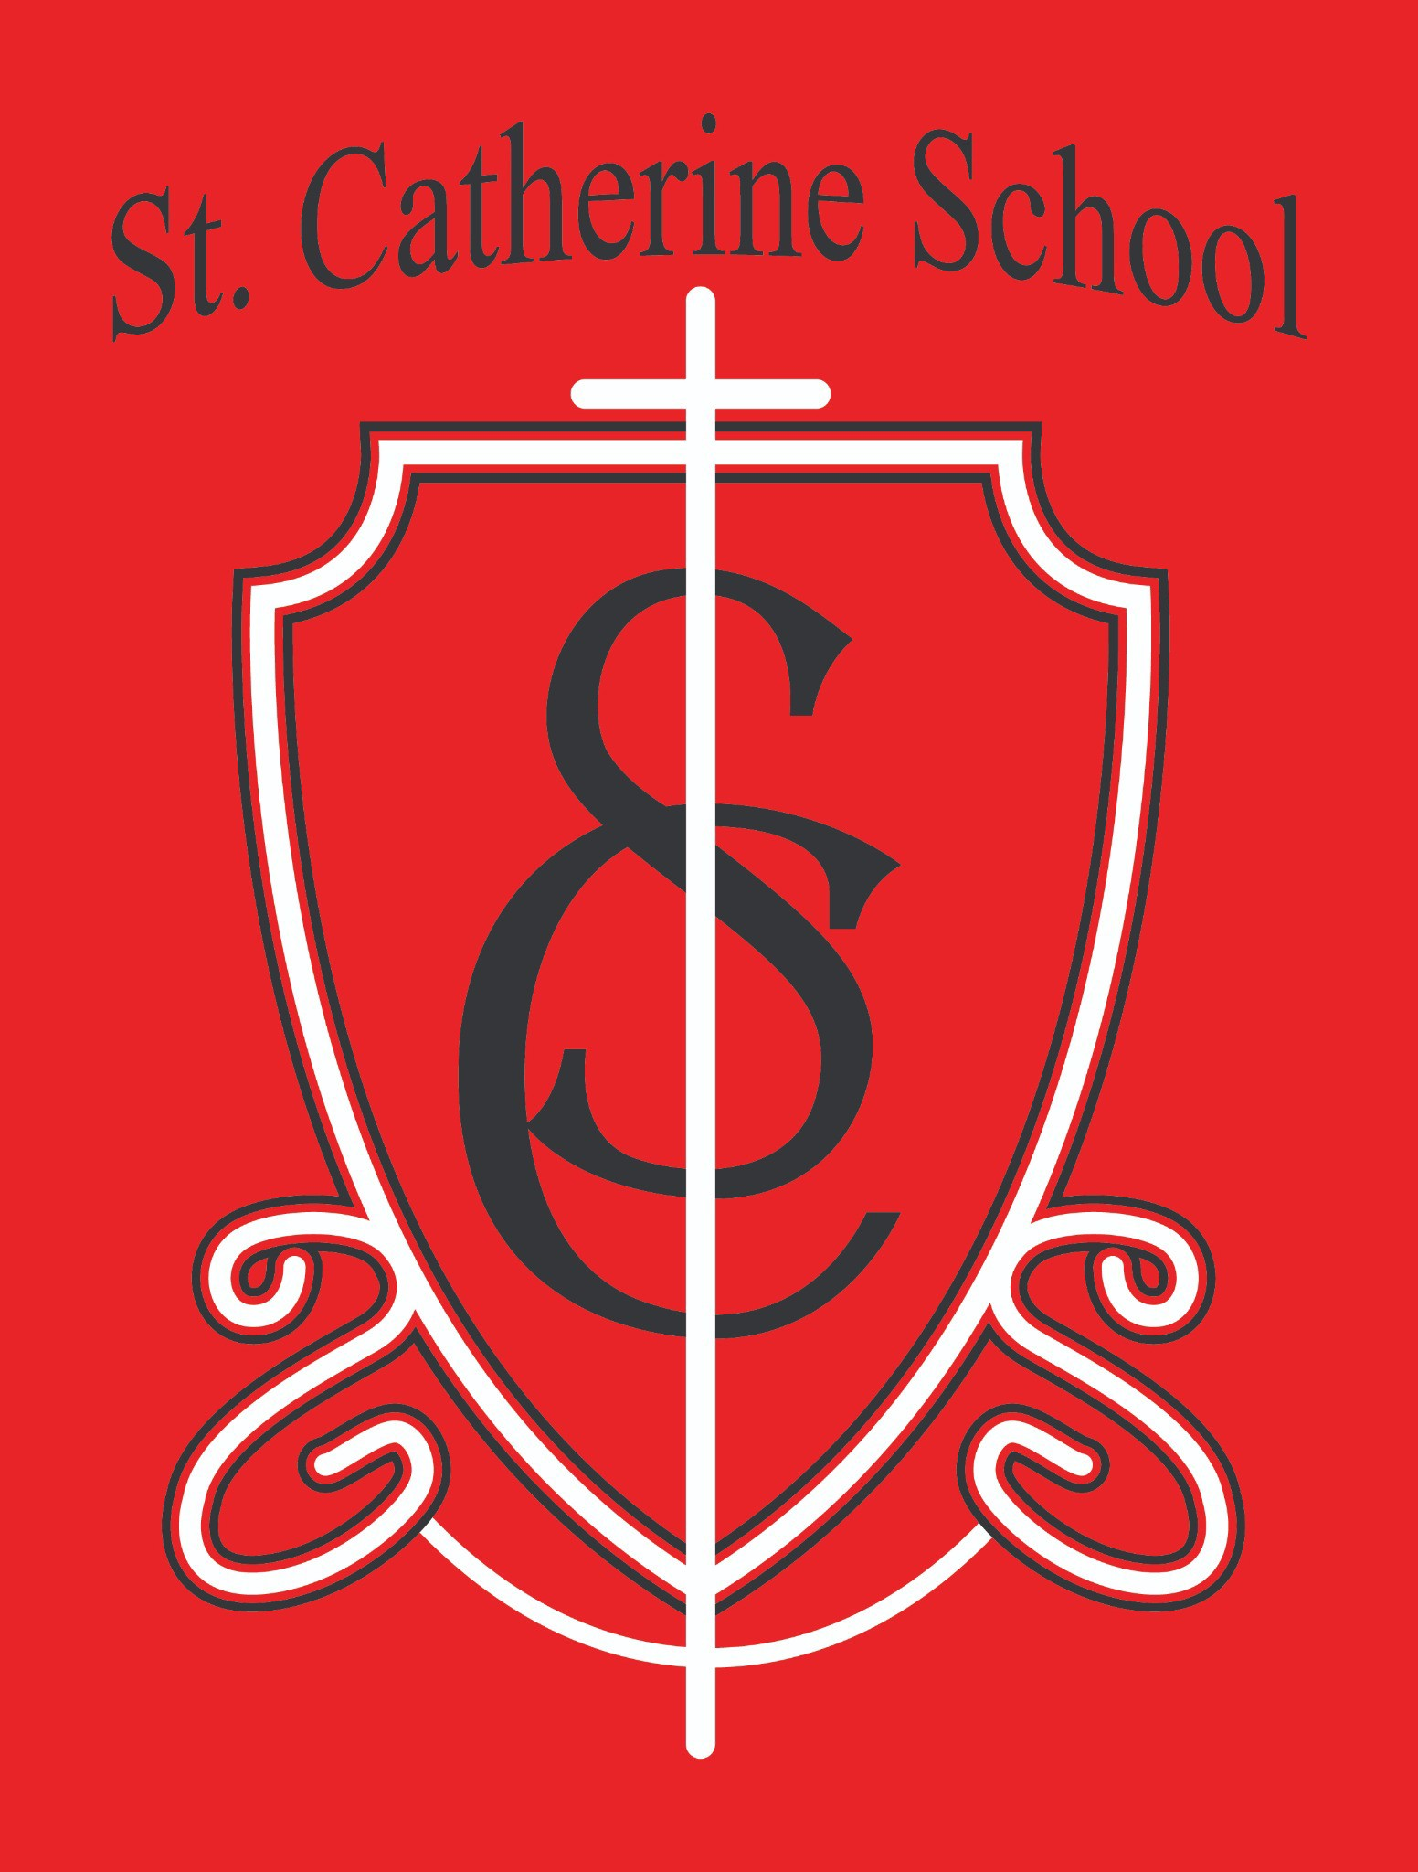

**St. Catherine School Weekly Newsletter (Week of January 2-3)**

[**To view the newsletter and weekly calendar click here**](https://nam02.safelinks.protection.outlook.com/?url=https%3A%2F%2Fwww.stcatherine.k12.nd.us%2Fparents&amp;data=05%7C02%7CTerra.Giesen%40k12.nd.us%7Cea56d820db414072cdf408dd2c10d1a9%7Cdbbf782acef14af186c81f9201061db6%7C0%7C0%7C638715172938268323%7CUnknown%7CTWFpbGZsb3d8eyJFbXB0eU1hcGkiOnRydWUsIlYiOiIwLjAuMDAwMCIsIlAiOiJXaW4zMiIsIkFOIjoiTWFpbCIsIldUIjoyfQ%3D%3D%7C0%7C%7C%7C&amp;sdata=xsnmEENaEjmoHd6313CdRX05WL2fbIDCJf1dM363%2FF4%3D&amp;reserved=0)

# Principal's Message

Dear St. Catherine Families,

This week, I want to shine the spotlight on our budding readers. Today in chapel, I was thrilled to see the number of students who turned in their completed reading sheets—I could not be prouder of their hard work and enthusiasm! Acknowledging these avid readers in front of their peers felt like a true celebration of their accomplishments.

Reading truly opens doors. Research consistently shows that strong reading skills developed in early elementary school correlate with higher academic performance later. In essence, children who become proficient readers in the primary grades tend to achieve greater success across multiple subjects throughout their educational journey. This is why we emphasize reading in so many ways at St. Catherine School—because it is both foundational to learning and essential for future success.

Seeing the excitement in our students’ eyes as they share their reading achievements reaffirms our commitment to nurturing a culture of literacy. Thank you for supporting your children at home and partnering with us to foster this love for reading. Together, we can continue to open doors to lifelong learning and faith-filled success.

In Christ,

Mr. Lee

# Reminders

* **No School – January 20 (Martin Luther King Jr. Day):** Enjoy the day off in observance of MLK Day.
* **January 21 – Intent to Attend Forms Sent Out:** Please keep an eye out for these forms. Your prompt response is appreciated.
* **Week of January 26–February 1 – Catholic Schools Week:** Mark your calendar and save the date for special activities and celebrations.
* **January 31 – Early Dismissal & All-School Mass (No Guest Lunch):** No buses will run this day, so please plan accordingly for student transportation.
* **February 6 – Parent-Teacher Conferences:** More information will be sent out soon.
* **Scherling Photography Class Composite Orders:** If you wish to order a class composite picture, please return your order form by **January 8**.
* **Arrival Time Reminder:** If your child is **not** eating breakfast at school, they should **not**

arrive before **8:10 AM**.

# St. Catherine Spotlight

## Back-to-School Blues?

If your children complained about coming back to school, believe me, you’re not alone—my kids did, too! I heard all about how “boring” school was going to be and how there’s “nothing fun to do.” Yet, once they stepped inside, they were overjoyed to see their friends and settle back into the routine. It’s a great reminder of how much our children value their school community—even if they won’t always admit it.

## A Shout-Out to Ms. Jess

Many of you might know Ms. Jess as the “church office lady,” but she’s our parish office administrator and a key supporter of our school. She manages everything from HR paperwork for our staff to coordinating payroll with the Diocese and even handles things for our cemetery and other parish needs. We want to take a moment to thank Ms. Jess for all she does behind the scenes to keep our school and parish running smoothly.

## Faith in Our Kitchen

Faith, our dishwasher, comes to us from the Open Door Center and is an integral part of our lunchroom team. **Today, we’ll be recognizing her at lunchtime for her birthday**, and I wanted parents to know she’s a special part of our St. Catherine village. Her daily efforts truly help our kitchen staff serve our students efficiently and cheerfully.



Stay Connected with St. Catherine School

📍 **Address:** 540 3rd Ave. NE, Valley City, ND 58072

**Email:** [nicholas.lee1@k12.nd.us](mailto:nicholas.lee1@k12.nd.us)

📧

**Phone:** 1-701-845-1453

📞

**Website:** [www.stcatherine.k12.nd.us](https://nam02.safelinks.protection.outlook.com/?url=https%3A%2F%2Fwww.stcatherine.k12.nd.us%2F&amp;data=05%7C02%7CTerra.Giesen%40k12.nd.us%7Cea56d820db414072cdf408dd2c10d1a9%7Cdbbf782acef14af186c81f9201061db6%7C0%7C0%7C638715172938292904%7CUnknown%7CTWFpbGZsb3d8eyJFbXB0eU1hcGkiOnRydWUsIlYiOiIwLjAuMDAwMCIsIlAiOiJXaW4zMiIsIkFOIjoiTWFpbCIsIldUIjoyfQ%3D%3D%7C0%7C%7C%7C&amp;sdata=E5PPew3WWSXKI9BI7LDcg4yrOXXvSuF%2ByIuGtKXGziA%3D&amp;reserved=0)

🌐

📘 **Follow Us on Facebook:** [St. Catherine School on Facebook](https://nam02.safelinks.protection.outlook.com/?url=https%3A%2F%2Fwww.facebook.com%2Fst.catherineschoolvc%2F&amp;data=05%7C02%7CTerra.Giesen%40k12.nd.us%7Cea56d820db414072cdf408dd2c10d1a9%7Cdbbf782acef14af186c81f9201061db6%7C0%7C0%7C638715172938310401%7CUnknown%7CTWFpbGZsb3d8eyJFbXB0eU1hcGkiOnRydWUsIlYiOiIwLjAuMDAwMCIsIlAiOiJXaW4zMiIsIkFOIjoiTWFpbCIsIldUIjoyfQ%3D%3D%7C0%7C%7C%7C&amp;sdata=AL0%2FqZ9sZbkWbV6EBIIwefcJ4m5YYSAf0gVhwtXOlJM%3D&amp;reserved=0)

*“Inspiring excellence through faith, learning, and service.”*