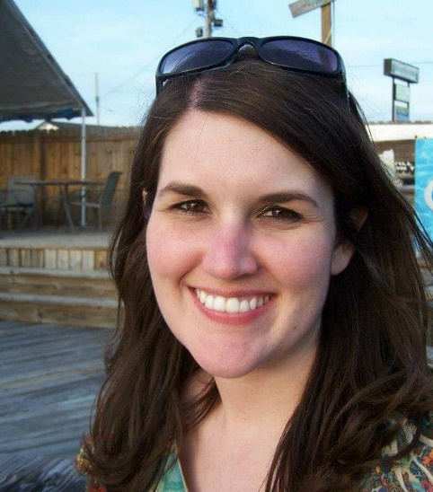 |  |  |  | Hello!  Dear 8th GRade Parent/guardian,  My name is Amanda Gambill, and I am the 8th grade school counselor at DeSoto Central Middle School. I am so excited and honored to be with this amazing DCMS family! I am committed to encouraging, supporting, and empowering our students to become their best selves. My primary task is to help ALL students become better learners by providing a comprehensive and developmental counseling program that meets their academic, personal/social, and career development needs.  I will be meeting with students individually and in classrooms, collaborating with parents and staff, and organizing school-wide events (such as the Kindness Challenge) to benefit and meet the needs of our DCMS community.  Support provided can be therapeutic, but the role of the school counselor is not to diagnose or provide therapy. I am able to provide temporary/short-term support to help students overcome acute issues having an impact on their school performance. I am a resource similar to the school nurse in that she can provide help but refers out for more serious problems. I am happy to provide a referral list to outside agencies and licensed mental health counselors if needed.  As the counselor, I have the privilege of providing support to every student at DCMS. Confidentiality is respected, unless students plan on hurting themselves, hurting someone else, or someone is hurting them. Although I do not require parent consent, if you would like to request I meet with your child for a specific concern, please do not hesitate to reach out.  I am thrilled to be here, and I thank you for the support you have shown me by valuing your child’s mental health. I look forward to a great school year and getting to know all of our wonderful students at DCMS!  Sincerely,  Amanda Gambill, M.S., NCC, NCSC
 | Contact info
amanda.gambill@dcsms.org
(662) 349-6660 ext.111
dcm.desotocountyschools.org
It’s a great day to be a jaguar!

