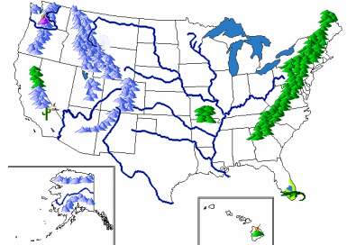
Class News
Mrs. Williams’ Second Grade
September 26, 2022

Reading: we will finish up Unit 1 and test skills learned in this unit

Language: synonyms

Spelling: sight words – test will be on Friday

Math: identify, create, and extend a wide variety of patterns

Science/Social Studies: wrap up unit on Map Skills – test on Tuesday

Next Page $↓$

Upcoming Events:
- Book Fair – Week of September 26
-our class will visit the Book Fair on Tuesday, September 27

- Early Dismissal @ Noon – Wednesday, September 28

- Conferences – Thursday, September 29 - No School for Students

- Friday, September 30 is a REGULAR SCHOOL DAY

