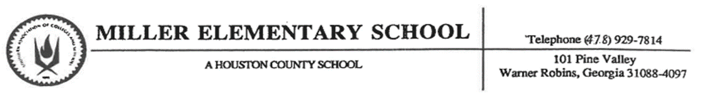
Notice of Minor Incident Referral (MIR)

Student: ___________________________________________ Date: ______________ Location: __________________

Teacher: ___________________________________________ Number of MIRs: 1 2 3 4
Consequences
1st MIR (this month) | Warning, parent contact in ClassDojo, consequences at home
2nd MIR (this month) | Parent phone call, student loses ½ break time
3rd MIR (this month) | Parent/teacher conference, student loses all of break time
4th MIR (this month) | Detention (Monday or Wednesday 4:00-4:30)
After the 4th MIR (this month) | Major Office Referral (to be handled by administrators)
Today your child received a Minor Incident Referral (MIR) at school after losing three points in Class Dojo and being provided with Think Time. Please review the incident below and the corresponding consequences. If you have any questions, please contact your child’s teacher.
Teacher Comments:
Inappropriate language, gestures, or behavior
Physical contact (non-aggressive)
Defiance/disrespect
Disruption throughout the day
Property misuse
Technology violation
Not following directions
Talking without permission (chronic)
Refusal to do classwork/participate (chronic)
Playing with toys or supplies
Aggressive or rough play
Throwing objects
Cheating
Name Calling

