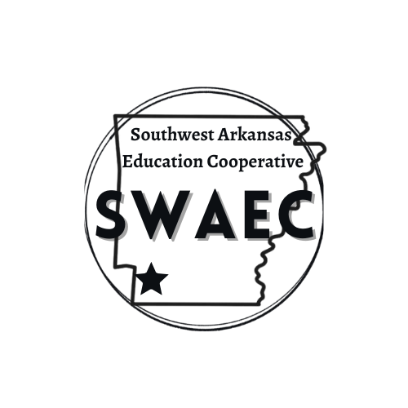

DATE: January 7, 2026

TO: S.W.A.E.C. Superintendents

FROM: Phoebe Bailey, Director

SUBJECT: January Board Meeting

The monthly Southwest Arkansas Education Cooperative Board Meeting will be held on Thursday, January 15, 2026, at the Hope Public School Administration Office. The board meeting will begin at 10:30 A.M., at the Co-op., Hope, AR.

Agenda:

- Call to Order
II. Old Business
- Approval of Minutes for December
- Financial and Expenditure Reports for December
- Hope Student Presentation
IV. New Business
- ECH Data Report (child count)
- Teacher Center Update- Monica Morris
- Atlas Interim Comparison (Fall 24 vs Fall 25)
- Director Updates and Reminders:
  - Statement of Financial Interest
  - Discussion School Choice Ad
- Personnel and Director contract
- Other Items May Be Added as Necessary
** Budget Prep session begins at 1:00 with Jason Miller**
https://www.escweb.net/ar_esc/catalog/session.aspx?session_id=571261

