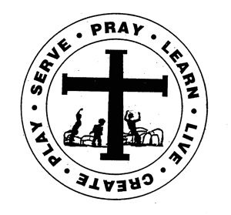
St. Edward Catholic School
Fr. Todd Petersen, Pastor * Jaci Garvey, Principal
210 W. 4th Street * Minneota, Minnesota 56264
Phone: (507) 872-6391 * Fax: (507) 872-5263
Email: jgarvey@stedscatholicschool.com
Website: www.stedscatholicschool.com

February 18, 2022
There will be No School on Monday, February 21st for President’s Day.
We will have another CUF raffle turn-in day on Tuesday, February 22nd. Mrs. Garvey will purchase 1 ticket from each student that turns in a full book of tickets. Monday, February 28th will be the last turn-in day for the Catholic United Financial Raffle. At this point, Trudy has collected over $4,000. We are just under $3,500 away from our goal.
Our next school Mass is Wednesday, February 23rd at 10:30 am. The 3rd and 4th grades will be leading. Come and celebrate the Mass with us.
Thursday, February 24th will be Birthday Lunch and we will be celebrating our February and July birthdays.
Primetime will be held on Friday, February 25th from 3-6 pm for the 3rd-6th grades. Please watch for permission slips for this event.
On Sunday, Feb. 27th from 5 – 7 pm we will be holding a round table type informational event for all families wanting more information about St. Edward School. Please reach out to friends and family to invite them to this event. Families with children of all ages are encouraged to attend.
The end of the 3rd quarter is Friday, March 11th. We have an early dismissal at 1:15 pm.
St. Edward School will again be offering Summer Care from 7:15 am – 6 pm weekdays to students between the ages of 5-12. This program was a great success last year and we are looking forward to even more fun! Watch for more information.
May God Bless,

Mrs. Garvey

