

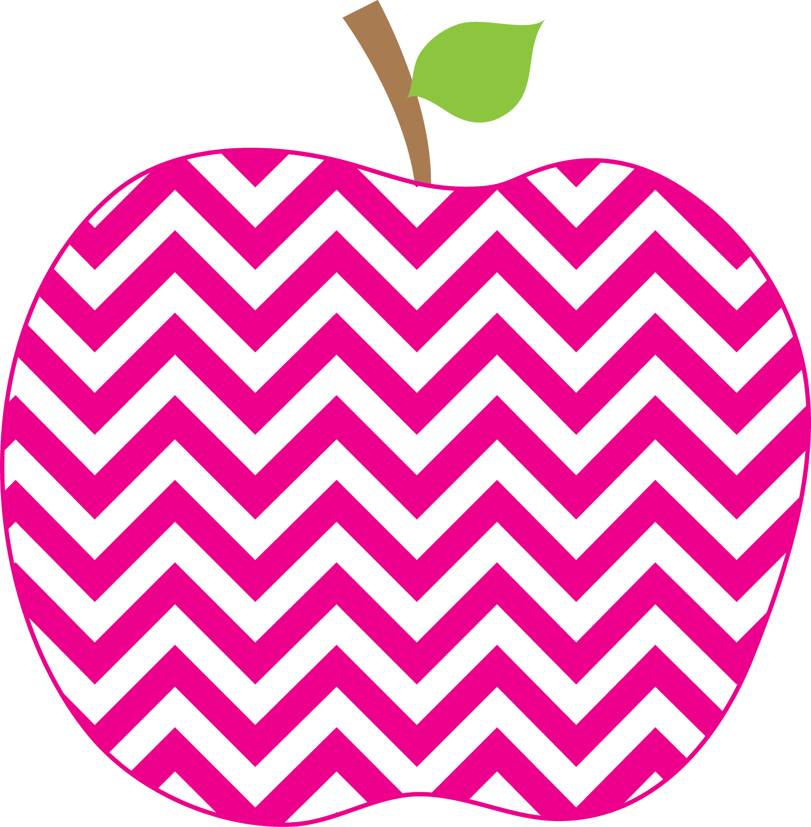



E. Robinson Weekly
Ms. E

February 24, 2025

Reading:
Phonics Skills:
*Long /i/ spelled –igh, -y, ie

High-Frequency Words:
sleep don’t right came

RED Words:
too why

Grammar Skill: Adverbs

Math:
*Adding Tens and Ones

Social Studies/Science- Matter: Solid, Liquid, Gas

This Week’s Focus:

Star Apple of the Week:
Faith Young
* Please make sure that you are helping your child with his/her homework each night. Also make sure to sign the behavior sheet located in the back of the binder each day.
.

Friday, February 28th Special Snack

March 3rd- 7th Read Across
America Week

Friday, March 14th Report Cards
Go Home

Reminders:
Important Dates:

