Miss Primus’ HR Schedule
7:10-7:40 Breakfast/ Morning Time
7:40- 9:20 Science and Social Studies 9:25- 11:00 ELA
11:10-12:00 Related Arts
12:05- 12:30 Lunch
12:30- 12:50 Recess
12:55- 2:25 Math
2:25- 2:35 WIN / Small Group
2:35 Pack Up for Dismissal
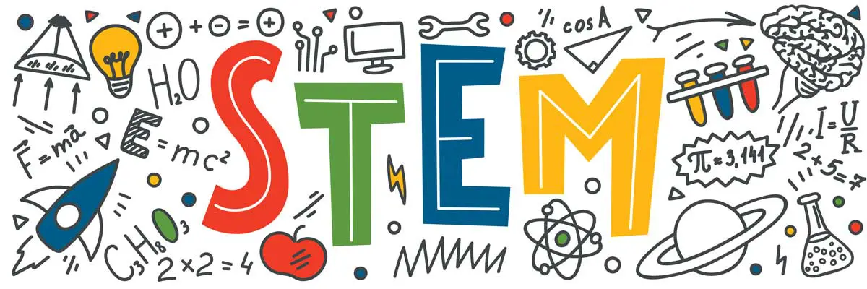
7:50- 8:40
(9/4,10/9, 11/13, 1/3, 2/12, 3/18, 4/29)

