FRANKLIN COUNTY HIGH SCHOOL
EXAMPLE ADVANCED COLLEGE FOUR-YEAR PLAN
CLASS 0f 2026 or Later
NAME: _____________________________________________________ DATE: ________________________________
Tennessee Graduation Requirements:

English: 4 credits
Math: 4 credits
Science: 3 credits
Social Studies: 3 credits
Personal Finance: 0.5 credit
Wellness: 1 credit
PE: 0.5 credit
Fine Arts: 1 credit
Foreign Language: 2 credits
Elective Focus: 3 credits
Additional Requirements/Information:
In addition to the above requirements, Franklin County requires 6 additional credits for a total of 28 credits needed in order to graduate. Students are required to take the ACT. Each student’s course of study in high school is based on individual interests and needs. This is a sample plan of an advanced, rigorous course of study.

Additional Information:
Prerequisites must be met for classes. Please visit our website at https://fchs.fcstn.net/ and click on “Guidance” for information on honors classes, dual credit classes, dual enrollment classes, and AP classes. In addition to in-person AP math and science classes, FCHS now offers online AP classes at no cost for juniors and seniors with at least a 3.0 GPA. Classes offered are listed on the back of this sheet. AP classes are 5 weighted points towards the GPA. Honors, Dual Credit, and Dual Enrollment classes are 4.5 weighted points towards the GPA. In order to graduate with Honors, students must complete 12 honors classes AND have a 4.0 or higher GPA.
FCHS REQUIRES 28 CREDITS FOR GRADUATION
9th Grade 10th Grade
1. English I Honors 1. English II Honors
2. Algebra I Honors 2. Algebra II Honors
3. Geometry Honors 3. Statistics Dual Credit Honors
4. Physical Science Honors 4. Biology I Honors
5. World History Honors 5. Chemistry Honors
6. Wellness 6. Art History AP (Fine Arts)
7. Career Exploration/PE 7. Tennessee History
8. Elective (Focus) 8. Elective (Focus) or Dual Credit elective

11th Grade 12th grade

1. English Lang AP or Motlow Eng 1010 1. English Lit AP or Motlow English 1020
2. Motlow Pre-Calculus 1710 or Motlow Statistics 1530 2. Calculus Honors
3. Pre-Calculus Honors Dual Credit 3. Calculus AP
4. Biology II Honors or Chemistry II Honors 4. Chemistry II Honors or Biology II Honors
5. Biology AP or Physics Honors 5. Physics Honors or Biology AP
6. US History Dual Credit Honors 6. US Gov’t & Civics/To Be Determined
7. Foreign Language I 7. Personal Finance/Economics
8. Foreign Language II 8. Elective (Focus) or Dual Credit elective or AP Online
or Foreign Language III

POST SECONDARY PLANS
2 Year College: _____ 4 Year College: _____ Tech School: _____ Military: _____ Job: _____
The above is a general plan based upon state guidelines. Plans may change from year to year.
Student Signature__________________________________________________________________________

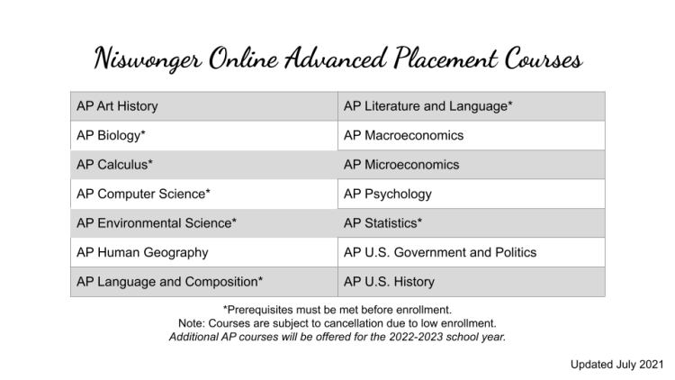
Prerequisites:
AP Art History: No prerequisite - Great introductory AP course!
AP Biology: In person Niswonger prerequisites are Biology I and Chemistry I. Algebra I is
recommended. FCHS prerequisite is honors Biology.
AP Calculus AB: In person Niswonger prerequisites are Algebra I, Geometry, Algebra II, Pre-Calculus or Trigonometry/Analytical Geometry. FCHS prerequisite is honors Calculus.
AP Calculus BC: Prerequisites are Algebra I, Geometry, Algebra II, Pre-Calculus or Trigonometry
AP Computer Science A: Prerequisite is Algebra I. Algebra II is recommended.
AP Environmental Science: Prerequisite is Algebra I. Two years of high school science with labs is recommended.
AP Human Geography: No prerequisite - Great introductory AP course!
AP Language & Composition: Prerequisites are English I and English II.
AP Macroeconomics: No prerequisites. Algebra I is recommended.
AP Microeconomics: No prerequisites. Algebra I is recommended.
AP Psychology: No prerequisite - Great introductory AP course!
AP Statistics: Prerequisite is Algebra II.
AP US Government & Politics: No prerequisite
AP US History: No prerequisite
AP Literature & Composition: Prerequisites are English I, English II, and English III or AP Language & Composition.

