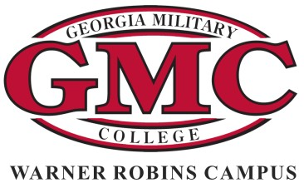

Georgia Military College
Warner Robins Campus

ACADEMIC AREA ACHIEVEMENT SCHOLARSHIPS
2022-2023

Please select one area in which the candidate is indicating particular talents & experience: Mathematics & Technology Natural Sciences & Medicine
Humanities & the Arts Social Sciences

NAME:
Last First Middle

MAILING ADDRESS:

CITY: STATE: ZIP:

TELEPHONE:
Daytime Evening

E-MAIL ADDRESS:

Name of High School and Date of Graduation:

High School GPA:

Name(s) of Clubs/Activities in your Academic Area in which you have been involved: Years of Experience With These Particular Clubs/Activities:

Please complete this application and submit it, along with a 500 Word Essay Showcasing Your Achievement in Your Chosen Discipline & a Letter of Recommendation from the Counselor, Discipline Specific Faculty Member, or Club Advisor, in one of the following manners:

Mail or submit in person to: Georgia Military College 801 Duke Avenue
Warner Robins, GA 31093 Attn: Scholarships

Email to: Ms. Elizabeth Self
eself@gmc.edu

Scholarship application deadline: August 12th, 2022

Upon receipt of this scholarship, student is agreeing to attend GMC-Warner Robins starting Quarter 1 (August) 2022 and to become involved with this Academic Area on campus.

