Heather Herstine
New Brighton Area School District

Training Documents
ViewBoard

Table of Contents
Table of Contents 2
Learning Objectives 3
Getting to Know Your ViewSonic Board 4
Exterior 4
Interface 5
Favorite Apps 5
Toolbar 6
Airclass 7
Signing into Google Drive 8
WhiteBoard 9
Signing in 9
Toolbars 9
Magic Box 10
Accessing Google Drive files 11
Tools 12
Shapes 12
Saving WhiteBoard Canvas 12
Customizing the Whiteboard Canvas 13
Streaming Content 14
Companion App 16
Participate (Home) 16
Whiteboard Remote Control 17
MyViewBoard.com 18
WikiHelp 18
Originals 18
Teacher Certification 19
References 20

Learning Objectives
This training document is designed to introduce you to the basics of the ViewSonic ViewBoard. At the end of this training, you will be able to:
- perform basic operations on the ViewBoard including powering on, accessing the whiteboard function, writing, screen mirroring/casting, and logging into Google Drive
- synthesize current curriculum with the ViewBoard interface
- apply current instructional techniques to the ViewBoard

Getting to Know Your ViewSonic Board

Exterior
On the lower right corner of the ViewBoard, you’ll find several function buttons and inputs.
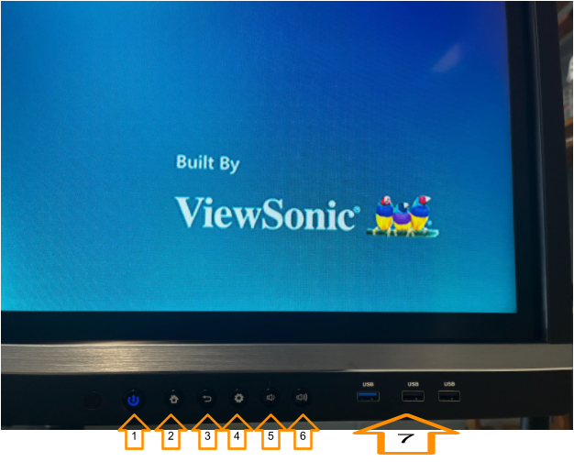

- Power
- Home
- Back
- Settings
- Volume Down
- Volume Up
- USB Inputs

Interface
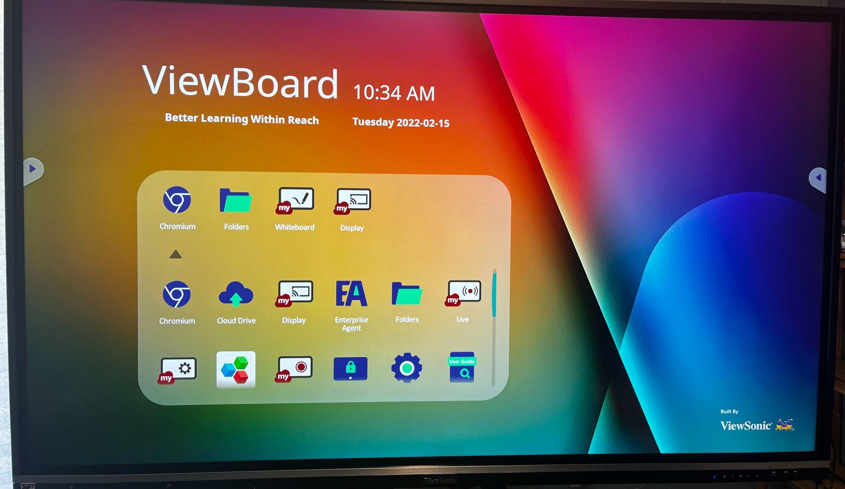
When you power on the board, this screen will appear. This is “Home”.

Favorite Apps
- Chromium - native browser (Note: avoid live searching in front of students)
- Folders - Sign into Google Drive
- MyViewBoard Whiteboard - Interactive display
- MyViewBoard Display - native screencasting tool (great for virtual days!)
- MyViewBoard Record - Record steps in a process

Toolbar
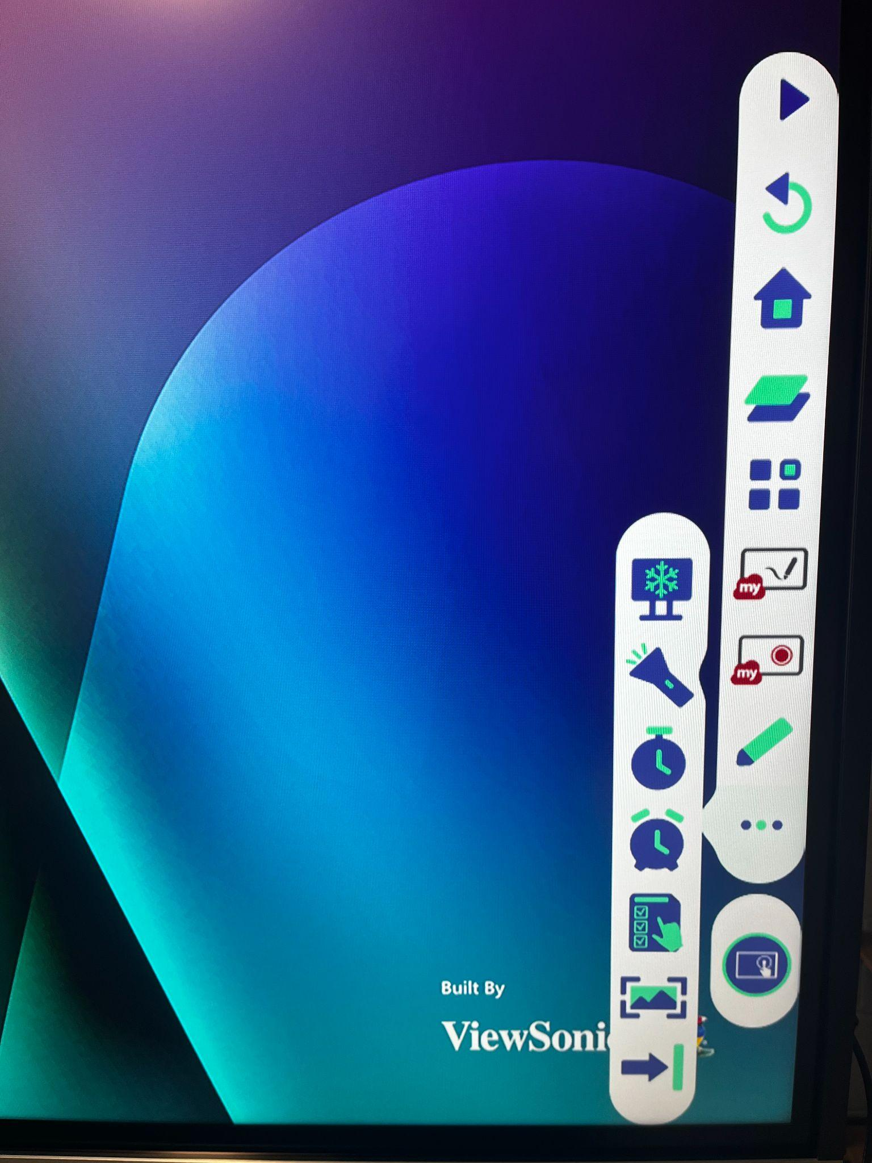
The toolbar can be accessed by tapping the arrows on either side of the board.
Open/Close Toolbar
Back
Home
App Stacks
Apps List
Whiteboard
Screen Record
Annotate (opens new menu)
More (opens pop out on left)
Inputs (opens new menu)
Screen Freeze (opens new menu)
Screen Capture
Hide/unhide toolbar
Spotlight
Stopwatch
Timer
Air Class (opens new menu)

Airclass
When the QR code appears, students should scan the code in their Companion app. Once all participating students have scanned, tap “Enter the Class”. Then choose a function.
1
2
3
4
5
6
7
8

- Voter: single and multiple choice questions
- Judge: True/False questions
- Responder: Race to answer first
- Selector: Randomly select a participant
- Grouping: Assign participants to groups
- Message: allow/deny participants to direct message the ViewBoard
- Manager: Add participants (displays QR code)
- Exit: Leave the AirClass tool

Signing into Google Drive
You can access your Google Drive files including Smart Notebook and Easy Teach, Slides/PowerPoint, and Docs from your ViewBoard. This is a great way to create interactive lesson materials and present them to the class.
To sign into Google Drive, follow these steps:
- Tap Folders on the main screen
- Tap Cloud Drive on the left side
- Tap Add
- Tap Add Account
- Tap Google Drive
- Sign in with your school email address and password
- When prompted, tap Allow
- A browser will open. Close this browser to return to Folders.

WhiteBoard
The Whiteboard function allows you to simply write notes on the board or create elaborate presentations and everything in between. Whiteboard is infinite.

Signing in
When you first open the Whiteboard, you will be prompted to sign in as shown below. If you have the Companion App, you can scan the QR code to sign in. Otherwise, tap the G to sign in with your school email address and password.

Toolbars
When you sign in, you’ll see a toolbar like the one pictured below.
1
2
3
4
5
6
7
8
9
10
11
12
13
14
- Wireless presentation
- Screen Capture
- Move Toolbar
- File
- Magic box - interactive and web content
- Embedded browser - image search
- Infinite Canvas - use two hands to zoom in/out
- Selection
- Pen - tap twice for more options
- Eraser
- Shapes and Lines
- Text/Handwriting - toggle between by tapping
- Undo
- Redo
On the left side, is another toolbar.
1
2
3
4
5
6
7
8
- Background selector - choose from a variety of background options. Filter by subject.
- Move Toolbar
- Present Mode - hides task and title bars
- Paste from Clipboard
- Previous Page
- Next Page
- New Page
- Pages in Whiteboard - create, select, sort, and delete pages

Magic Box
Magic Box offers powerful tools to make your whiteboard more engaging.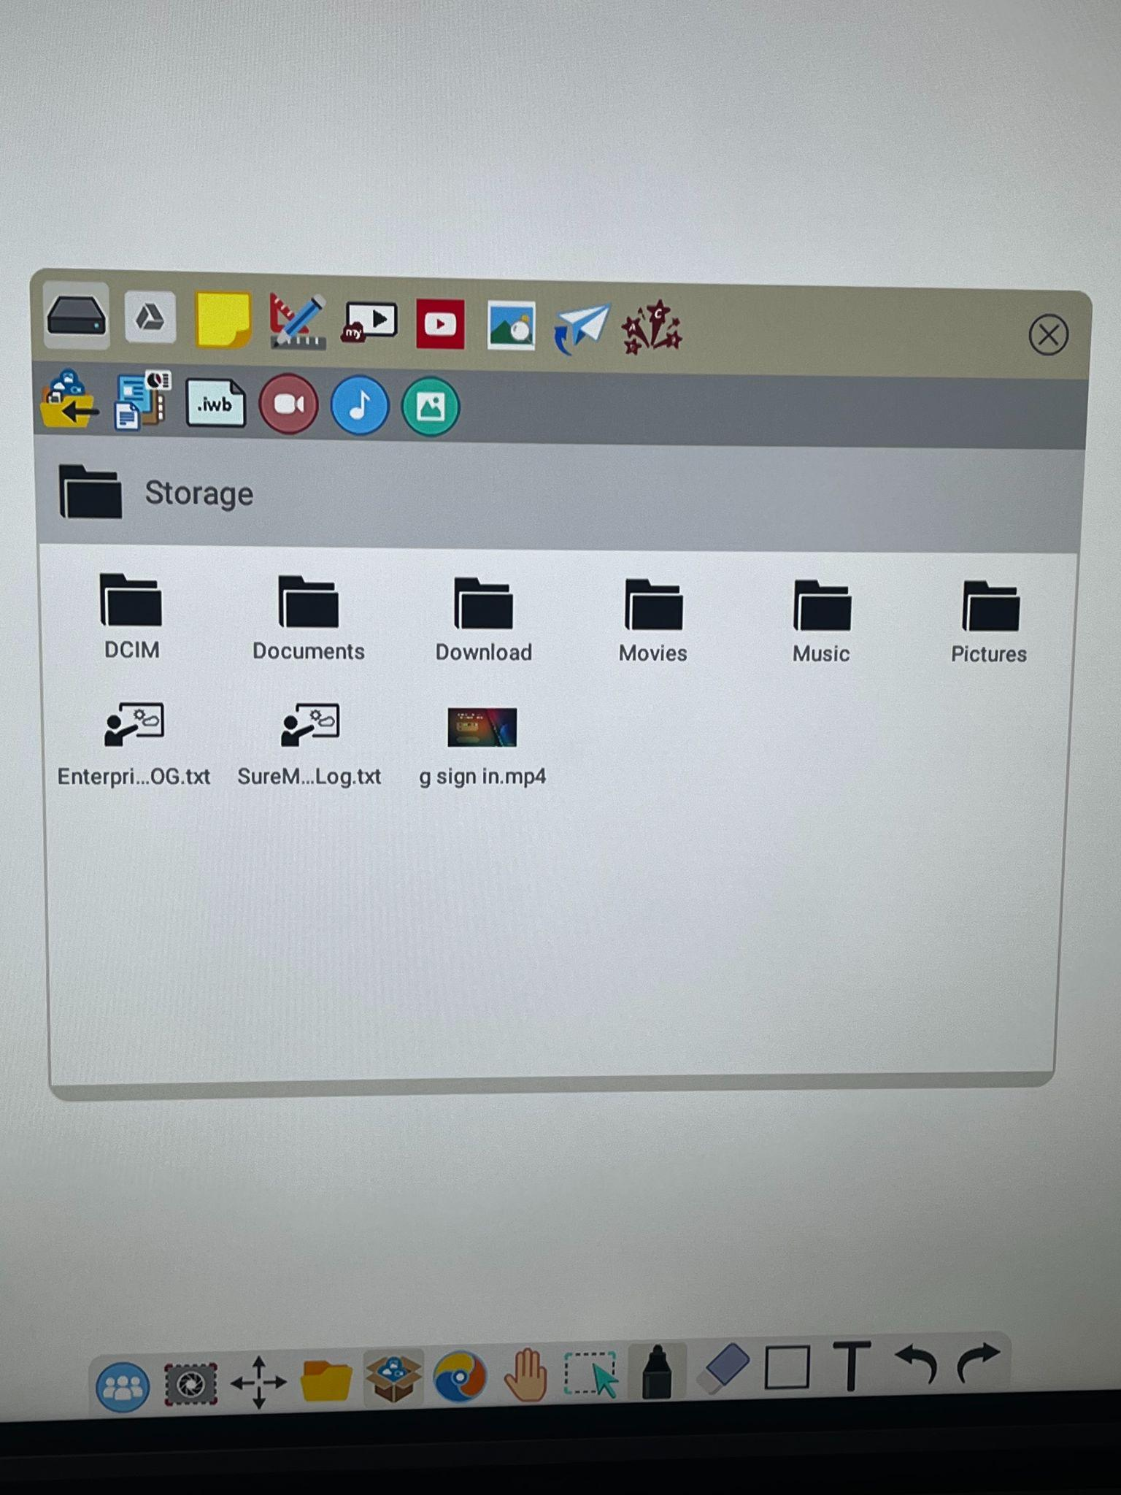
Magic Box
1
3
4
5
6
7
8
9
2
- On board storage
- Google Drive
- Sticky Notes
- Tools - ruler, compass; more tools being added regularly
- myViewBoard Clips - curated, safe, and certified educational videos
- YouTube - drag and drop into whiteboard; ad free
- Image Search - safely search web for images; drag and drop into whiteboard
- Throw - browse documents participants have shared with whiteboard session
- Pop Quiz - create a quiz that students will answer from their personal devices

Accessing Google Drive files
- Follow steps above for Signing into Google Drive
- Open Whiteboard
- Sign in via Companion App with QR Code or email address and password
- Open Magic Box
- Select the Google Drive icon (second icon from left)
- Tap My Drive and navigate to appropriate folder/document

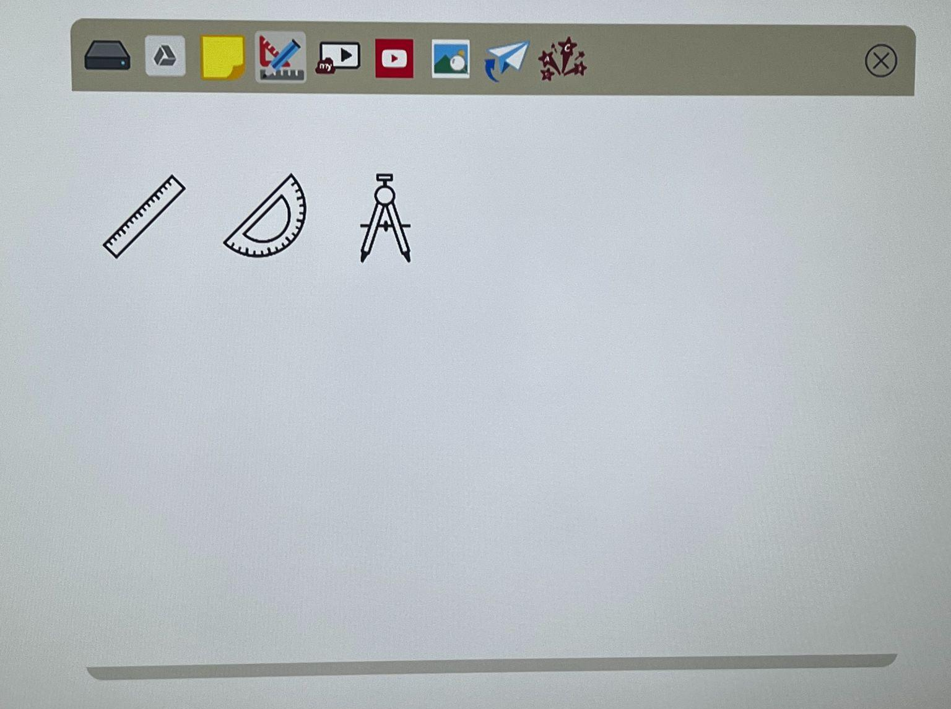
Tools
To insert a tool:
- Tap Tools icon
- Double tap desired tool
- Tool will automatically appear on the canvas

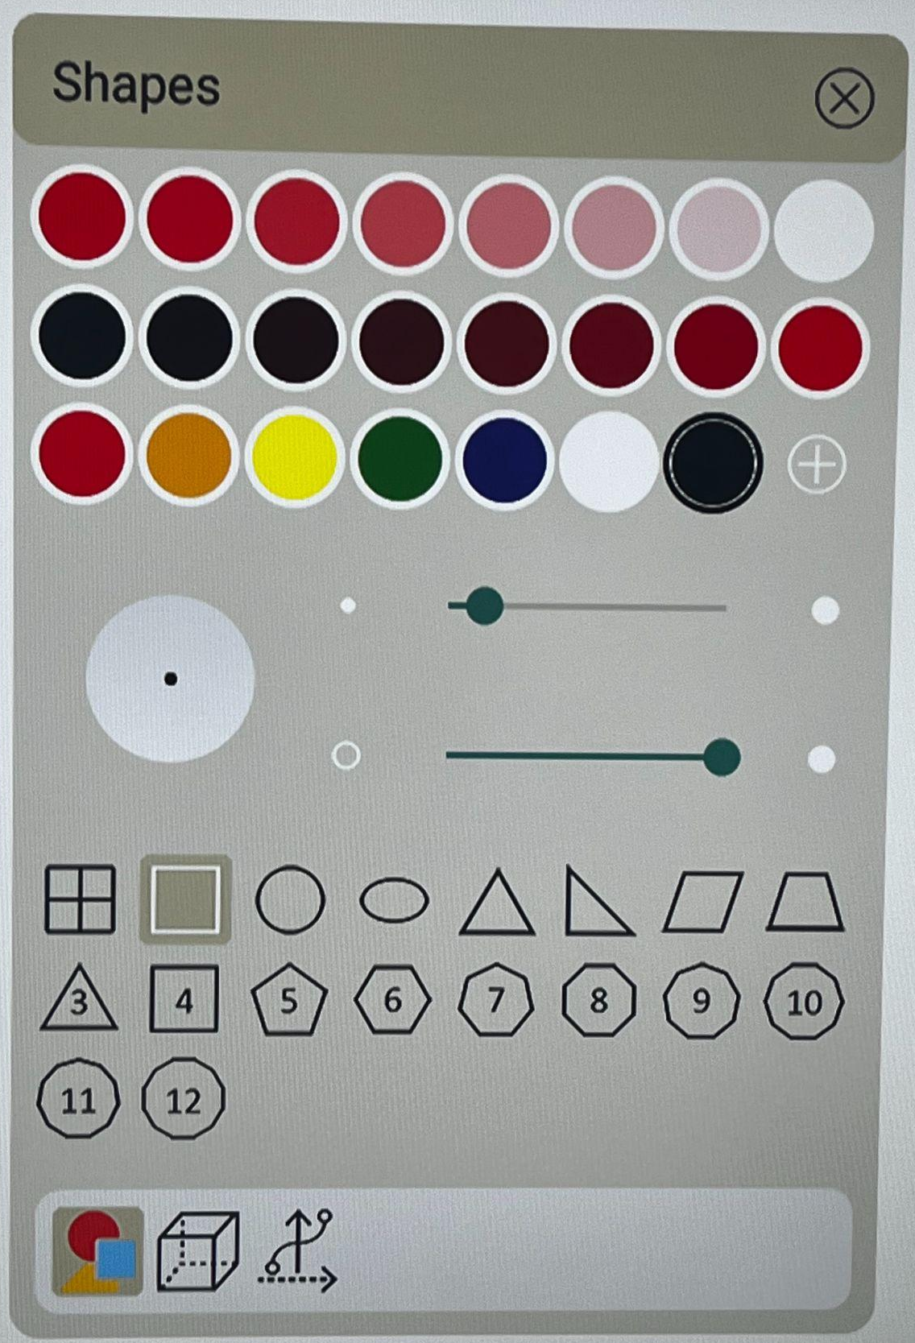
Shapes

To insert a shape:
- Tap the Shapes icon on the toolbar
- Choose a color first!
- Choose shape (flat, 3D, or line)
- Draw on whiteboard canvas

Saving WhiteBoard Canvas
1
2
3
4
5
6
- New Canvas - if a canvas is open, you will be prompted to save it before creating a new one
- Open - Open a .vboard file canvas from local drive or cloud storage
- Save
- Save As - create a new copy of the canvas to local drive or cloud storage
- Export - save whiteboard canvas as .png, .jpg, .pdf, or .pptx
- QR Code Share - converts canvas to .pdf. Students can scan the QR code and take a copy of the lesson with them

Customizing the Whiteboard Canvas
Customizer includes canvas enhancers like speech bubbles, graphic organizers, and much more. You can filter by subject to find the right image. One such customization option includes pre-installed images such as those shown below.

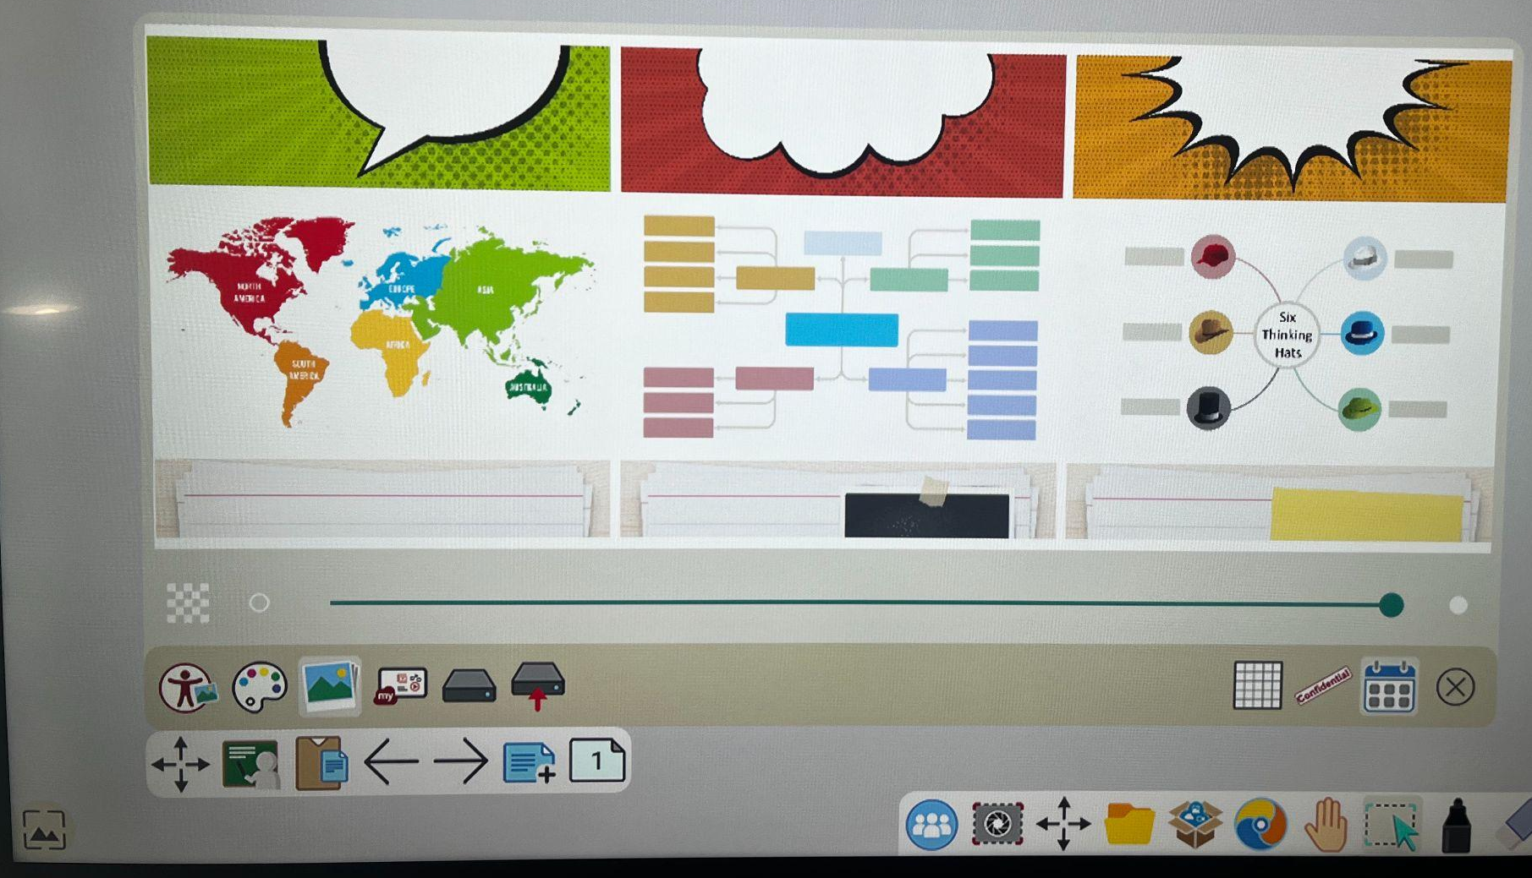
Another customization option is myViewBoard Originals. These can also be accessed from myviewboard.com.

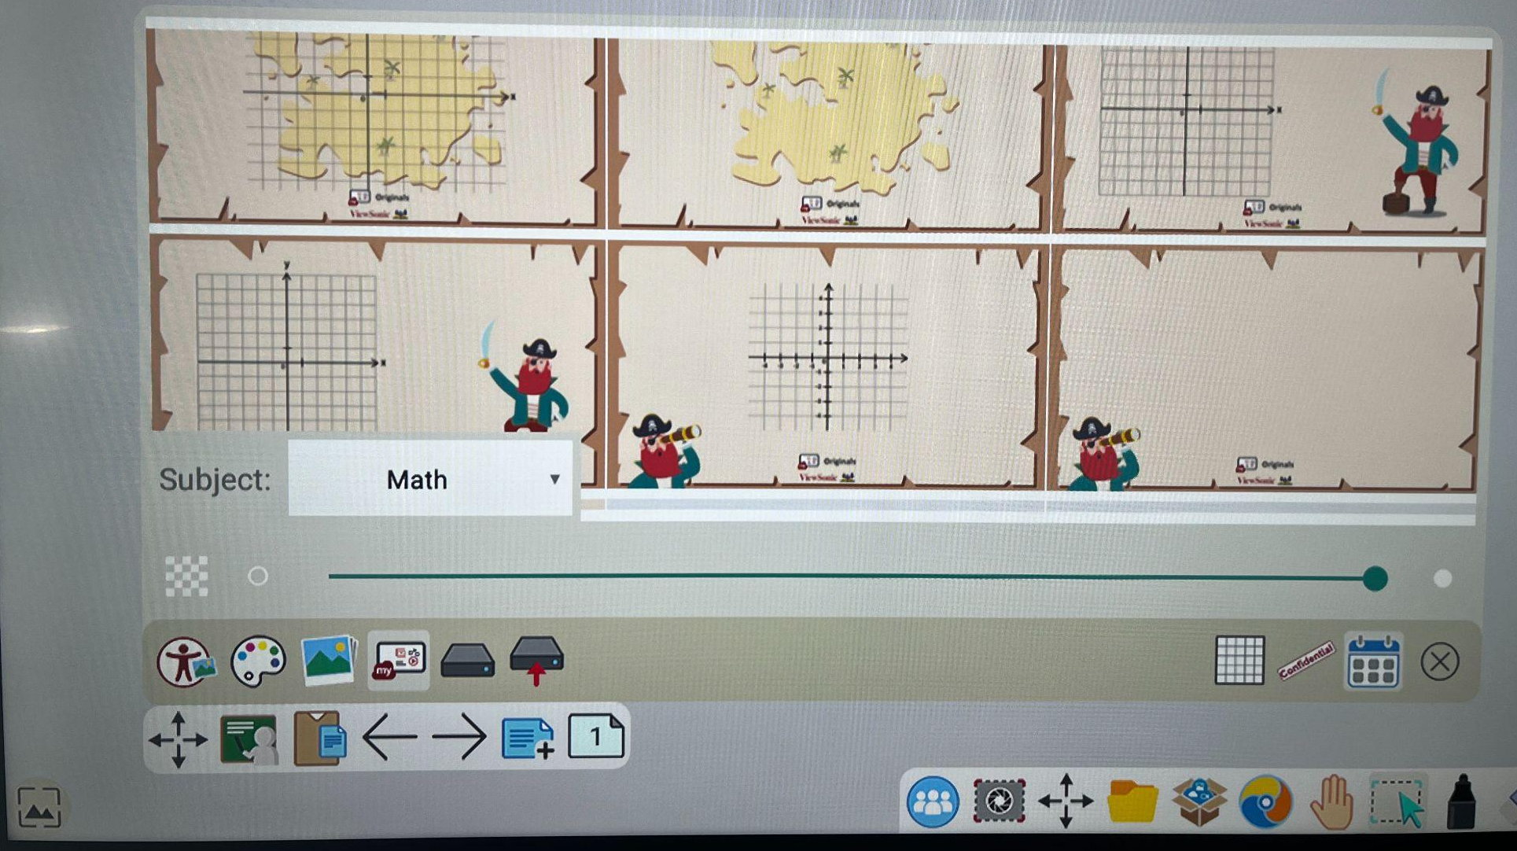

Streaming Content
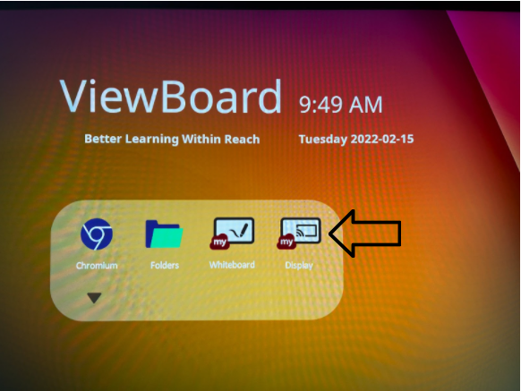
You can stream content from your laptop to your ViewBoard. This may include educational content from Disney+, Hulu, Netflix, YouTube, or other similar platforms. Follow the steps below to stream your content from your device to your ViewBoard.

- From Chrome, sign into the platform
- Locate the content you want to display
- On the ViewBoard, tap the Display icon

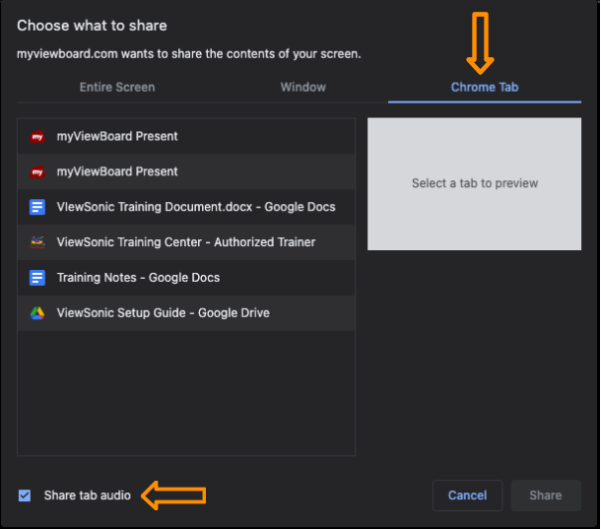
- In another Chrome tab, go to: myviewboard.com/display
  - Enter the Display Code
  - Enter the One Time Password
  - Click Present
  - Choose Chrome Tab > Select tab to share
  - Make sure Share Audio is checked

Companion App
The Companion App can be added to a mobile device via the Apple App Store or Google Play. A web version is also available when an app download is not available such as on an older MacBook. To sign in to the Companion app, the Teacher should always select Host/IT Admin. Choose Sign in with Google, and use your school email address and password.
pictures

Participate (Home)
The Participate tab, which looks like a house, includes host controls and allows you to interact with Whiteboard sessions from other users. This will mostly be used for students.
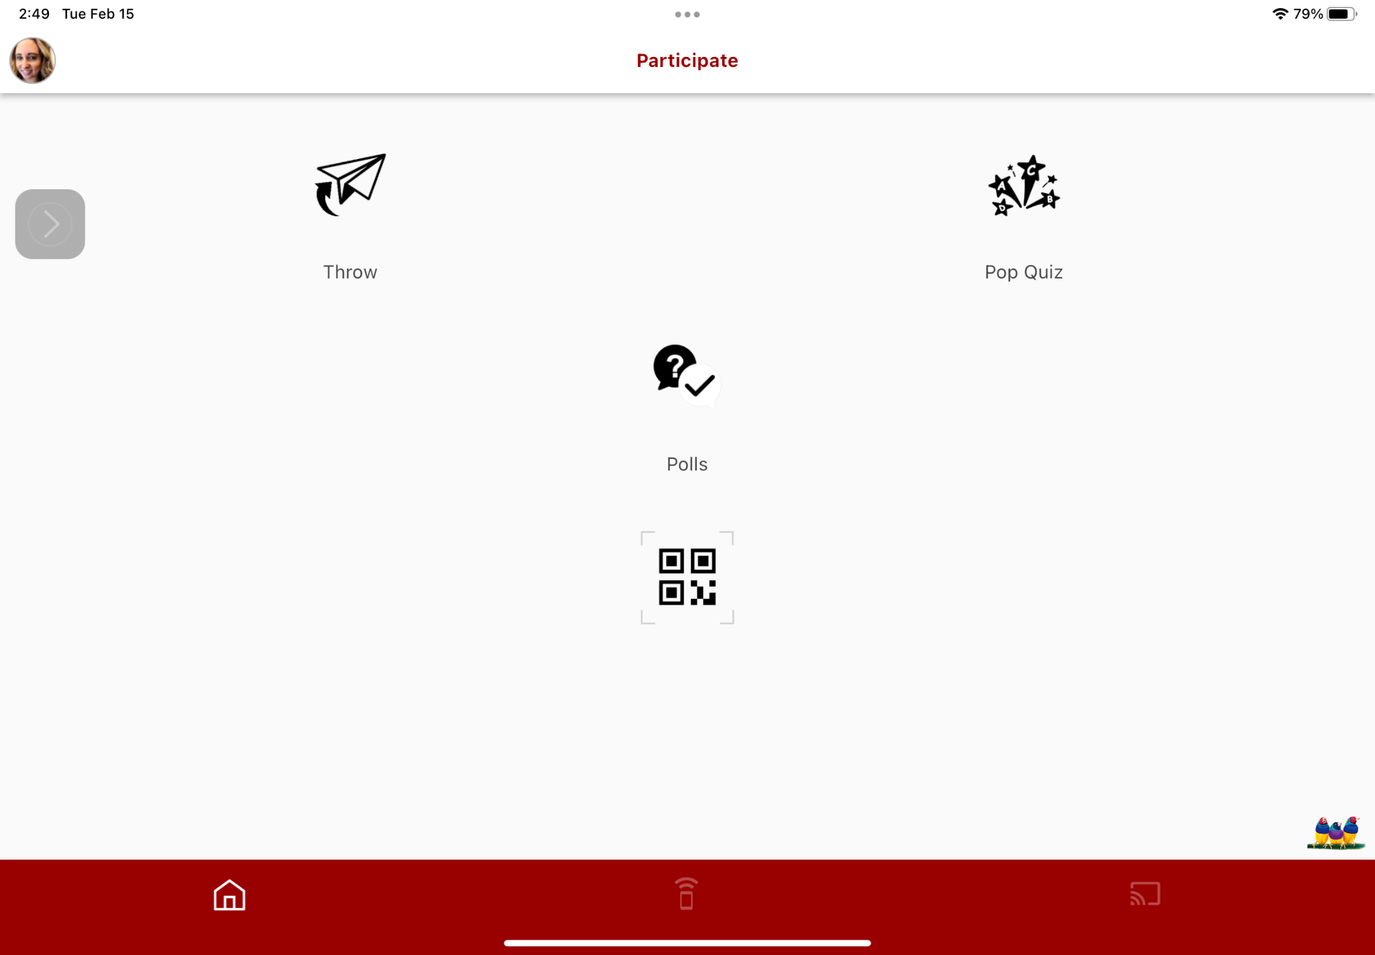

- Throw: send a photo or video from your mobile device to the ViewBoard.
- Pop Quiz: Answer a pop quiz and throw it to the board
- Polls: Answer polls using multiple choice, true/false, rating, voting, random draw, and free format questions
Note: Pop Quizzes and Polls are not designed for formal grading purposes (formative or summative), but may be useful for informal “temperature checks” and gamification of learning.

Whiteboard Remote Control
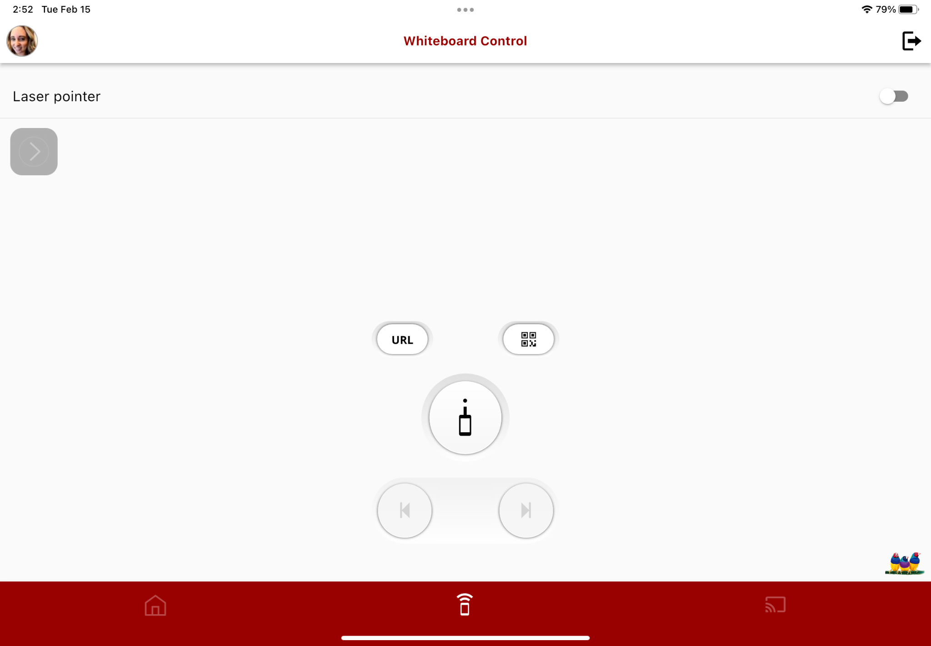
Note: You must be signed into the Whiteboard and the Companion App with the same account to use the remote control function.
1
2
3
4

- URL: Display Whiteboard URL and QR code for Throw, Pop Quiz, and Polls interaction
- Laser Pointer: turn your device into a laser pointer
- QR Code: Generate QR code; when students scan this code, they can take the whiteboard session with them on their device
- Previous and Next: move between pages

MyViewBoard.com

WikiHelp
myViewBoard Wiki has answers to all of your ViewBoard questions!
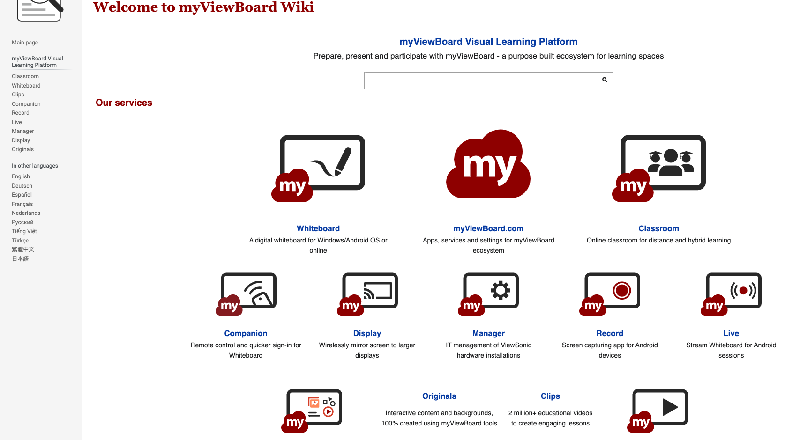

Originals
Originals offers prepared lessons. You can filter by subject and grade level. Original lessons include games and other content by clicking on them from this page.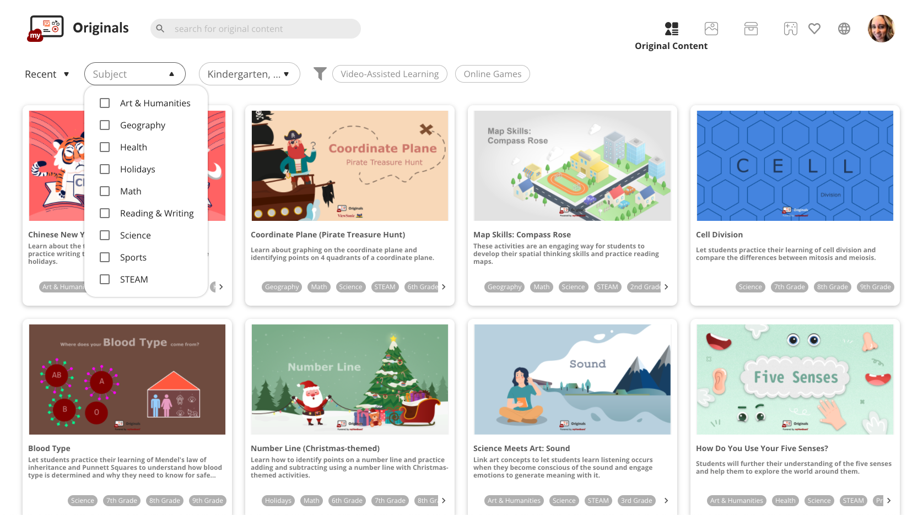

Teacher Certification
If you are interested in learning more about ViewBoard, you may visit viewsonic.com/us.learn. Click Register Now, submit the form, and choose Certified Educator when you arrive at the screen seen below.
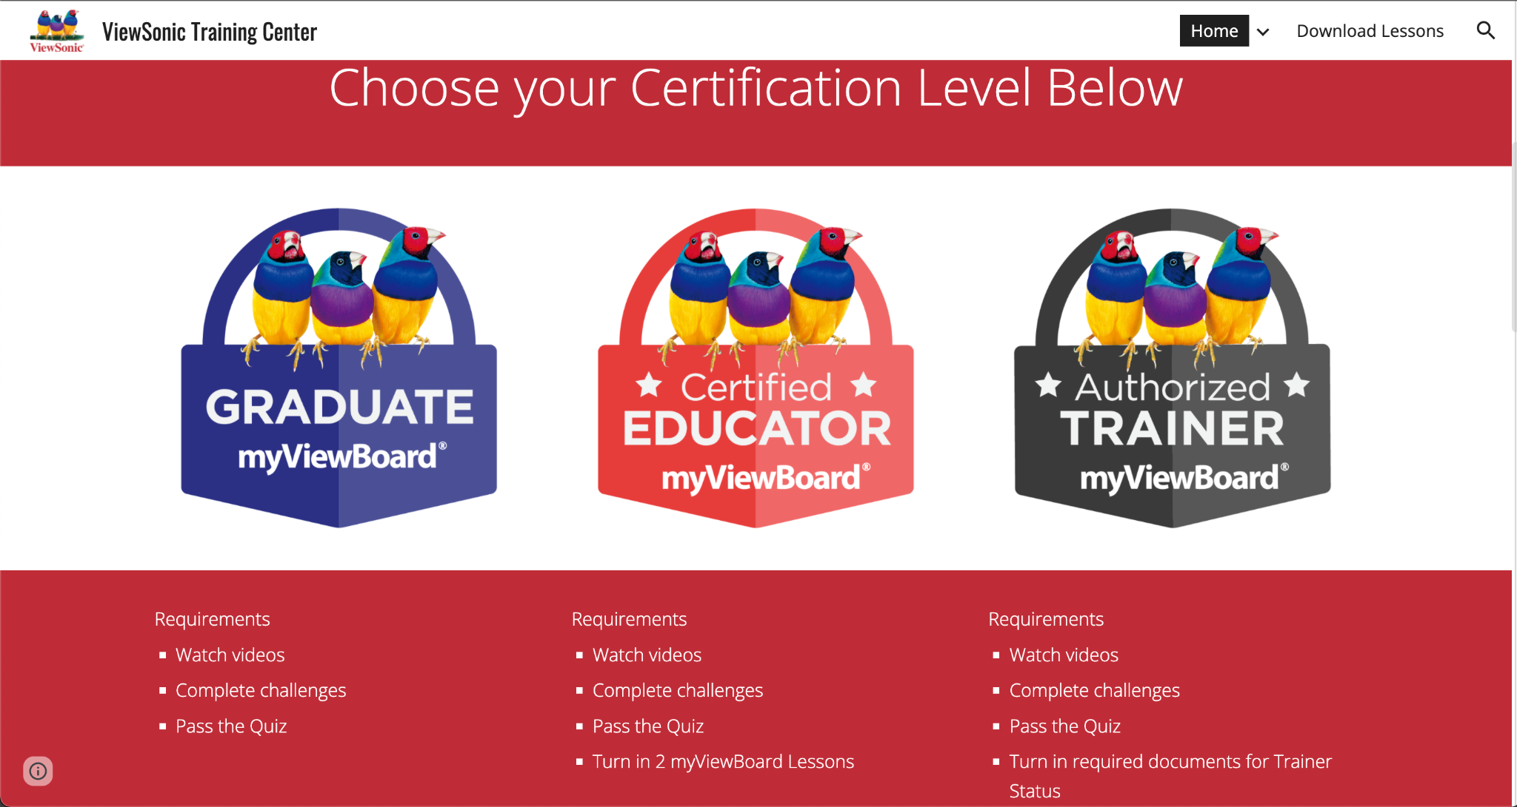

References
Magic Box: https://wiki.myviewboard.com/Magic_Box
myViewBoard Wiki: https://wiki.myviewboard.com/Welcome_to_myViewBoard
myViewBoard Originals: https://myviewboard.com/originals
Polls: https://wiki.myviewboard.com/Polls_Quiz
Teacher Certification: viewsonic.com/us/learn

