OFFICE OF THE DIRECTOR  Office of the State Public Health Director | 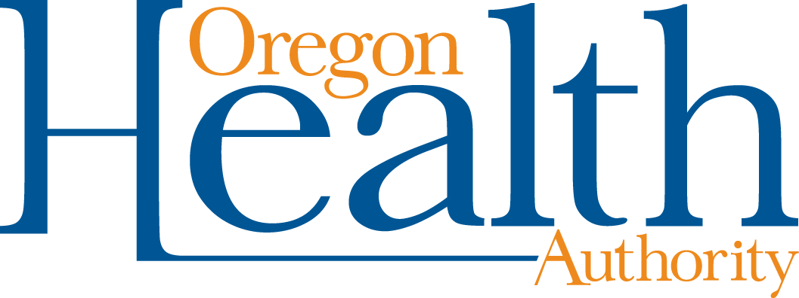

COVID-19 Vaccine Medical Exception Request Form
I am requesting an exception from the COVID-19 vaccination requirement on the basis of a diagnosed physical or mental condition that limits my ability to receive the COVID-19 vaccination, as certified by my medical provider below.
Individual’s name: | Date of birth:
Phone number:

Signature: | Date:
Employer/Organization: | Job Title/Position:
Please note that if your exception request is approved, you may be required by your employer or other responsible party to take additional steps to protect you and others from contracting and spreading COVID-19. Workplaces are not required to provide this exception accommodation if doing so would pose a direct threat to the excepted individual or others in the workplace or would create an undue hardship.

Statement from Medical Provider
Your patient, named above, has requested an exception to the COVID-19 vaccination requirement due to a medical condition. Please provide the information below.

Please check an option below and complete related questions:
The patient should not receive the COVID-19 vaccination due to a medical condition.
What is the medical condition that prevents them from receiving the COVID-19 vaccination?

Yes No Is the medical condition permanent?
Yes No Is the medical condition temporary? If yes, what is the expected duration?

Please describe how this medical condition impacts their ability to receive the COVID-19 vaccination.

The patient may not receive a certain type of COVID-19 vaccination. The patient may receive a vaccination manufactured by .
The patient may receive a COVID-19 vaccination.
I certify the above information to be true and accurate.
Printed name of medical provider: | Date:
Signature of medical provider: | Work address:
 | Work telephone number:
Document accessibility: For individuals with disabilities or individuals who speak a language other than English, OHA can provide information in alternate formats such as translations, large print, or braille. Contact the Health Information Center at 1-971-673- 2411, 711 TTY or COVID19.LanguageAccess@dhsoha.state.or.us.

