District Math Lesson Plan Template

Teacher: Yolanda Randolph Date: March 31-April 04, 2025 Subject: Math Period: Fifth

Alabama CCRS/COS: Standards
- 3.17 Measure lengths using rulers marked with halves and fourths of an inch to generate data and create a line plot marked off in appropriate units to display the data.
- 3.18 Tell and write time to the nearest minute; measure time intervals in minutes (within 90 minutes.)
- 3.18a Solve real-world problems involving addition and subtraction of time intervals in minutes by representing the problem on a number line diagram.
Standards for Mathematical Practice
- MP.1 Make sense of problems and persevere in solving them
- MP.3 Construct viable arguments and critique the reasoning of others
- MP.4 Model with mathematics
- MP.7 Look for and make use of structure
- MP.8 Look for and express regularity in repeated reasoning

Outcome(s)/Objective(s)/I can statement
- Show and tell the time to the nearest minute using analog and digital clocks.
- Find elapsed time using a number line.
- Measure lengths using rulers marked with halves and fourths.

ACTIVATING LEARNING STRATEGY/STRATEGIC TEACHING STRATEGIES:
 | KWL |  | Word Splash |  | Anticipation Guide |  | Lecture |  | Graphic Organizer/VLT |  |  | Poem, Rhymes, etc.
 | Survey |  | Possible Sentence |  | Think-Pair-Share |  | Reading |  | Pictograph |  |  | Acronyms/Word
 | First Word |  | Concept Map |  | Vocabulary Overview |  | Model |  | Diagram |  |  | Other: ___________________
 | Word Map |  | Frayer Model |  | Daily Language Practice (DLP)___________________ |  | Hands-on |  | Mind Map/Visual Guide
Engagement Strategies:
- Collaborative Group Work - Writing to Learn - Literacy Groups Other: _____________________
- Questioning Techniques - Scaffolding Text -Classroom Talk - T.W.I.R.L.

Technology Integration: Smart board Document Camera IPADS Mac Books Computers Kindles Interactive Tablets Digital/ Video Camera Clickers ACCESS Computer Program:savvasrealize.com and savvaseasybridge.com_ Other:______________________________________

PROCEDURAL CONTENT (application)
 |  | Monday | Tuesday | Wednesday | Thursday | Friday
Essential Question |  |  | Topic 16: Essential Question:  How do we prepare for ACAP Summative testing? | Topic 16: Essential Question:  How do we prepare for ACAP Summative testing? | Topic 16: Essential Question:  How do we prepare for ACAP Summative testing? | Topic 16: Essential Question:  How do we prepare for ACAP Summative testing?
Daily Objective(s)  I Can Statement |  | 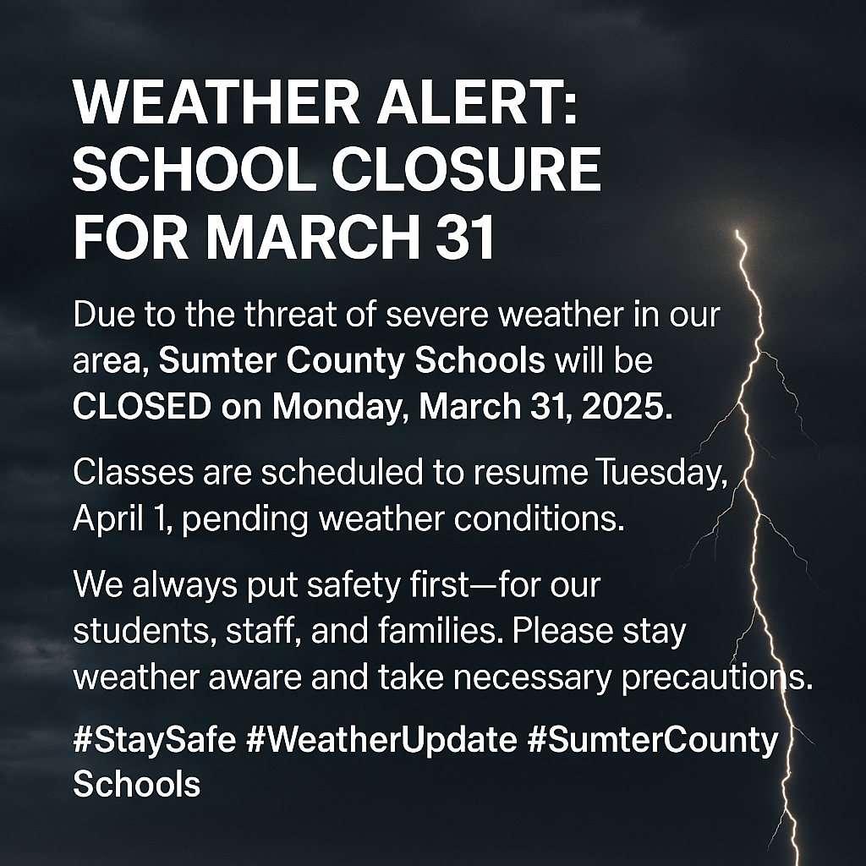 | TS review standards for ACAP Summative test.  I can understand and apply key mathematical concepts, problem-solving strategies, and the ability to represent mathematical ideas in various forms. | TS review standards for ACAP Summative test.  I can understand and apply key mathematical concepts, problem-solving strategies, and the ability to represent mathematical ideas in various forms. | TS review standards for ACAP Summative test.  I can understand and apply key mathematical concepts, problem-solving strategies, and the ability to represent mathematical ideas in various forms. | TS review standards for ACAP Summative test.  I can understand and apply key mathematical concepts, problem-solving strategies, and the ability to represent mathematical ideas in various forms.
Preview  (Before)  Warm-up- Hook |  |  | Number Talk  Solve and Share | Number Talk  Solve and Share | Number Talk  Solve and Share | Number Talk  Solve and Share
Instruction  (During)  I Do-  We Do-  Y’all Do-  You Do- |  |  | 30 Minutes  Explicit Instruction on Skills from Topic  Make Sense and Persevere  Review lessons from Topic  Look Back  Convince Me  Guided Practice  Independent Practice  Problem-Solving | 30 Minutes  Explicit Instruction on Skills from  Topic  Make Sense and Persevere  Review lessons from Topic  Look Back  Convince Me  Guided Practice  Independent Practice  Problem-Solving | 30 Minutes  Explicit Instruction on Skills Topic  Make Sense and Persevere  Review lessons from Topic  Look Back  Convince Me  Guided Practice  Independent Practice  Problem-Solving | 30 Minutes  Explicit Instruction on Skills from Topic  Make Sense and Persevere  Review lessons from Topic  Look Back  Convince Me  Guided Practice  Independent Practice  Problem-Solving
Small Groups |  |  | Intervention Activity:  Use Models  Model | Intervention Activity:  Use Models | Intervention Activity:  Use Models | Intervention Activity:  Use Models
After/Homework |  |  | Review ACAP standard using Pathway to Proficiency | Review ACAP standard using Pathway to Proficiency | Review ACAP standard using Pathway to Proficiency | Review ACAP standard using Pathway to Proficiency
 | Assessment (Formative): Class Work Notebook Homework Quizzes Tests Computer Activities Collaborative Work Project/ Other:

Assessment (Summative): Quizzes Tests Group Activities Project Based Other: ___________________

Summarizing: 3-2-1 Ticket out the Door The Important Thing Cue Cards Teacher Questions Student Summary Other: _________________

