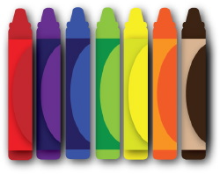 September

Pre-K News

We are having a marvelous time in Pre-K getting to know your children! We have enjoyed learning ALL about them and your family. They have shared their posters and filled us in about ALL their FAVORITE things. We are delighted to see them learn and grow. This month we will be learning so many exciting new things. Our topics will include Family, Apples, and Fall! We will continue to review rules and procedures of our classroom and school. Your children are a blessing to us, and we are thrilled to learn all about each of them and look forward to them being a successful Pre-K student!

Let’s go Bulldogs!

Items to Review:

ABC’S

Colors

Shapes

Numbers to 10

Counting to 20

I can Spy these Words! I, a, big, little, the, am, & see!

Mark Your Calendar

September 1stth - Labor Day (NO School)

September 5th Grand Parent PICNIC (Hat Day)

September 12th Kona Ice (Sunglasses Day) –

September 19th – Literacy Day

September 26th – Glow Party

Reminders:

Please remember to send a water bottle daily.

Review Skill Sheet in Binder.

