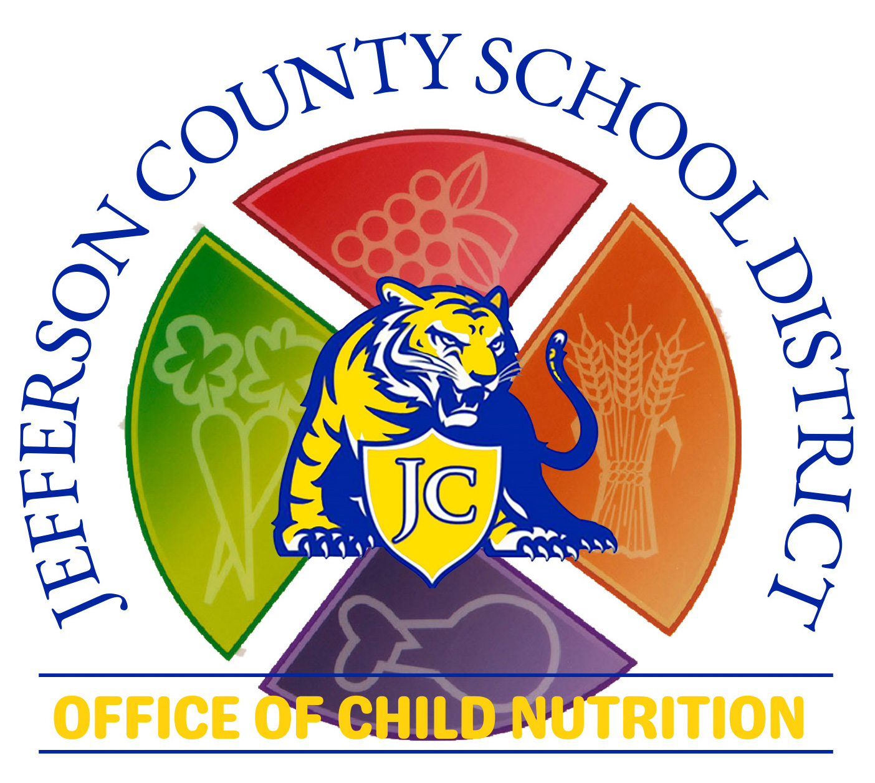
COMMUNITY ELIGIBILITY PROVISION
SAMPLE PUBLIC RELEASE
SCHOOL YEAR 2023- 2024

The Jefferson County School District is pleased to announce the district will participate in the Community Eligibility Provision (CEP) during the 2023 - 2024 school year providing meals, regardless of eligibility category, at NO CHARGE for all students at the following schools Jefferson County Elementary, Jefferson County Middle and Jefferson County High School that participate in the National School Lunch Program or School Breakfast Program. CEP is made possible through the United States Department of Agriculture (USDA) Special Assistance Certification and Reimbursement Community Eligibility Provision. Federal reimbursement for meals is based on the Identified Student Percentage (ISP) established by the District in April. All adults, e.g., visitors, teachers, support staff members, and administrators of the district must assume the full cost of the meal which is $2.75 for Breakfast and $4.00 for Lunch.

Nondiscrimination Statement:
In accordance with Federal civil rights law and United States Department of Agriculture (USDA) civil rights regulations and policies, the USDA, its Agencies, offices, and employees, and institutions participating in or administering USDA programs are prohibited from discriminating based on race, color, national origin, sex, disability, age, or reprisal or retaliation for prior civil rights activity in any program or activity conducted or funded by USDA.

Persons with disabilities who require alternative means of communication for program information (e.g. Braille, large print, audiotape, American Sign Language, etc.), should contact the Agency (State or local) where they applied for benefits. Individuals who are deaf, hard of hearing or have speech disabilities may contact USDA through the Federal Relay Service at (800) 877-8339. Additionally, program information may be made available in languages other than English.

To file a program complaint of discrimination, complete the USDA Program Discrimination Complaint Form, (AD-3027) found online at: http://www.ascr.usda.gov/complaint_filing_cust.html and at any USDA office, or write a letter addressed to USDA and provide in the letter all of the information requested in the form. To request a copy of the complaint form, call (866) 632-9992. Submit your completed form or letter to USDA by:
(1) mail: U.S. Department of Agriculture, Office of the Assistant Secretary for Civil Rights, 1400 Independence Avenue, SW, Washington, D.C. 20250-9410;
(2) fax: 202-690-7442; or
(3) email: program.intake@usda.gov

This institution is an equal opportunity provider.

