JHW ELEMENTARY ELECTRONIC DEVICE CHECK OUT FORM
306 Florida Ave Lake Wales, Fl 33853 863-678-4211

STUDENT LAST NAME______________________ FIRST NAME______________________

Parent Name: _______________________________ Email Address: ____________________________

Parent Address:_______________________________________________________________________

Device Type: Chromebook Value: $250.00 -$400.00

DEVICE BARCODE:______________________________________________

This computer agreement is to signify that the above-named student parent/guardian is fully responsible for maintaining this device. Prior to student checkout, this form must be signed by both the student and the student’s parent or guardian and returned to the school office. It is agreed that Janie Howard Wilson Elementary (JHW) School is not responsible for any loss or damage done to the device while in possession of the student. If loss or damage occurs, the student and parent/guardian are responsible for the repair or replacement of the device.
- I understand that the Chromebook is my responsibility while checked out from JHW and I am responsible for any damages to the Chromebook while in my possession.

- I understand that the appropriate use contract previously signed applies to devices checked out from JHW.

- I consent to allow my child to accept responsibility for this device and its use for as long as it is checked out to my child or in their possession.

- It is understood that unpaid bills for device misuse may result in the school putting a hold on student records. Continued misuse of a school device may result in a loss of this privilege and potential discipline according to the guidelines in the Student Code of Conduct. Failure to return the device at the end of the checkout period will result in a police report being filed for stolen property belonging to the Lake Wales Charter School District, JHW Elementary School.

I understand and agree to these device use guidelines and authorize my student to complete the Device Checkout section on this form in order to check out the device for home use and I understand the requirements stated above:

_________________________________________ __________________________
Parent Signature Date

_________________________________________ __________________________
Student Signature Date

Please use the back of this form to label any concerns you have regarding this device. For example, label any missing keys.
Condition when checked out: Label the computer:
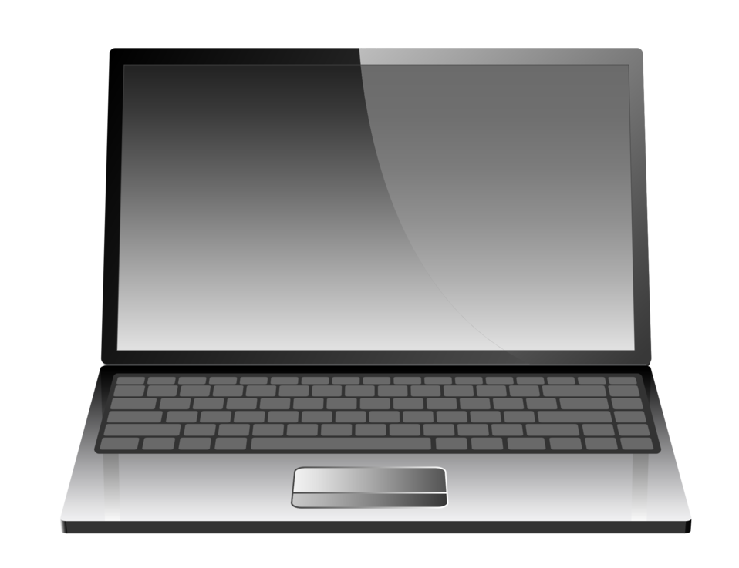

Return Date: __________________

Staff Signature (when Chromebook returned):____________________
Condition when returned: Label the computer:
Charger Returned: _________

