AP US History Syllabus
2024-25
Mr. Boone
Veterans HS

Course Description
AP United States History focuses on developing students’ abilities to think conceptually about U.S. history from approximately 1491 to the present and apply historical thinking skills as they learn about the past. Seven themes of equal importance — identity; peopling; politics and power; work, exchange, and technology; America in the world; environment and geography; and ideas, beliefs, and culture — provide areas of historical inquiry for investigation throughout the course. This course meets the American History requirement for our county school system. High school credit is gained by passing the class. College credit is earned on a national AP exam and is determined by each individual college and university. This class will naturally cover the topics and standards of regular U.S. History as well. To find more information regarding the curriculum and the Georgia Performance Standards refer to the Georgia Department of Education website at http://public.k12.ga.us/ (or search GeorgiaStandards.org).

Materials and Texts

Newman, John J. AMSCO Advanced Placement US History (4th edition). Des Moines: Perfection Learning, 2020.
- This book will need to be purchased ASAP. It can be purchased directly from the publisher (Perfection Learning) or from Amazon. Used copies are as acceptable as new ones!
- You WILL BE HELD RESPONSIBLE for readings from this book beginning with Period 2. That gives you roughly 2 weeks to get a copy.

Historical Thinking Skills
The curriculum framework defines historical thinking skills that are central to the study and practice of history. Students who become proficient in these skills will be able to act as apprentice historians—using the cognitive tools of the discipline to master its subject matter. Students will emphasize the conceptual and interpretive nature of history rather than simply memorization of events in the past. The curriculum framework describes 4 categories of skills & 9 unique historical thinking skills within those categories.

I. Chronological Reasoning
- Compare causes and/or effects, including between short-term and long-term effects
- Analyze & evaluate historical patterns of continuity and change over time
- Connect patterns of continuity and change over time to larger historical processes or themes
- Analyze & evaluate competing models of periodization of American history

II. Comparison and Contextualization
- Compare related historical developments & processes across place, time, and/or different societies, or within one society
- Explain & evaluate multiple and differing perspectives on a given historical phenomenon
- Explain & evaluate ways in which specific historical phenomena, events, or processes connect to broader regional, national, or global processes occurring at the same time

III. Crafting Historical Arguments from Historical Evidence
- Analyze commonly accepted historical arguments & explain how an argument has been constructed from historical evidence
- Construct convincing interpretations through analysis of disparate, relevant historical evidence
- Evaluate and synthesize conflicting historical evidence to construct persuasive historical arguments
- Analyze features of historical evidence such as audience, purpose, point of view, format, argument, limitations, and context germane to the evidence considered
- Based on analysis and evaluation of historical evidence, make supportable inferences and draw appropriate conclusions

IV. Historical Interpretation and Synthesis
- Analyze diverse historical interpretations
- Evaluate how historians’ perspectives influence their interpretations & how models of historical interpretation change over time
- Draw appropriately on ideas and methods from different fields of inquiry or disciplines
- Apply insights about the past to other historical contexts or circumstances, including the present

Course Outline

You will notice some overlap between periods. Following the example of many subfields within U.S. History,
as well as the approach adopted by most U.S. history textbooks, the concept outline reflects an
acknowledgment that historians differ in how they apply boundaries between distinct historical eras.

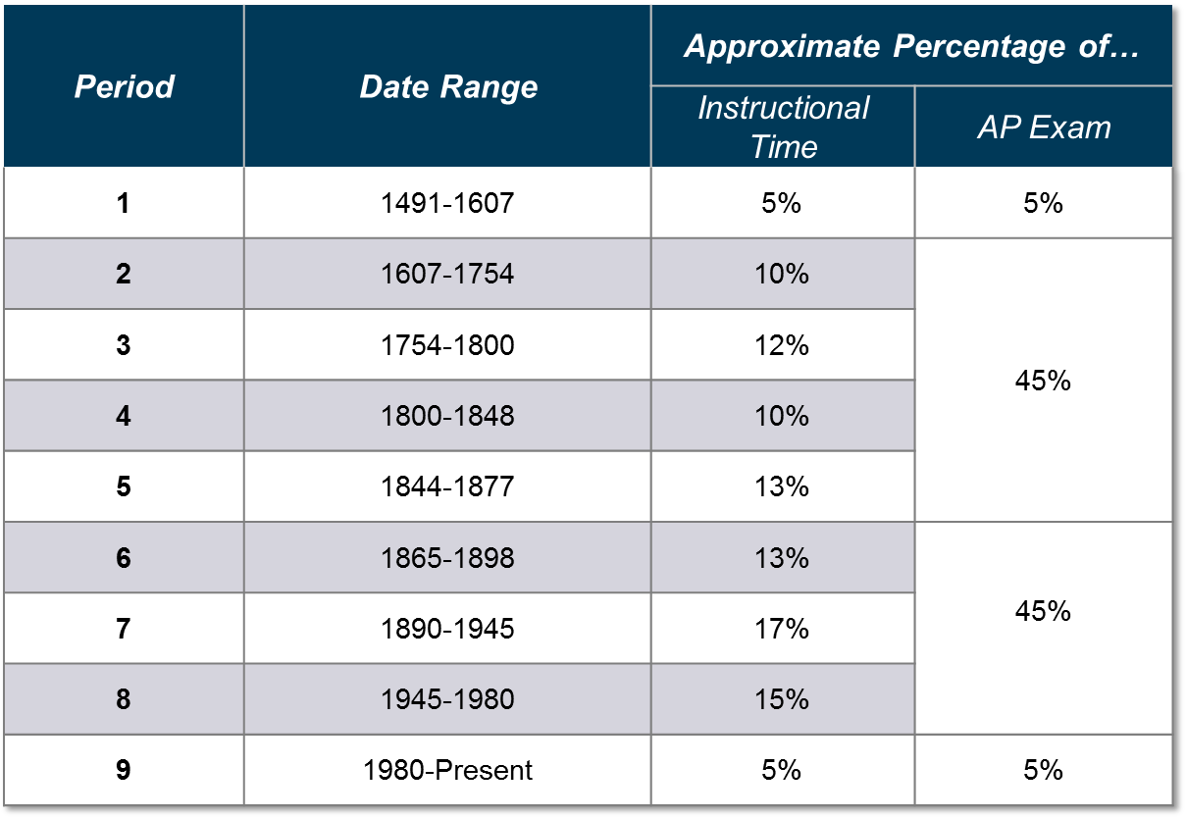Period

APUSH EXAM,
The AP Exam questions measure students’ knowledge of U.S. History and their ability to think historically. Questions
are based on key and supporting concepts, course themes, and historical thinking skills.

Format of Assessment
Section I Part A: Multiple Choice | 55 Questions | 55 Minutes | 40% of Exam Score
- Questions appear in sets of 2–5.
- Students analyze historical texts, interpretations, and evidence.
- Primary and secondary sources, images, graphs, and maps are the basis for most questions.

Section I Part B: Short Answer | 4 Questions | 45 Minutes | 20% of Exam Score
- Questions provide opportunities for students to demonstrate what they know best.
- Some questions include texts, images, graphs, or maps.

Section II Part A: Document Based | 1 Question | 60 Minutes | 25% of Exam Score
- Analyze and synthesize historical data.
- Assess written, quantitative, or visual materials as historical evidence.

Section II Part B: Long Essay | 1 Question | 35 Minutes | 15% of Exam Score

- Students select one question among two.
- Explain and analyze significant issues in U.S. history.
- Develop an argument supported by an analysis of historical evidence.

Grading Policy:

The system that will be utilized for grading and all grades will fall under the three categories detailed below.

Assignments will vary in point value depending on the length, breadth, and depth of the topic at hand. Periodic

progress reports will be issued, but students are responsible for keeping up with their grades and can track them via

Infinite Campus. All assignments will be returned to students after grading is completed, though MAJOR TESTS AND QUIZZES

will be kept by the instructor once remediation has been completed.

**A note on QUIZZES** - these can be UNANNOUNCED!

Grading Categories
Daily Work (15%) – Short quizzes (reading/notes), Homework & Warm-Up Checks, Writing Skills Practice, etc.
Minor Assessments (20%) – Quizzes, SAQ’s, Mini-DBQ’s/LEQ’s
Major Assessments (45%) – Period/Unit Exams, LEQ’s, DBQ’s, Projects
Final Exam (20%)

Comprehensive Final Exam, Practice Exam, & Georgia Milestones

AP “Final” Exams
It is a given that comprehensive, cumulative tests will be given to prepare the student for mastery on the national AP exam. Both semesters will include a COMPREHENSIVE TEST that assesses all info taught since the start of the course. THIS IS NOT
THE SAME AS A FINAL EXAM AND CANNOT BE EXEMPTED.

***The actual FINAL – WHICH MAY BE EXEMPTED BASED ON GRADES, ATTENDANCE, DEBTS OWED, AND BEHAVIOR – will consist of MCQ’s and FRQ’s.

There is NO GEORGIA MILESTONE TEST for this course.

AP CLASSROOM/COLLEGE BOARD INFORMATION:
- 8/25/24 - Deadlines for students to confirm or create a College Board account and electronically join AP classes on College Board. (APcentral.collegeboard.org, Helpline for students and parents 1-888-225-5427). STUDENTS MUST FIX COLLEGE BOARD ACCOUNT ISSUES. VHS CANNOT ASSIST YOU IN THIS MATTER.
- 10/25/24 –Deadline for students to register for AP exams on the College Board website.
- Exam cost/fees: More information forthcoming.

Canvas: This application will be used to keep students and parents informed of class assignments and other important announcements. I will provide you with the code for joining the class page if you are not added automatically upon class enrollment.
AP Classroom: This will allow you to practice for the exam with AP style questions of all types – Multiple Choice, Long – Essay, Document Based Questions, and Short Answer Questions. This website will also be utilized for class assignments this year, as the exam will be online in May. http://apcentral.collegeboard.com/
Cyberbullying: As defined by Dictionary.com, “the act of harassing someone online by sending or posting mean messages.” Please keep in mind that the Edmodo communication system is designed to work as an extension of the classroom; therefore, anything done on the site through the access of a school course group code will be treated the same as if it were said aloud in the classroom. Inappropriate comments or use of the site can result in disciplinary action.
Chromebook/electronic devices policy
- No cell phones, ear buds, headphones in class! This is a schoolwide rule.
- All students are issued a district-provided chrome book for instructional purposes, student engagement, and student learning. Chrome book use is at the direction and discretion of the classroom teacher.
- Using a Chromebook in class is treated just as any other classroom activity or assignment. If you are off task and unable to complete work in the allotted amount of time, you will not be afforded additional time to complete. Use your and my time wisely.
- Please bring the Chromebook to class charged. There will be no charging during class.

Study Techniques
- STUDY! You are really 100 % responsible for the textbook material. I will not use class time to simply review
what you were supposed to read. The course has too much information for students who will not apply
themselves. My job as teacher is to facilitate you and assist you in preparing for the exam. I will help you get
ready to analyze, theorize, critically think, etc., but if you don’t prepare yourself, class time will be wasted.

- Keep pace with daily & weekly assignments. Cramming is not the recommended performance mode,
Especially come May when you find you are responsible for mastery of over 500 years of American History).

- Work together, study together, critically think together, etc. Remember, “no man is an island,” (except for the case
of individual assignments and grades that are given).

- Check out historical magazines, etc. Get a good overview of historical scholarship. Watch the news.

- Think themes and big ideas with supporting information. Review frequently.

Required Supplies
- A binder for this class
- Dividers (approximately 10)
- Paper in the binder
- Pencils/Pens – blue/black ink ONLY - any assignments submitted in other colors will receive NO CREDIT.

Make-Up Work, Late Work, Remediation, & Tutoring

Class Assignments
Students are expected to keep up with reading assignments – the reading schedule will be provided at the beginning of each unit and is available on the class website. Reading will be necessary to do well in the course: assignments, reading checks, quizzes, and exams. Time in class will be spent on addressing student questions and ideas from the readings and using the information learned from the readings. We will focus on developing the various writing skills necessary for the AP Exam – short answer writing (SAQ), long essay writing (LEQ), and document-based analytical writing (DBQ). The course will also involve reading & analyzing primary source documents and completing projects. There is an end-of-year major review project and a comprehensive final exam, to help prepare students for the AP Exam.

Due Dates
- In-class assignments are to be turned in by the end of class.
- Homework assignments and projects are to be turned in at the beginning of class on the day that the assignment is due.
- Because of the ability to turn in assignments in multiple ways, the due dates are concrete. An assignment is considered on time if it is turned in physically on or before the day it is due in class. It is also considered on time if it is received my 11:59 PM through Canva/AP Classroom or email the day it is due. Assignments turned in after this time will be marked as late and given a maximum grade of 70. Any assignment turned in over 5 class days late will result in a maximum grade of 50. Any assignment turned in after this time will not be accepted.
- Assignments can be turned in physically or by email – the goal is to get it submitted to the instructor. I prefer physical if possible - less can go wrong this way. However, email will be accepted when necessary.
- It is the expectation that you will check Canvas at least once daily whether you are present or absent from class. If you have any questions about assignments, you may contact the teacher through email or Canvas.
- NI’s and Instructional absences do NOT change school policy.

Make-up Work
- It is the student’s responsibility to check for any work missed due to an absence.
- Make-up work is due within 24-48 hours of returning to school from an absence. Length of time will vary depending on the amount of work, etc.
- A zero will be placed in the gradebook until work is completed. No IF’s, AND’s or BUT’s.
- **Important Note: In the event of a voluntary or involuntary absence from school (i.e. personal illness, ISS/OSS discipline, school activity, or system shut down), it is your responsibility to utilize the various points of contact (Canvas and/or email) with your instructor in order to keep up with and continue the course of study. Neglecting this responsibility may result in failure of the course. The penalty for late work with no prior communication is zero (0) grade on the assignment. Be responsible and complete all work assigned in the set time frame to avoid an issue and/or penalty.
- Test/quiz retakes: You will have TWO per semester, so make them count!

Extra Credit
- There are no opportunities for extra credit. This will help prepare students for post-secondary education environments (college and the workplace), where extra credit does not exist.
- It is imperative that students pay attention in class, study, and come for tutorials (if necessary) to succeed in the course.

Remediation/Enrichment:
SOAR - On Tuesdays you will meet with your academic teachers for an opportunity for review, remediation, or enrichment specific to your needs. This will give students an opportunity to master ideas and content not yet achieved as well as extend learning when mastery has already been accomplished. Make good use of this opportunity for success.

Make-Ups/Tutoring

I will be available BEFORE SCHOOL on TUESDAYS & THURSDAYS from 7:15-7:50 (barring required meetings and/or previous appointments) beginning August 13.

Signature Page – Please return by Wednesday, 8-7-25!
I have read this syllabus and understand the objectives, requirements, and
expectations for this AP U.S. History course. I also promise not to lie, cheat, or assist
others in those actions.

I understand that I, as an AP student, am responsible for registering online for my exams.
Failure to do so will that I am unable to participate in AP testing for this course this school year.

Veterans High School is responsible for meeting College Board deadlines regarding test registration. Once I
have chosen to test/not test and submitted my registration through the College Board website, I am
responsible for any fees incurred should I later change my decision.

Student Name (Printed)____________________________________________________________

Student Signature ________________________________________________________________

Parent/Guardian Name (printed)________________________________________________

Parent/Guardian Name (signature)_________________________________________________________

