As students, we will:
●Listen and learn from my teachers and parents to improve literacy and math.
●Read books daily in my Lexile Range for at least 20 minutes and use my Google Classroom for work completion in all academic areas using accessible online programs.
●Set/Meet/Discuss & Exceed my Academic & Learning focused goals with my teacher & parents.
●Track my goal progress using my goal setting tools.
●Use teacher feedback to grow. I will also record & discuss my weekly grades with my parents & teachers in my Red Devil Folder.
●Track & celebrate my progression & achievement of both my academic & learning focused goals in my Red Devil Folder.
●Share my work with my parents each Tuesday through my Red Devil Folder

Activities to Build Partnerships
Parent Volunteer Orientation
September 8, 2026 @ 9:00am January 12, 2027 @ 9:00am
Open House
August 3, 2026- 4:30pm-7:00pm
August 4, 2026- 8:30am-11:00am

Annual Title 1 Meeting
August 12, 2025 8:00am & 3:00pm

Workshops/PTO
PTO/ Math Night@ Piggly Wiggly – August 25, 2026 5:30pm-6:30pm
PTO/ S.T.E.A.M/Science Fair @ College and Career Academy- October 22, 2026 5:30pm-6:30pm
Raise Them Up Bowdon Outreach- November 30, 2026 9:00am
PTO/ Literacy Night @ Bowdon Library – January 26, 2027 5:00pm-6:00pm
PTO/Living History Museum @ Bowdon Historical Society- March 23, 2027 5;30pm-6:30pm

Effective Ways We Communicate with Stakeholders
Midterm Dojo School Messenger Conferences
School Email Report Cards Facebook Infinite Campus
Newsletters School Marque Red Devil Folders
(You may contact Ginny Edwards, Principal, Mrs. Nikki Ethridge & Rachel Herman, Assistant Principals or Your child’s teacher for more help concerning student instructional supports)

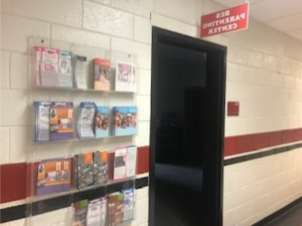
Visit our BES Parenting Center
Our Parenting Center is located in the
Front office area. We have several items that may be checked out for parent’s use.

See Mrs. Cindy for more details.


owdon Elementary School
2023-2024
School-Parent Compact

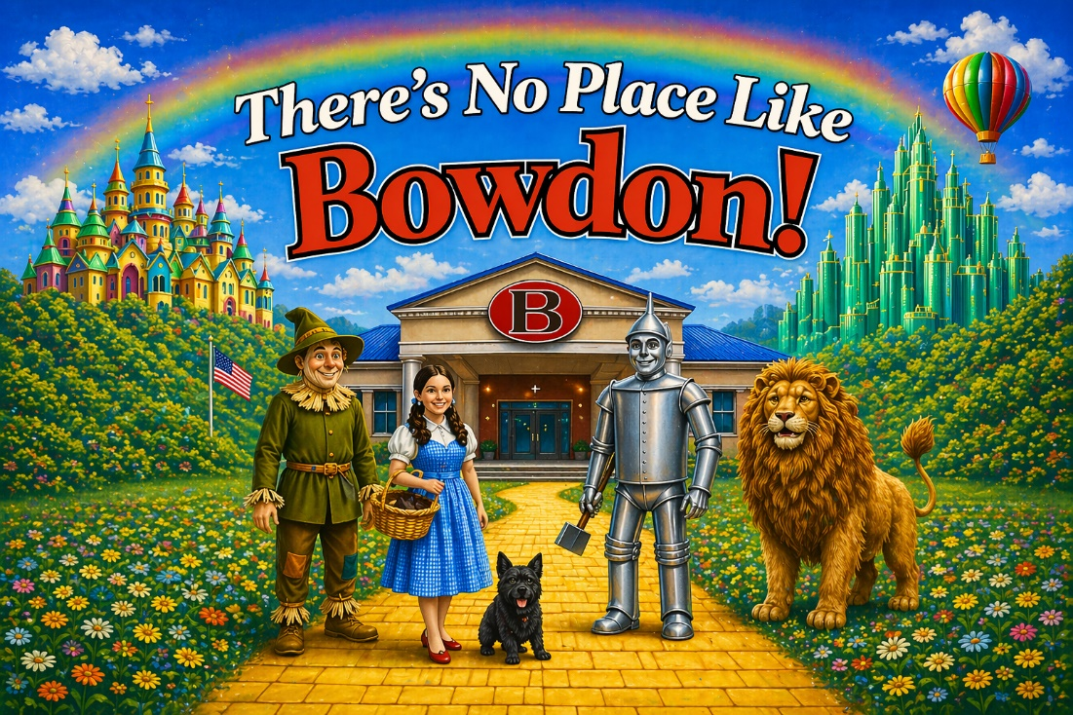
Bowdon Elementary
2026-2027
School-Parent Compact

223 Kent Ave.
Bowdon, Ga. 30108
770-258-2161
770-258-8204 (Fax)

#builtbyBowdon
#NoPlaceLikeBowdon

REVISION: June 1, 2026

Revision Date: June 21, 2023

Our Goals for Student Achievement District Goals
The percentage of students scoring at Proficient or above on the Spring 2023 STAR Reading & STAR Math will increase by three percentage points.
School Goals
●Bowdon Elementary will increase the number of students scoring Proficient or above on the spring 2023 STAR Reading & STAR Math by three percentage points.
Areas of Emphasis
●Grades K-5 will focus on increasing Lexile Levels in Reading and Early Literacy Skills
●Grades K-2 focus on increasing understanding of Number Sense.
●Grades 3-5 focus on increasing understanding of Problem Solving in Math, Fact Fluency and Operations/Fractions

Our Goals for Student Achievement
District Goals
The percentage of students scoring at Proficient or above on the Spring 2026 STAR Reading & STAR Math will increase by three percentage.
School Goals
Bowdon Elementary will increase the number of students scoring Proficient or above on the spring 2025 STAR Reading & STAR Math by three percentage points. BES will increase 3rd, 4th, and 5th grade ELA GMAS scores by at least 3 percent. Additionally, fifth grade science will improve by 3 percent.
Areas of Emphasis
●Grades K-5 will focus on early literacy skills with emphasis on phonics instruction, fluency, and writing skills. Special attention will be focused on writing and language acquisition
●Grades K-2 focus on increasing understanding of Number Sense and Geometric Reasoning
●Grades 3-5 focus on increasing understanding of Problem Solving in Math, Fact Fluency and Operations/Fractions.
What is a School-Parent Compact?
Our annual school-parent compact offers ways that we can work together to help our students succeed. This compact provides strategies to help connect learning at school and at home. Together with Carroll County Schools, we are positively changing lives as we “builtbyBowdon” for Bowdon Elementary School.
Jointly Developed
The parents and staff worked together and shared ideas to develop the school-parent compact. Teachers from each grade level met to suggest valuable commitments to ensure students are engaged and learning. Parents provided valuable feedback on the drafts presented at three different Title One Input Meetings. We encourage all parents and students to continually provide feedback throughout the year. All feedback is collected and reviewed for future revisions to the compact.

As a school, we will:
●Develop homework assignments that allow parent participation and provide parents with resources for helping their child in literacy and math through parent newsletters.
●Reward students meeting their reading goals and increased Lexile levels
● Integrate STEM, critical thinking, and problem-solving in all content areas.
●Communicate student progress using Class DOJO, Parent Conferences, Mid-terms, report cards, goal sheets, and parent phone calls.
●Students current reading Lexile level will be reported to parents at a minimum of once per nine weeks.
●Infinite Campus is updated weekly with student achievement information that can be accessed by parents for all content areas in grades 3, 4 and 5.
●If needed, parents are welcome to set up an appointment with the
teacher to observe in the classroom.
●Focus on safety and security for our students and their social/emotional needs.
●For students that fall in intervention status, BES will provide Intervention boxes that contain at home family guided activities for the areas of sight words, decoding, letter sound, and recognition.
●Ensure that student led conferences are conducted using student created digital student portfolio for fifth grade students
For Questions or Concerns: Please Call Ginny Edwards, Principal at BES.

As parents, we will:

●Use strategies highlighted in the parent newsletter for helping my student better understand literacy and math.
●Monitor reading twenty minutes daily.
●Report at-home reading has occurred by recording book titles in your child’s Reading journal each night Pk-2.
●Monitor our student’s book choices to assure it is in an appropriate Lexile level.
●Review weekly academic progress by discussing returned in the Red Devil Folder each Tuesday night.
●Encourage and assist my student’s fluent recognition of sight words.
●Assist student in learning to recognize numbers, addition & subtraction facts, multiplication & division facts, fluently.
●Review my student’s growth in writing.
●Monitor my child’s progress on academic goals by checking the Red Devil Folder for goal progress.
“NoPlaceLikeBowdon

