August/Sept.

August 29-Sept.2

**Important dates:**

* Star Student will start after Labor Day! Stay tuned!
* August 29th-Sept 9th- books r fun book blast fundraiser
* August 31st- picture day

**Weekly focus:**

**Theme**– All About Me

**Letters**- I, U

**Math**- count to 25 by ones, write and work with numbers 0-5, name 2d shapes, sort objects by categories, positional words

**Reading/ language-** ask and answer questions about what is read, recognize rhyming words, identify letters of the alphabet

**Writing**- names correctly, letters of the week



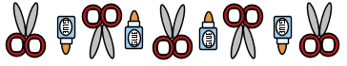

Reminders:

Picture Day is Wednesday!

Dress your best and brush your teeth. 😊

Homework:

Math numbers

Math counting

Name Tracing

All About Me Bag

Return on Friday!!!