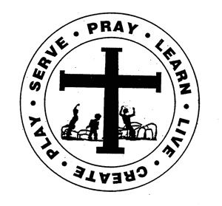
St. Edward Catholic School
Fr. Todd Petersen, Pastor * Jaci Garvey, Principal
210 W. 4th Street * Minneota, Minnesota 56264
Phone:(507) 872-6391 * Fax: (507) 872-5263
Email: jgarvey@stedscatholicschool.com
Website: www.stedscatholicschool.com

February 10, 2022

Thank you to everyone who helped us celebrate Catholic Schools Week last week! So many hands were needed to make things work! Thanks to those who organized and helped with the chili feed on Sunday and to everyone who brought in donations for the various local charities. Thanks to the parents and grandparents who helped pull together outfits for our dress-up days. Thanks to everyone who took time out of their day to come to eat lunch with us, led a mini session, told us about your career, or spent time with us during Mardi Gras! Thanks to Cynthia for making us wonderful meals. Thanks to the 8th graders and many other students who did a tremendous amount of setting up, taking down, and behind the scenes organizing. Thanks to the teachers, for everything. Thanks to the Flurry of Fun Committee and their helpers for putting together the perfect finale to our week! Thanks to everyone who so generously supports our school through their gifts of time, talent, and treasure!
Tuesday will be another turn-in day for the Catholic United Financial Raffle. Each student that turns in a full book will receive a monster cookie.
There will be an Education Committee Meeting on Tuesday, February 15th at 6 pm. All are welcome and encouraged to attend. The Zoom link will be sent out next week.
Our next school Mass is Wednesday, February 16th at 10:30 am. The 5th and 6th grades will be leading us. Come and celebrate the Mass with us.
We will be having “Fake Injury” Day as a dress day on Friday, February 18th.
There will be no school on Monday, February 21st.
We will be having a Round table discussion on Sunday, February 27th at 5 pm. The topic will be “School Choice”.
St. Edward School will again be offering Summer Care from 7:15 am – 6 pm weekdays to students between the ages of 5-12. This program was a great success last year and we are looking forward to even more fun! We are currently looking for staff for this wonderful program. We will need one person to act as director/lead teacher and several assistant teachers and aides. Please reach out if you are interested in helping with the program or if you would like to register your children.
May God Bless,

Mrs. Garvey

