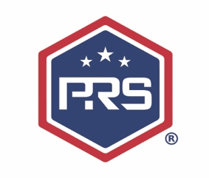
2020-2021
PIKE ROAD HIGH SCHOOL

Course: Intervention
Instructors: Mrs. Parks (1st- 4th)
Mrs. Hudson (5th-8th)

COURSE DESCRIPTION
Intervention class will serve as support to all classes. This course will serve as a study hall, allowing students an opportunity to work independently on other class assignments as well.

ASSIGNMENTS
Students will be responsible for completing all core and elective assignments on time. Edgenuity will also be used to aid our learners in their academic success. Edgenuity is a leading provider of K-12 online curriculum and blended learning solutions.

GRADING SCALE
100 - 90 A
89 – 80 B
79 – 70 C
69 – Below I

