January 5-7 Student Packet
January 10-14 Student Packet
RL 5.1- Objective-Quote accurately from a text when explaining what the text says explicitly and when drawing inferences from the text
January 5 Lesson
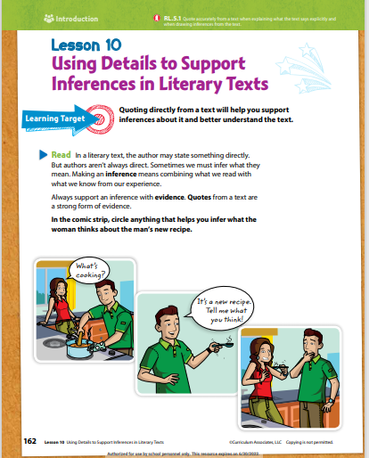
Bellringer
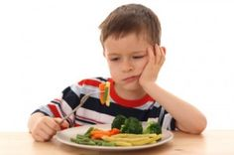
What can you infer from this image?
RL 5.1- Objective-Quote accurately from a text when explaining what the text says explicitly and when drawing inferences from the text
1. SO – Today the student will learn how to quote accurately from a text when explaining what the text says explicitly and when drawing inferences from the text.
2. SP/RW – The students need to know how to use evidence from the text to support the inference (thinking)-Mrs. Crittle
3. PK – Example of inference- If your class schedule starts at 7 o’clock and ends at 3 o’clock you can infer you will be in class for 8 hours. -Mrs. Crittle
4. CV – Details, quotes, infer, accurately-Mrs. Crittle
Vocabulary
Details: the fine points of a subject
Quotes: Something written or said by another person
Infer: guess correctly; solve by guessing
Inference: a conclusion reached on the basis of evidence and reasoning.
accurately: with few mistakes; strictly correctly
5. DI- [Monday]- Short passage
- Teach (I Do): Utilize Word Document for short passage and student package. I DO: Model Sample Test Items #7. We DO: Practice using (Student Package)
- YOU DO: Exit Ticket.
Closing- Select students to orally state what was learned from the lesson.
Inferences | Making Inferences | Award Winning Inferences Teaching Video | What is an inference? - YouTube
Inferring | Reading Strategies | EasyTeaching - YouTube
Making Inferences - YouTube
Making inferences in literary texts | Reading | Khan Academy - YouTube

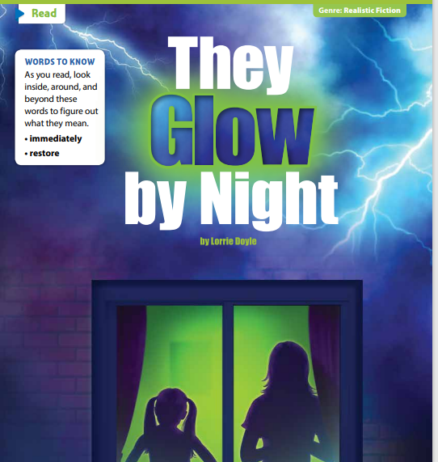
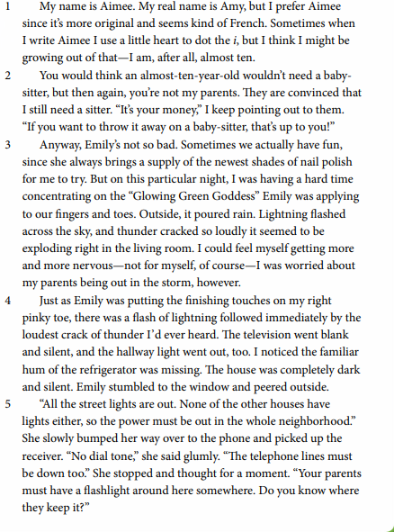
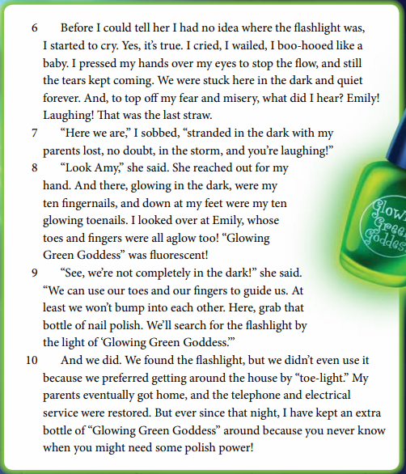
Story Time Break Down
Character/Role_________________________________________________________________
Character/Role_________________________________________________________________
Character/Role_________________________________________________________________
Character/Role_________________________________________________________________
Setting________________________________________________________________________
Problem_______________________________________________________________________Solution_______________________________________________________________________
Compare______________________________________________________________________Contrast_______________________________________________________________________
Inference______________________________________________________________________Theme________________________________________________________________________
New Word/Definition____________________________________________________________
Point of View__________________________________________________________________

I Do We Do You Do Activity
RL 5.1 #7
I Do
- What can the reader infer about Amy? (RL5.1 #7)
A. She is in elementary school.
B. She is in high school.
C. She is in middle school.
D. She is in daycare.
We Do
- What can the reader infer about Emily? RL 5.1 #7
- She is afraid of the storm.
- She is not afraid of the storm.
- She cried during the storm.
- She hid under the bed during the storm.

- What can the reader infer about Amy’s Parents? RL 5.1 #7
- Amy’s parents think she doesn’t need a babysitter.
- Amy’s parents think she needs a babysitter.
- Amy’s parents think she is not old enough to stay at home by herself.
- Amy’s parents think she is old enough to stay at home by herself.
You Do
- What can the reader infer about Amy? RL 5.1 #7
- She is worried about her cat in the storm.
- She is worried about her dog being in the storm.
- She is worried about her parents being out in the storm.
- She is worried about Emily going outside during the storm.

- What can the reader infer about Amy crying? RL 5.1 #7
- She feared the storm.
- She was scared bout her parents being in the storm.
- She feared the storm and was worried about her parents being out in the storm.
- She feared the television wouldn’t come back on after the storm.

- What can the reader infer about Emily? RL 5.1 #7
- Emily is bossy and loud.
- Emily is clumsy and stubborn.
- Emily is clever and creative.
- Emily is kind and caring.

Homework from December 3 Bi-Weekly Test RL 5.2
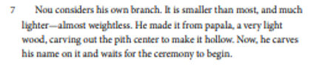
8. Which two actions show how Nou made his firebrand? RL 5.2#4 2 ANSWERS
A. Nou’s firebrand was big.
B. Nou’s firebrand was small with a hollow pitch center.
C. Nou’s firebrand was light and weightless.
D. Nou carved his name on is firebrand.

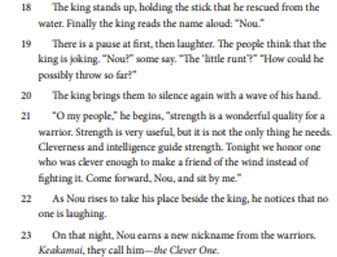
10. Which two actions show that the people in his Village acknowledge him in a positive way? RL 5.2#4 2 ANSWERS
A. The king honors him for his win in the firebrand ceremony.
B. The people in his village gives him a new nickname called Keakamai which is the Clever One.
C. The people in his village think the king is joking about him winning the firebrand throwing ceremony.
D. The people in his village laugh when the king calls out Nou’s name for the winner of the firebrand throwing ceremony.
January 6 Lesson
Bell Ringer
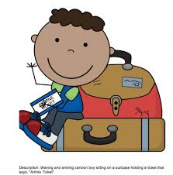
What can you infer from this image?
RL 5.1- Objective-Quote accurately from a text when explaining what the text says explicitly and when drawing inferences from the text
1. SO – Today the student will learn how to quote accurately from a text when explaining what the text says explicitly and when drawing inferences from the text.
SP/RW –– In the real-world students need to find clues to get answers. (Mrs. Crittle)
PK –Example of inference- If I put a picture on the screen of rain drops and an umbrella what can you conclude about the image? (Mrs. Crittle)
4. CV- Details, quotes, infer, accurately-Mrs. Crittle
Vocabulary
Details: the fine points of a subject
Quotes: Something written or said by another person
Infer: guess correctly; solve by guessing
Inference: a conclusion reached on the basis of evidence and reasoning.
accurately: with few mistakes; strictly correctly
5. DI- [Tuesday]-Short Passage
- Teach (I Do): Utilize Word Document for short passage and student package. I DO: Model Sample Test Items #35 We DO: Practice using (Student Package)
- YOU DO: Exit Ticket.
Closing- Select students to orally state what was learned from the lesson
Inferences | Making Inferences | Award Winning Inferences Teaching Video | What is an inference? - YouTube
Inferring | Reading Strategies | EasyTeaching - YouTube
Making Inferences - YouTube
Making inferences in literary texts | Reading | Khan Academy - YouTube

Story Time Break Down
Character/Role_________________________________________________________________
Character/Role_________________________________________________________________
Character/Role_________________________________________________________________
Character/Role_________________________________________________________________
Setting________________________________________________________________________
Problem_______________________________________________________________________Solution_______________________________________________________________________
Compare______________________________________________________________________Contrast_______________________________________________________________________
Inference______________________________________________________________________Theme________________________________________________________________________
New Word/Definition____________________________________________________________
Point of View__________________________________________________________________

I Do We Do You Do Activity
RL 5.1 #35
I Do
Read paragraph 2.
They are convinced that I still need a sitter.
1.Which line from the story explains why Amy needs a sitter? (RL 5.1 #35)
- “If you want to throw it away on a babysitter, that’s up to you” (paragraph 2)
- “Anyway, Emily’s not so bad” (paragraph 3)
- “I am after all almost ten” (paragraph 1)
- “You would think an almost ten-year-old wouldn’t need a babysitter”
(Paragraph 1)

We Do

Read paragraph 3.
I could feel myself getting more and more nervous.
2.Which line from the story explains why Amy was nervous? (RL 5.1 #35)
- “I was worried about my parents being out in the storm” (paragraph 3)
- “The television went blank and silent” (paragraph 4)
- “There was a flash of lightning followed immediately by the loudest crack of thunder I’d ever heard” (paragraph 4)
- “Stranded in the dark with my parents lost, no doubt, in the storm”
- (Paragraph 7)

Read paragraph 8.
And there, glowing in the dark, were my ten fingernails, and down at my feet were my ten glowing toenails.
3.Which line from the story explains how the Glowing Green Goddess nail polish helps Amy and Emily? (RL 5.1 #35)
- “We can use our toes and fingers to guide us” (paragraph 9)
- “We found the flashlight” (paragraph 10)
- “And the telephone and electrical service were restored” (paragraph 10)
- “Grab that bottle of nail polish” (paragraph 9)

You Do
Read paragraph 4.
There was a flash of lightning followed immediately by the loudest crack of thunder I’d ever heard.
4.Which line from the story explains how the storm affected the appliances in the house? (RL 5.1 #35)
- “Outside it poured rain” (paragraph 3)
- “The television went blank and silent” (paragraph 4)
- “There was a flash of lightning followed immediately by the loudest crack of thunder” (paragraph 4)
- “I noticed the familiar hum of the refrigerator was missing” (paragraph 4)

Homework January 5 Lesson You Do’s RL 5.1
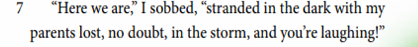
- What can the reader infer about Amy crying? RL 5.1 #7
- She feared the storm.
- She was scared about her parents being in the storm.
- She feared the storm and was worried about her parents being out in the storm.
- She feared the television wouldn’t come back on after the storm.

- What can the reader infer about Amy? RL 5.1 #7
- She is worried about her cat in the storm.
- She is worried about her dog being in the storm.
- She is worried about her parents being out in the storm.
- She is worried about Emily going outside during the storm.

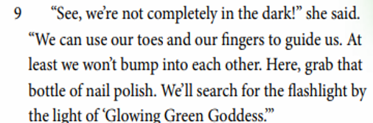
- What can the reader infer about Emily? RL 5.1 #7
- Emily is bossy and loud.
- Emily is clumsy and stubborn.
- Emily is clever and creative.
- Emily is kind and caring.

January 7 Lesson
Bellringer
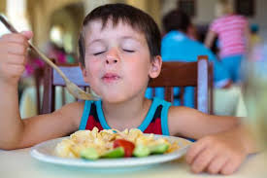
What can you infer from this image?
RL 5.1- Objective-Quote accurately from a text when explaining what the text says explicitly and when drawing inferences from the text
1. SO – Today the student will learn how to quote accurately from a text when explaining what the text says explicitly and when drawing inferences from the text.
2. SP/RW – In the real world if you are reading something and you are familiar with the topic you can apply prior knowledge to what you are reading. (Crittle)
3. PK – Example of inference- If I go to the mall with and come out with a bag you can infer I bought something. (Crittle)

4. CV – Details, quotes, infer, accurately-Mrs. Crittle
Vocabulary
Details: the fine points of a subject
Quotes: Something written or said by another person
Infer: guess correctly; solve by guessing
Inference: a conclusion reached on the basis of evidence and reasoning.
accurately: with few mistakes; strictly correctly
5.DI- [Wednesday]-Short Passage
Quick Quiz
- Teach (I Do): Utilize Word Document for short passage and student package. I DO: Model Sample Test Items #7, 35. We DO: Practice using (Student Package) for inferences.
- YOU DO: Exit Ticket. (Mrs. Floyd will give directions and expectations)
Closing-Select students to describe 2 important things learned from the lesson.
Inferences | Making Inferences | Award Winning Inferences Teaching Video | What is an inference? - YouTube
Inferring | Reading Strategies | EasyTeaching - YouTube
Making Inferences - YouTube
Making inferences in literary texts | Reading | Khan Academy - YouTube

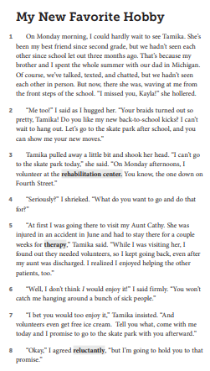

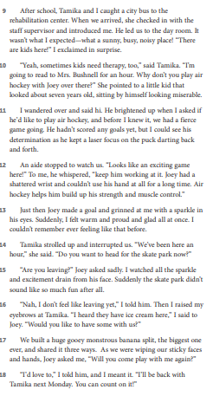

Story Time Break Down
Character/Role_________________________________________________________________
Character/Role_________________________________________________________________
Character/Role_________________________________________________________________
Character/Role_________________________________________________________________
Setting________________________________________________________________________
Problem_______________________________________________________________________Solution_______________________________________________________________________
Compare______________________________________________________________________Contrast_______________________________________________________________________
Inference______________________________________________________________________Theme________________________________________________________________________
New Word/Definition____________________________________________________________
Point of View__________________________________________________________________

I Do We Do You Do Activity
RL 5.1 #7 #7b
I Do
- What can the reader infer about Kayla and Tamika’s old hobby? RL 5.1 #7
- They used to play basketball after school.
- They used to go to skate park after school.
- They used to go to the rehabilitation center to volunteer after school.
- They used to go to the park after school.

- Which detail from the passage best supports the answer to Part A (Number 1)? RL 5.1 #7B
- “I cant go to the skate park today” (paragraph 3)
- On Monday afternoons, I volunteer at the rehabilitation center” (paragraph 3)
- “Let’s go to the skate park after school and you can show me your new moves” (paragraph 2)
- “Tell you what, come with me today and I promise to go to the skate park with you afterward” (paragraph 7)
We Do
- What can the reader infer about Kayla? RL 5.1 #7
- She is happy to volunteer at the rehabilitation center.
- She doesn’t want to volunteer at the rehabilitation center.
- She is mad about having to volunteer at the rehabilitation center.
- She is upset with Tamika for signing her up to volunteer at the rehabilitation center.
- Which detail from the passage best supports the answer to Part A (Number 3)? RL 5.1 #7B
- “ Well, I don’t think I would enjoy it” (paragraph 6)
- “You won’t catch me hanging around a bunch of sick people” (paragraph 6)
- “I bet you would to enjoy it” (paragraph 7)
- “And volunteers even get free ice cream” (paragraph 7)
You Do
- What can the reader infer about Tamika? RL 5.1 #7
- She doesn’t like skating anymore.
- She is trying to persuade or convince Kayla to volunteer at the rehabilitation center.
- She doesn’t want to be friends with Kayla anymore.
- She has found a new friend over the summer break.

- Which detail from the passage best supports the answer to Part A (Number 5)? RL 5.1 #7B
- “I can’t go to the skate park today” (paragraph 3)
- “What do you want to go and do that for” (paragraph 4)
- “At first I was going there to visit my Aunt Cathy” (paragraph 5)
- “I bet you would enjoy it, and volunteers even get free ice cream” (paragraph 7)
Homework You Do Activity from January 6 Lesson RL 5.1
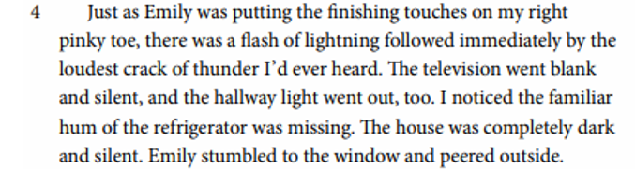
You Do
Read paragraph 4.
There was a flash of lightning followed immediately by the loudest crack of thunder I’d ever heard.
Which line from the story explains how the storm affected the appliances in the house? (RL 5.1 #35)
- “Outside it poured rain” (paragraph 3)
- “The television went blank and silent” (paragraph 4)
- “There was a flash of lightning followed immediately by the loudest crack of thunder” (paragraph 4)
- “I noticed the familiar hum of the refrigerator was missing” (paragraph 4)

January 10 Lesson
Bellringer
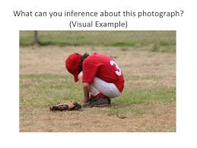
What can you infer from this image?
RL 5.1- Objective-Quote accurately from a text when explaining what the text says explicitly and when drawing inferences from the text
SO – Today the student will learn how to quote accurately from a text when explaining what the text says explicitly and when drawing inferences from the text.
2. SP/RW – In the real world you may have to problem solving skills to understand a text.-Crittle
3. PK –Example of inference- For the last 2 Wednesday’s you have submitted and completed a quick quiz, you can infer you will have a quick quiz every Wednesday.-Crittle
4. CV – Details, quotes, infer, accurately-Mrs. Crittle
Vocabulary
Details: the fine points of a subject
Quotes: Something written or said by another person
Infer: guess correctly; solve by guessing
Inference: a conclusion reached on the basis of evidence and reasoning.
accurately: with few mistakes; strictly correctly
5..DI- [Thursday]-Short Story
- Teach (I Do): Utilize Word Document for short passage and student package. I DO: Model Sample Test Items #7, 35. We DO: Practice using (Student Package) for inferences.
- YOU DO: Exit Ticket.
Closing-Select students to describe 2 important things learned from the lesson.
Inferences | Making Inferences | Award Winning Inferences Teaching Video | What is an inference? - YouTube
Inferring | Reading Strategies | EasyTeaching - YouTube
Making Inferences - YouTube
Making inferences in literary texts | Reading | Khan Academy - YouTube

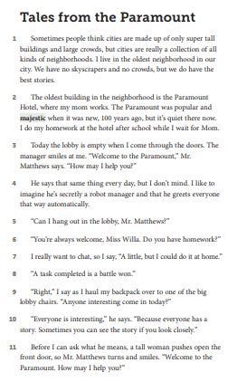
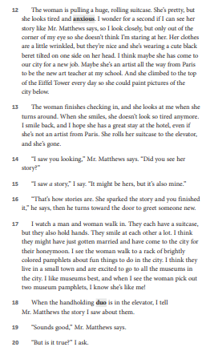
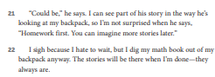

I Do We Do You Do Activity
RL 5.1 #7
I Do
- What can the reader infer about Miss Willa? (RL5.1 #7)
- She is old enough to stay at home by herself.
- She isn’t old enough to stay at home by herself.
- She needs a babysitter.
- Mr. Matthew is her babysitter.
We Do
- What can the reader infer about Miss Willa’s Mom? (RL5.1 #7)
- She trusts Willa to stay at home by herself after school.
- She doesn’t trust Willa to stay at home by herself after school.
- She pays Mr. Matthews to babysit Willa after school.
- She makes Willa work at the hotel after school.

- What can the reader infer about Paramount Hotel? (RL5.1 #7)
- The hotel gets a lot of guest.
- The hotel doesn’t get a lot of guests.
- The hotel is closed.
- The hotel needs repairs.
You Do
- What can the reader infer about Mr. Matthews? (RL5.1 #7)
- He tries to convince or persuade Willa to do her homework.
- He wants Willa to work the front door at the hotel.
- He wants Willa to work the front desk at the hotel.
- He wants Willa to help her mom work at the hotel.

- What can the reader infer about the man and the woman? (RL5.1 #7)
- They have lived in this neighborhood a long time.
- They are new to the neighborhood and area.
- They live in the hotel.
- They know Mr. Matthews.

Homework-January 7 Lesson RL 5.1 You Do Activity
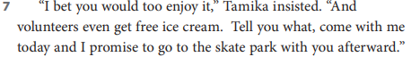
You Do
- What can the reader infer about Tamika? RL 5.1 #7
- She doesn’t like skating anymore.
- She is trying to persuade or convince Kayla to volunteer at the rehabilitation center.
- She doesn’t want to be friends with Kayla anymore.
- She has found a new friend over the summer break.

- Which detail from the passage best supports the answer to Part A (Number 5)? RL 5.1 #7B
- “I can’t go to the skate park today” (paragraph 3)
- “What do you want to go and do that for” (paragraph 4)
- “At first I was going there to visit my Aunt Cathy” (paragraph 5)
- “I bet you would enjoy it, and volunteers even get free ice cream” (paragraph 7)

January 11 Lesson
Bellringer
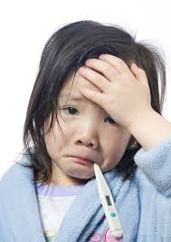
What can you infer from this image?
RL 5.1- Objective-Quote accurately from a text when explaining what the text says explicitly and when drawing inferences from the text
SO – Today the student will learn how to quote accurately from a text when explaining what the text says explicitly and when drawing inferences from the text.
2. SP/RW – Knowing how to quote directly from the text will help support inferences and better understand the text. -Crittle
3. PK –Ask students if they know how to use prior knowledge after reading an article to settle an inference-Crittle
4. CV – Details, quotes, infer, accurately-Mrs. Crittle
Vocabulary
Details: the fine points of a subject
Quotes: Something written or said by another person
Infer: guess correctly; solve by guessing
Inference: a conclusion reached on the basis of evidence and reasoning.
accurately: with few mistakes; strictly correctly

5.DI- [Monday]-Short Story
- Teach (I Do): Utilize Word Document for short passage and student package. I DO: Model Sample Test Items #7. We DO: Practice using (Student Package) for inferences.
- YOU DO: Exit Ticket.
Closing-Select students to describe 2 important things learned from the lesson.
Inferences | Making Inferences | Award Winning Inferences Teaching Video | What is an inference? - YouTube
Inferring | Reading Strategies | EasyTeaching - YouTube
Making Inferences - YouTube
Making inferences in literary texts | Reading | Khan Academy - YouTube

I Do We Do You Do Activity
RL 5.1 #35
I Do
- Read paragraph 2.
The oldest building in the neighborhood is the Paramount Hotel.
Which line from the story explains how old the Paramount Hotel is? (RL 5.1 #35)
- “I live in the oldest neighborhood in our city” (paragraph 1)
- “100 years ago,” (paragraph 2)
- “But it’s quiet there now” (paragraph 2)
- “When it was new” (paragraph 2)
We Do
- Read paragraph3.
Welcome to the Paramount, Mr. Matthews says. “How may I help you?”.
Which line from the story explains what Mr. Matthews’s job is at the hotel? (RL 5.1 #35)
- “He says that same thing every day” (Paragraph 4)
- “Can I hang out in the lobby” (Paragraph 5)
- “I like to imagine he’s secretly a robot manger and that he greets everyone that way automatically” (Paragraph 4)
- “The manager smiles at me” (Paragraph 3)

- Read paragraph 17.
I watch a man and woman walk in.
Which line from the story explains that the man and the woman is not from the area? (RL 5.1 #35)
- “I see the woman walk to a rack of brightly colored pamphlets about fun things to do in the city” (Paragraph 17)
- “I think they live in a small town and are excited to go to all the museums in the city” (Paragraph 17)
- “I like museums best” (Paragraph 17)
- “I think they might have just gotten married and have come to the city for their honeymoon” (Paragraph 17)

You Do
- Read paragraph 2.
Your always welcome, Miss Willa do you have homework.
Which line from the story explains what Miss Willa is doing at the Paramount Hotel? (RL 5.1 #35)
- “I really want to chat” (Paragraph 7)
- “Can I hang out in the lobby” (Paragraph 5)
- “I say as I haul my backpack over to the one of the big lobby chairs” (Paragraph 9)
- “I do my homework at the hotel after school while I wait for Mom” (Paragraph 2)

Homework from January 10 I Do Activity RL 5.1
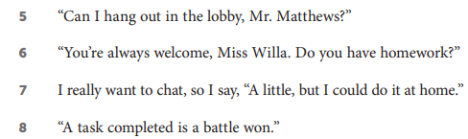

You Do
- What can the reader infer about Mr. Matthews? (RL5.1 #7)
- He tries to convince or persuade Willa to do her homework.
- He wants Willa to work the front door at the hotel.
- He wants Willa to work the front desk at the hotel.
- He wants Willa to help her mom work at the hotel.

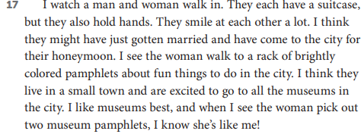
- What can the reader infer about the man and the woman? (RL5.1 #7)
- They have lived in this neighborhood a long time.
- They are new to the neighborhood and area.
- They live in the hotel.
- They know Mr. Matthews.

January 12 Lesson
Bellringer
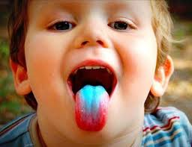
What can you infer from this image?
RL 5.1- Objective-Quote accurately from a text when explaining what the text says explicitly and when drawing inferences from the text
SO – Today the student will learn how to quote accurately from a text when explaining what the text says explicitly and when drawing inferences from the text.
2. SP/RW – The students need to know how to state the claim in the text. Prove to themselves they know what they know-Crittle
3. PK – Ask students if they understand how to look for context clues to assist them in explaining/ and/or paraphrasing the text to answer a question (s)-Crittle
4. CV – Details, quotes, infer, accurately-Mrs. Crittle
Vocabulary
Details: the fine points of a subject
Quotes: Something written or said by another person
Infer: guess correctly; solve by guessing
Inference: a conclusion reached on the basis of evidence and reasoning.
accurately: with few mistakes; strictly correctly

5.DI- [Tuesday]-Short Story
- Teach (I Do): Utilize Word Document for short passage and student package. I DO: Model Sample Test Items #35. We DO: Practice using (Student Package) for inferences.
- YOU DO: Exit Ticket.
Closing-Select students to describe 2 important things learned from the lesson.
Inferences | Making Inferences | Award Winning Inferences Teaching Video | What is an inference? – YouTube
Inferring | Reading Strategies | EasyTeaching – YouTube
Making Inferences – YouTube
Making inferences in literary texts | Reading | Khan Academy – YouTube

Sir Gawain and the Green Knight by Chris Bartlett
1 On New Year’s Day, the mysterious Green Knight rode into the heart of King Arthur’s castle and issued a challenge to the Knights of the Round Table. He would grant any knight a single stroke with his green axe against his neck—but only if that knight would return the favor, one year and one day later.
2 King Arthur began to accept the challenge, but Sir Gawain offered to take his king’s place. Gawain then took up the enormous green axe and, with a mighty swing, sliced off the Green Knight’s head. Surely that will be the end of it, Gawain thought. Surely my king is now safe.
3 But the Green Knight, still very much alive, stood and picked up his own head. He reminded Gawain that they had an appointment in one year and a day, and he rode quickly away on his horse
4 Gawain’s fellow knights gathered around him. “We are sorry we let you take on this burden:’ they said. “We will not let you face the Green Knight alone”
5 But Gawain replied, “This is no burden, and I am not sorry. I do what I do for my king and for my honor. I will face the Green Knight alone, and I will do so with all good cheer.”
6 One year and one day later, Gawain met the Green Knight as he had promised. He lay aside his sword, shield, and helmet, and then strode toward the Green Knight. Gawain bent low to receive the blow from the axe. At the stroke of the axe, Gawain flinched. ____
7 “Are you afraid?” asked the Green Knight.
8 “Get on with the business:’ Gawain snapped. Again, the Green Knight raised his axe. He took aim and swung, but Gawain was unharmed.
9 Surely that will not be the end of it, Gawain thought, as he readied himself again. But the Green Knight presented Gawain with his great axe, bowed low to the ground, and rode away.

Independent Activity/Pulling
RL 5.1 #35
- Read Paragraph 2.
King Arthur began to accept the challenge, but Sir Gawain offered to take his place. Which line from the story explains the first challenge between Sir Gawain and The Green Knight? (RL 5.1#35)
- “Gawain then took up the enormous”
- “But the Green Knight, still very much alive”
- “He reminded Gawain that they had an appointment”
- “He took aim and swung”
2.Read Paragraph 3.
He reminded Gawain that they had an appointment in one year and a day. Which line from the story explains the second challenge between Sir Gawain and The Green Knight? (RL 5.1#35)
- “One year and one day later”
- “Gawain then took up the enormous”
- “Gawain bent low to receive the blow”
- “He lay aside his sword”

- Read Paragraph 1.
The mysterious Green Knight rode into the heart of King Arthur’s castle and issued a challenge. Which line from the story explains the length of the challenged issued by the Green Knight? (RL 5.1#35)
- “He would grant”
- “But only if that knight”
- “King Arthur began to accept the challenge”
- “Gawain then took up the enormous green”2

- Read paragraph 4.
Gawain’s fellow knights gathered around him. Which line from the story explains how Gawain’s fellow knights felt about the challenge? (RL 5.1#35)
A “But Gawain replied”
B “I do what I do”
C “Are you afraid”
D “We are sorry we let you take on this burden”
January 13 Lesson
Bellringer
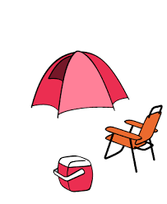
What can you infer from this image?
RL 5.1- Objective-Quote accurately from a text when explaining what the text says explicitly and when drawing inferences from the text
SO – Today the student will learn how to quote accurately from a text when explaining what the text says explicitly and when drawing inferences from the text.
2. SP/RW – The students need to know how to use evidence from the text to support the inference (thinking)-Crittle
3. How do you use clues stated in the text to support your inference?-Crittle
4. CV – Details, quotes, infer, accurately-Mrs. Crittle
Vocabulary
Details: the fine points of a subject
Quotes: Something written or said by another person
Infer: guess correctly; solve by guessing
Inference: a conclusion reached on the basis of evidence and reasoning.
accurately: with few mistakes; strictly correctly

5.DI- [Wednesday]-Short Story-Group Work-Quick Quiz
- Teach (I Do): Utilize Word Document for short passage and student package. I DO: Model Sample Test Items #7 #35. We DO: Practice using (Student Package) for inferences.
- YOU DO: Exit Ticket.
Closing-Select students to describe 2 important things learned from the lesson.
Inferences | Making Inferences | Award Winning Inferences Teaching Video | What is an inference? – YouTube
Inferring | Reading Strategies | EasyTeaching – YouTube
Making Inferences – YouTube
Making inferences in literary texts | Reading | Khan Academy – YouTube

