**Meningococcal Information**

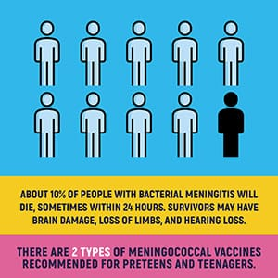

**What is meningococcal disease?**

* Meningococcal disease is any illness caused by the bacteria Neisseria meningitidis.
* It is the leading cause of bacterial meningitis in children 2-18 years of age in the U.S.
* Meningococcal disease can be very serious, even life-threatening in 48 hours or less.
* The two most severe and common illnesses caused by meningococcal bacteria include:  
  - Meningitis - an infection of the fluid and lining around the brain and spinal cord  
  - Septicemia - a bloodstream infection.

**Symptoms**

* Sudden onset of a high fever
* Headache
* Stiff neck
* Nausea
* Vomiting
* Increased sensitivity to light
* Rash
* Confusion
* Severe aches and pain in the muscles, joints, chest or belly

**How does meningococcal disease spread?**

* Meningococcal disease is spread person-to-person by sharing respiratory secretions, through kissing or coughing, close or lengthy contact, and among people who share a room or live in the same household.
* Anyone can get meningococcal disease, but teens and college freshmen who live in residence halls are at increased risk.
* Some people can "carry" meningococcal bacteria in their nose and throat without getting meningococcal disease, but can still infect other people.
* Most cases of meningococcal disease are spread by people who "carry" the bacteria with no symptoms, appear to be random, and not linked to other cases.
* Meningococcal outbreaks can occur in communities, schools, colleges, prisons, and in other high-risk populations.

**Meningococcal Vaccine Information**

* Meningococcal vaccine(s) is recommended for all preteens and teens.
* All 11 and 12 year olds should be vaccinated with serogroups A, C, W, and Y meningococcal conjugate vaccine (MCV4). A booster dose is recommended at age 16.
* Teens and young adults, 16 through 23 year olds, may also be vac  
  cinated with a serogroup B meningococcal vaccine (SBMV), preferably at 16 through 18 years old.
* Both MCV4 and SBMV can be given at the same time, talk to your provider.
* Teens with HIV should get three doses of MCV4.
* People 55 years of age and older should get Meningococcal polysaccharide vaccine (MPSV4).
* People at increased risk (ex: no spleen or poor spleen, autoimmune disease) during an outbreak, should be vaccinated.

**For more information, visit** <https://www.alabamapublichealth.gov/immunization/meningococcal.html>