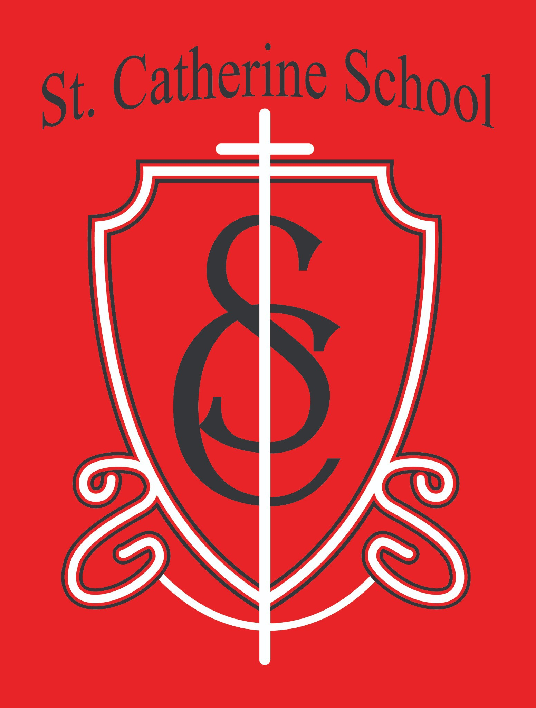

St. Catherine School Weekly Newsletter (Week of 12/1- 12/5)

Principal's Message
One of the true joys of this season is the beauty of gathering as a school community, and last night’s annual St. Catherine School Christmas Program was no exception. It is always a privilege to see our students shine, to watch their personalities come alive on stage, and to feel the joy that radiates from them as they share the message of Christmas.
A heartfelt bravo to Ms. Busch and Mr. Kjelland for their tremendous work in preparing our students. The amount of behind-the-scenes time, practice, and patience it takes to pull off a program like this is remarkable, and they did it with such grace and enthusiasm. My goodness—I laughed out loud several times, and the students sounded so good! What a wonderful evening for our school family.

Reminders
End of Quarter: The last day of the quarter is Thursday, December 19th. Report cards will be mailed out the following week.
A Message from Ms. Busch: Ms. Busch would like to extend a big thank you to all parents for your support of the Christmas Program. She is very proud of every student for their hard work and joyful participation.
Parking Lot Safety: Please use caution in the parking lot, especially after fresh snowfall. Even with our snow removal service doing a great job, conditions can become slippery between

visits. Thank you for keeping our students safe during drop-off and pickup.

Little Saints Childcare – We’re Hiring!
We are seeking caring and dependable team members to join Little Saints Childcare. Current openings include:

Lead Toddler Teacher
- Assistant Teachers (part-time, flexible hours)

Food Service Assistant
If you or someone you know may be an excellent fit for a joyful, faith-filled environment, please encourage them to apply.

Application Link:
https://bit.ly/461DRdc

St. Catherine Spotlight

Helping in Our Infant Room
One of the unexpected blessings of having Little Saints Childcare as part of our ministry is the joy that fills the building—even on the busiest days. I had the chance to help in our infant room this week, and let me tell you: it is nearly impossible to have a bad day when you are holding an infant. Their calm presence, little smiles, and total trust are a reminder of the beauty of life at every stage. What a gift to have this growing ministry in our school.

The Christmas Program
What a night! Our annual Christmas Program was a wonderful celebration of music, joy, and the true meaning of Christmas. I especially enjoyed seeing my own children mostly do the job they were assigned—along with a little healthy goofing off that made me laugh. Moments like these remind me of how blessed we are to gather as a school family and share the talents God has given our students.

The Jesse Tree Tradition in Chapel
If you’re not familiar with our Jesse Tree tradition, it is a beautiful part of our Advent preparation. Each day, students hear a Scripture story from the Old Testament that points toward the coming of Christ. After the reading, an ornament representing that story is added to our Jesse Tree in the chapel.
The symbols—such as Noah’s ark, Jacob’s ladder, or the burning bush—help our students see how God prepared His people for the Savior across generations. It’s a meaningful way for our school community to journey together toward Christmas.

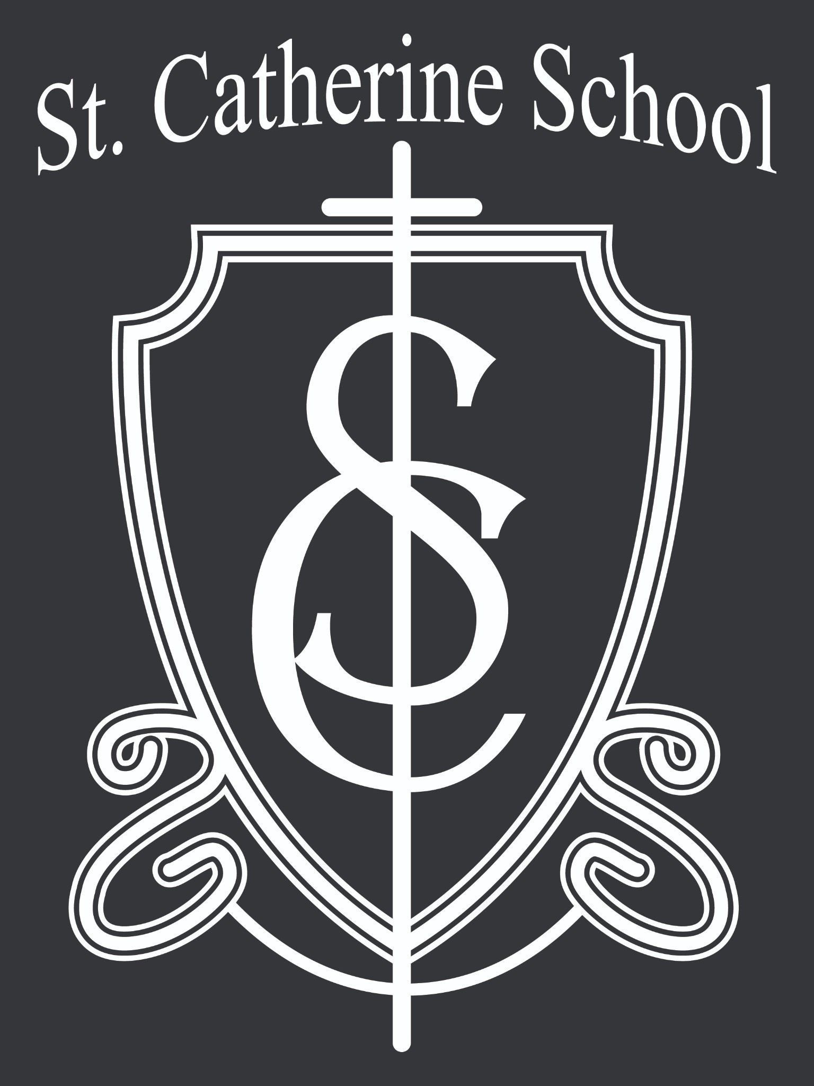

Stay Connected with St. Catherine School
📍 Address: 540 3rd Ave. NE, Valley City, ND 58072
Email: nicholas.lee1@k12.nd.us
📧
Phone: 1-701-845-1453
📞
Website: www.stcatherine.k12.nd.us
🌐
📘 Follow Us on Facebook: St. Catherine School on Facebook

“Inspiring excellence through faith, learning, and service.”

