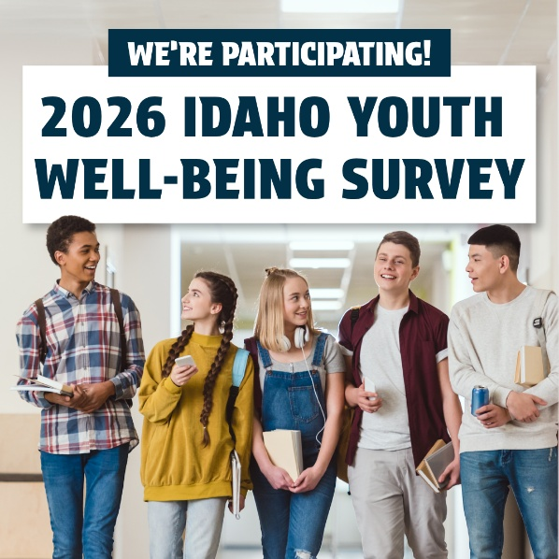

Youth Well-being Survey Information

This school year, Deary Middle School and High School will be participating in the Idaho Youth Well-being Survey (IYWS). The IYWS is a survey for students in grades 6-12 that helps schools and communities improve youth well-being. Schools/districts that participate in the IYWS gain highly useful insights into their student populations and what they need to succeed. That information can then be utilized to help create healthy, safe, and supportive environments for young people in our community.

The IYWS was created by Idaho education experts, parents, and youth well-being stakeholders. It is offered to any school serving middle/junior high and or high school students free-of-charge through a partnership between Communities for Youth and the Idaho Department of Education.

In accordance with Idaho state law, all students that would like to participate in the Idaho Youth Well-being Survey must first obtain parent permission (this is sometimes referred to as parent consent). Provide consent for your child here.

If you would like additional information about the Idaho Youth Well-being Survey please explore the below resources:

IYWS PARENT INFO SHEET

IYWS STUDENT INFO SHEET

COMMUNITIES FOR YOUTH IDAHO YOUTH WELL-BEING SURVEY INFO PAGE

IDAHO DEPARTMENT OF EDUCATION YOUTH WELL-BEING SURVEY INFO PAGE

