Communication About Student Learning

Report Cards

October 6
(progress reports due after Aug 31)

January 12
(progress reports due after Nov. 14)

March 16
(progress reports due after Feb. 3)

May 25
(progress reports due after Apr. 19)

Virtual Family Night

October 23,2020

March 11, 2021

Parent Teacher Conference

October 25, 2022 5-8 pm

February 28, 2023 5-8 pm

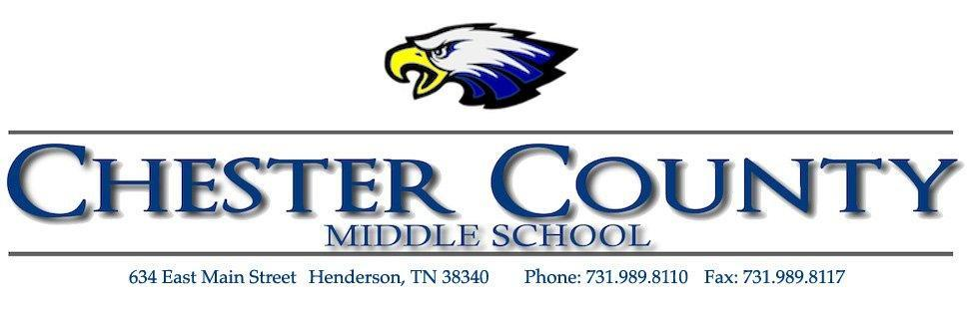

2022-23 School-Parent Compact

What is a School-Parent Compact?

A School-Parent Compact is an agreement that families, students, and teachers develop together. It explains how families and teachers will work together to make sure all students reach grade level standards.

Effective Compacts:

-link goals to the School Improvement Plan;
-focus on student learning skills;
-describe how teachers will help students develop skills using high-quality instruction;
-share strategies families can use at home;
-and explain how teachers and families will communicate about student progress

Jointly Developed

The families, students, and staff of Chester County Middle School developed this School-Parent Compact. Teachers suggested home learning strategies, families added ideas to make them more specific, and students told us what would help them learn. Meetings and events are held each year to review the compact and make changes based on student and family needs.
Renee Thomas
731-989-8110
www.ChesterCountySchools.org

Our Goals for Student Achievement

District Goals
Chester County Schools, on the 2023 state tests for Language Arts, will raise the district-wide percentage of All Students scoring On Track/Mastered from 36.6% (Fall 2021) to 44.5% (Fall 2023) and increase the district-wide percentage of key subgroups scoring On Track/Master.

Chester County Schools, on the 2023 state tests for Math, will raise the district-wide percentage of All Students scoring On Track/Mastered from 38% (Fall 2021) to 45.8% (Fall 2023) and the district-wide percentage of key subgroups scoring On Track/Master.

Chester County Schools, during the 2020/2021 school year, will lower the district-wide percentage of students district-wide who are absent from school for 14.7% (Fall 2021) or more of days registered (chronically absent) to 12.7% or less.

School Goals
Increase the percentage of students who are on track or mastered from 36.6% (Fall 20210 to 44.5% (Fall 2023) on TCAP ELA in 2023.

Increase the percentage of students who are on track or mastered from 38% (Fall 2021) to 45.8% (Fall 2023) on TCAP Math in 2023.

During the 2022/2023 school year CCMS will reduce the chronically absent rate from 23.7% to 20.7%.

Teachers, families, students – Together for Success
In the Classroom  We will work with students and families to support students’ success in reading and Math. Some of our key connections with families will be:  -Family Fun Nights that will focus on ELA, Math and Science  -Our monthly newsletter will feature games that families can play to review vocabulary words that have been introduced in class.  Our school web page will have links to family friendly websites for building vocabulary and math skills. |  | At Home  CCMS families joined staff to develop ideas about how families can support students’ success in reading and math. Families may have other ideas to add to this list.  -Try to attend our virtual Family Fun Nights or get information from my child’s teachers if we can’t attend.  -Play word games with the new vocabulary words and find ways to use these words in family conversations.  -Look at the class newsletter each month and check out the school’s website:  www.chestercountyschools.com
Students

CCMS students joined staff and families to develop ideas about how they can succeed in school and reach for the stars in math and reading. Students thought of the following ideas to make connections between learning at home and school:

-Talk with my family about new vocabulary words and what I am learning in math.
-Bring home our class newsletter and invitations for Family Fun Nights.
-Keep a log of games I play at home to practice new vocabulary words and math.

