

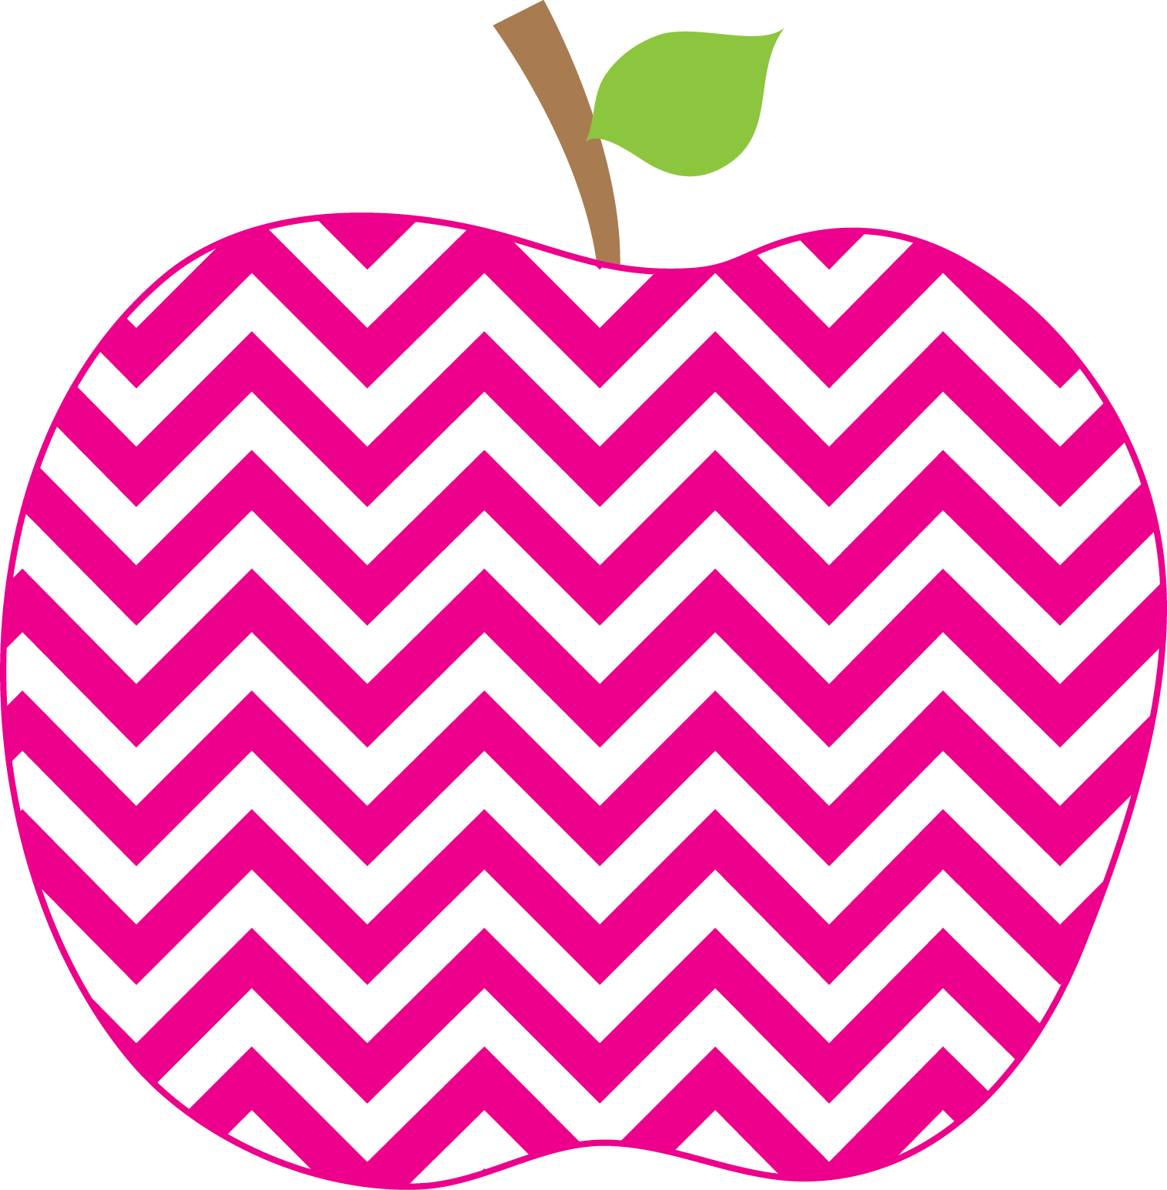



E. Robinson Weekly
Ms. E

October 28, 2024

Reading:
Phonics Skills:
*Final Blend -ng spelled ng
(-ang, -ing, -ong, -ung)

High-Frequency Words: (Review)
girl, her, with, any, from, where
like, water, but, do, long, my, no

RED Words:
from like

Grammar Skill: Exclamatory Sentences

Math:
*Making 10 to Add

Social Studies/Science- Past, Present, Future

**Please remember to send your child’s library book and binder to school each day.

This Week’s Focus:

Star Apple of the Week:
Hailey Holcomb
* * Please make sure to check the APPLE Binder each day for homework and sign the daily behavior sheet located in the back.

October 28th-Nov. 1st Red Ribbon Week

Tuesday, October 29th Field Trip to
Penton Farms

Friday, November 1st Fall Fun Day

Reminders:
Important Dates:

