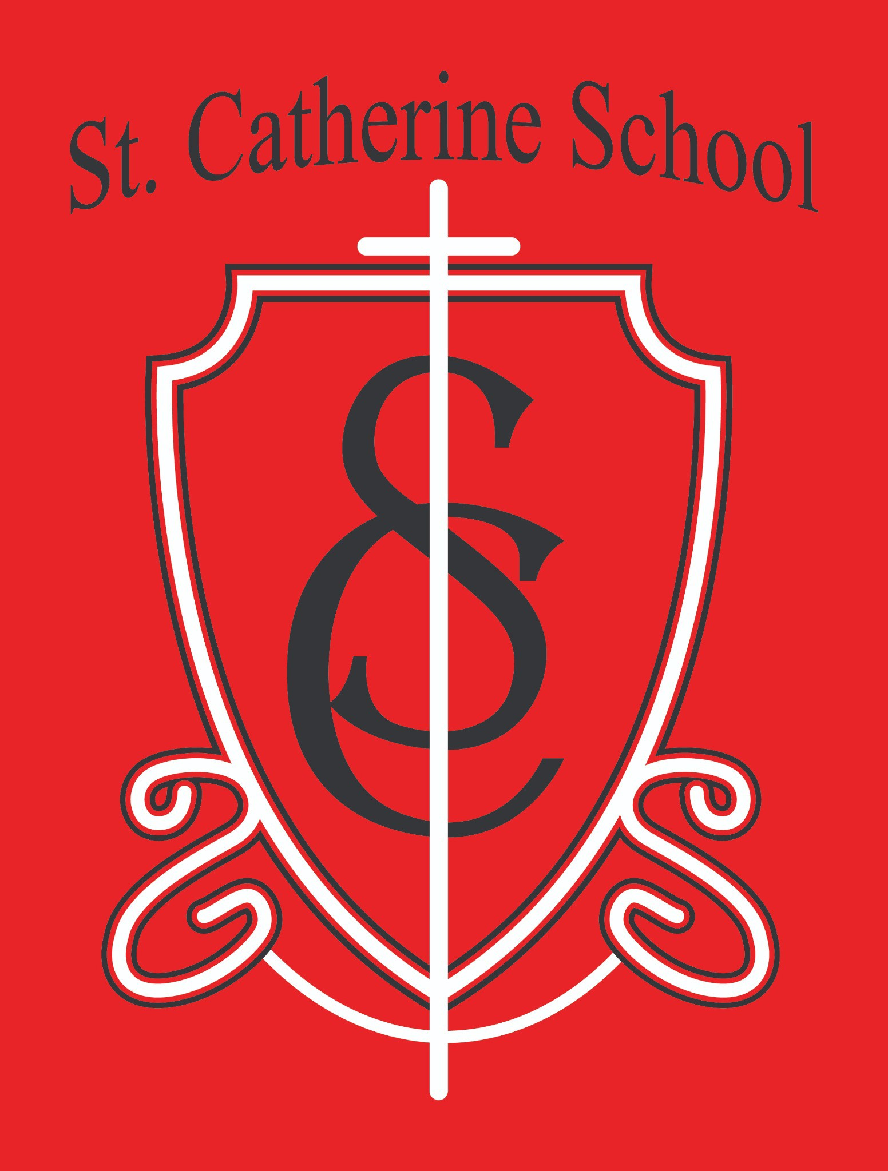

**St. Catherine School Weekly Newsletter (Week of March 31st-April 5th)**

[**https://www.stcatherine.k12.nd.us/parents**](https://nam02.safelinks.protection.outlook.com/?url=https%3A%2F%2Fwww.stcatherine.k12.nd.us%2Fparents&amp;data=05%7C02%7CTerra.Giesen%40k12.nd.us%7C1205b02b3cfb4a382e7b08dd74493e3a%7Cdbbf782acef14af186c81f9201061db6%7C0%7C0%7C638794580163578682%7CUnknown%7CTWFpbGZsb3d8eyJFbXB0eU1hcGkiOnRydWUsIlYiOiIwLjAuMDAwMCIsIlAiOiJXaW4zMiIsIkFOIjoiTWFpbCIsIldUIjoyfQ%3D%3D%7C0%7C%7C%7C&amp;sdata=jUBekUHB7z8SY%2BpnOQ0d4NylgLnlM4vwXDX%2FsHSGVao%3D&amp;reserved=0)

## Principal Reflection: The Strength of Our Community

On Thursday night, we had the joy of attending the annual **REACH Banquet (Religious Educators Advancing Christian Heritage)**—a celebration of faith, education, and the community that sustains both. The evening featured **beautiful artwork from our students**, music from our talented **5th and 6th grade band** and **Ms. Busch**, and a warm presence from many of our school staff. It was a wonderful reminder of how much love and talent fills our school community.

**REACH is a vital organization** that contributes financial support to our school each year, helping sustain our mission. While giving to an endowment may not always feel exciting, it’s one of the most **impactful and lasting ways** to support a school like St. Catherine. An endowment grows over time and continues to give back year after year. I always encourage people to consider the **long-term value of their gift**—because it makes a difference.

We also had the pleasure of hearing from **Mrs. Karissa Flieth**, principal at Trinity Elementary in Fargo. Her keynote focused on the **power of community in Catholic education**—that each student, each family, and each staff member knows the love of Christ and feels that they are an **essential part of the mission** each day.

That message deeply resonates with me. I am **so thankful for our community**, which continues to grow stronger with each new initiative. From those who gave to the **capital campaign**, to those preparing for the opening of **Little Saints Childcare**, our community stands strong—in **faith, in service, and in commitment** to providing an exceptional Catholic education here at **St. Catherine School**.

# Reminders

## No Toys, Trinkets, or Fidget Toys at School

🚫

Please **do not allow students to bring toys, trinkets, or fidget toys** to school unless it is for **Show and Tell** or has been **specifically approved** by a teacher or administration. These items have become a **major distraction in the classroom**, and students are getting in trouble for not following directions to put them away. Thank you for helping us maintain a focused learning environment!

## Holy Week Break – April 17–21

✝

There will be **no school from April 17–21** in observance of **Holy Week and Easter**.

## Save the Date – Spring Music Program

🎼

Join us for our **Spring Music Program** on **Thursday, May 8th at 6:30 PM**. We look forward to celebrating our students’ musical talents with you!

## Tuition Assistance – TAP Application Reminder

💰

Tuition assistance applications for the **2025–2026 school year** are now open.

Applications must be submitted through **FACTS Grant & Aid**. **Deadline: May 15, 2025** (Early applications encouraged).

📅

**Apply here:** [FACTS Sign-In](https://nam02.safelinks.protection.outlook.com/?url=https%3A%2F%2Fonline.factsmgt.com%2Fsignin%2F414FV&amp;data=05%7C02%7CTerra.Giesen%40k12.nd.us%7C1205b02b3cfb4a382e7b08dd74493e3a%7Cdbbf782acef14af186c81f9201061db6%7C0%7C0%7C638794580163597277%7CUnknown%7CTWFpbGZsb3d8eyJFbXB0eU1hcGkiOnRydWUsIlYiOiIwLjAuMDAwMCIsIlAiOiJXaW4zMiIsIkFOIjoiTWFpbCIsIldUIjoyfQ%3D%3D%7C0%7C%7C%7C&amp;sdata=o2CHjWxkEWQBWL4R7%2F%2B1DiTJoLU9zTDS9ebPwAcRuTc%3D&amp;reserved=0)

Questions? Contact the **school office** for assistance.

## Now Hiring: Daycare Lead Teachers (5 Positions Available)

🧸✝

We’re hiring **five Lead Teachers** for our **Little Saints Child Care** program!

📍 **Location:** St. Catherine School, Valley City, ND

📄 Apply by sending a **cover letter, resume, and three references** to:

**Beth Nadelin, Director** | [beth.nadelin@k12.nd.us](mailto:beth.nadelin@k12.nd.us)

📧

🔗 [Job Details & More Info](https://nam02.safelinks.protection.outlook.com/?url=https%3A%2F%2Fwww.stcatherine.k12.nd.us%2Femployment&amp;data=05%7C02%7CTerra.Giesen%40k12.nd.us%7C1205b02b3cfb4a382e7b08dd74493e3a%7Cdbbf782acef14af186c81f9201061db6%7C0%7C0%7C638794580163611912%7CUnknown%7CTWFpbGZsb3d8eyJFbXB0eU1hcGkiOnRydWUsIlYiOiIwLjAuMDAwMCIsIlAiOiJXaW4zMiIsIkFOIjoiTWFpbCIsIldUIjoyfQ%3D%3D%7C0%7C%7C%7C&amp;sdata=gFkmUk3VNMl1TUhnGgQxM%2BW3B4Y2L5OY0RnHUHoTKJw%3D&amp;reserved=0)

# St. Catherine Spotlight

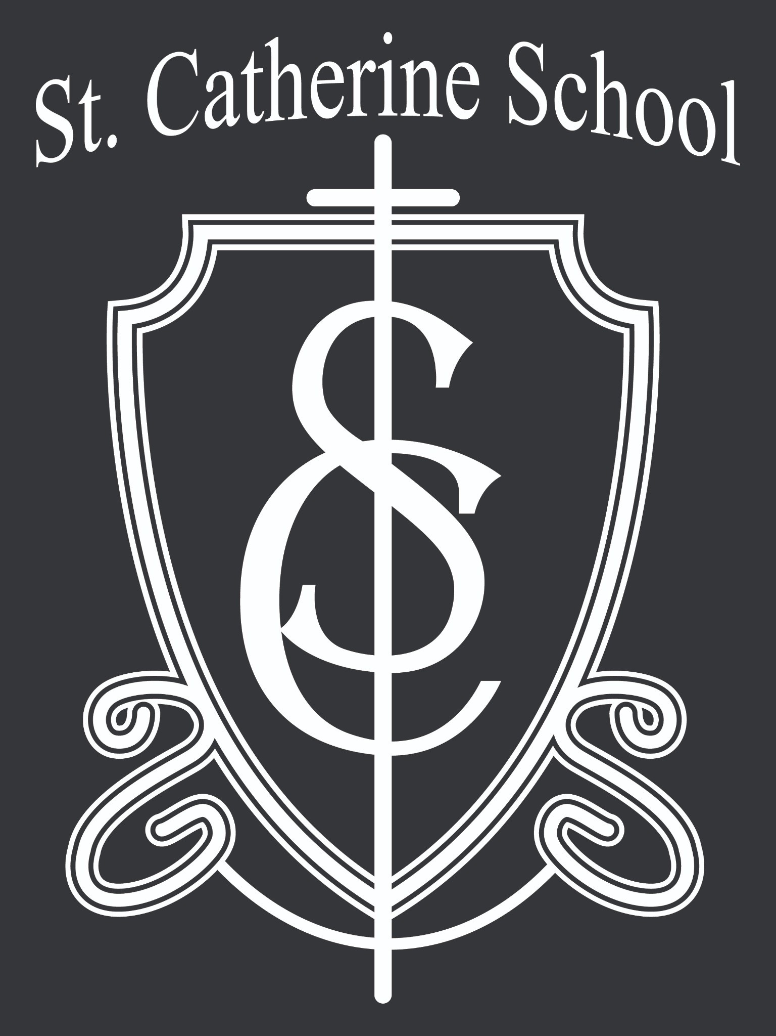

## 5th & 6th Grade Band Shines at REACH Banquet

🎶

A huge **congratulations to our 5th and 6th grade band** for their incredible performance at the REACH Banquet! Their dedication and preparation were so evident, and it was a joy to see their hard work pay off.

Special thanks to **Mr. Kjelland**, who continues to demonstrate what it means to teach with passion and love—so many students have flourished under his instruction. An extra shout- out to **Ms. Busch**, who played alongside the students and showed that **performance is a powerful part of music education**. Great job, everyone!

## National School Librarian Day – Honoring Mrs. Gulka

We had a chance to recognize **Mrs. Gulka** in the lunchroom📚on❤**National School**

**Librarian Day**! Her dedication to our students, staff, and school community is truly a **work of heart**. Thank you, Mrs. Gulka, for all the ways you support and inspire learning at St.

Catherine!

Stay Connected with St. Catherine School

📍 **Address:** 540 3rd Ave. NE, Valley City, ND 58072

**Email:** [nicholas.lee1@k12.nd.us](mailto:nicholas.lee1@k12.nd.us)

📧

**Phone:** 1-701-845-1453

📞

**Website:** [www.stcatherine.k12.nd.us](https://nam02.safelinks.protection.outlook.com/?url=https%3A%2F%2Fwww.stcatherine.k12.nd.us%2F&amp;data=05%7C02%7CTerra.Giesen%40k12.nd.us%7C1205b02b3cfb4a382e7b08dd74493e3a%7Cdbbf782acef14af186c81f9201061db6%7C0%7C0%7C638794580163748044%7CUnknown%7CTWFpbGZsb3d8eyJFbXB0eU1hcGkiOnRydWUsIlYiOiIwLjAuMDAwMCIsIlAiOiJXaW4zMiIsIkFOIjoiTWFpbCIsIldUIjoyfQ%3D%3D%7C0%7C%7C%7C&amp;sdata=luFlPrGJH0VVRHqdb0%2FdFfKls33aSJf2W4qgmOXYNPw%3D&amp;reserved=0)

🌐

📘 **Follow Us on Facebook:** [St. Catherine School on Facebook](https://nam02.safelinks.protection.outlook.com/?url=https%3A%2F%2Fwww.facebook.com%2Fst.catherineschoolvc%2F&amp;data=05%7C02%7CTerra.Giesen%40k12.nd.us%7C1205b02b3cfb4a382e7b08dd74493e3a%7Cdbbf782acef14af186c81f9201061db6%7C0%7C0%7C638794580163763801%7CUnknown%7CTWFpbGZsb3d8eyJFbXB0eU1hcGkiOnRydWUsIlYiOiIwLjAuMDAwMCIsIlAiOiJXaW4zMiIsIkFOIjoiTWFpbCIsIldUIjoyfQ%3D%3D%7C0%7C%7C%7C&amp;sdata=Nzywnqknr4%2Bl3gf%2BfWP1dGHxQv%2BrXdGFNL%2Bxytz%2BwEc%3D&amp;reserved=0)

*“Inspiring excellence through faith, learning, and service.”*