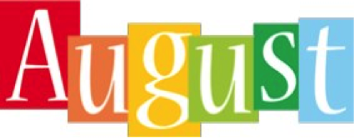

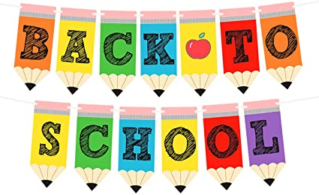

What an exciting time this will be for you and your child. Mrs. Amy and I are thrilled about welcoming each one of you to PLES and Pre-K. This will be a year of FUN, Making Friends, Singing, Drawing, Painting, Creating and Playing TO Learn! We hope that you will ENJOY it as MUCH as we will! During the month of August, we will be getting acquainted with the school rules and discovering colors and shapes. Also, we will explore the topic, “All About Me” where we learn about your child and family.

We will also work on literacy and math skills. We appreciate your participation in your child’s education. Please work on the items listed below with your child.

**Identifying First & Last Name**

**Colors**

**Shapes**

**Mark Your Calendar**

**August 7th First Day of School** (Boys)

**August 8th First Day of School** (Girls)

**August 11th** Monday - Wear Red

**August 12th** Tuesday - Wear Blue

**August 13th** Wednesday – Wear Yellow

**August 14th** Thursday - Wear Green

**August 15th** Friday - Wear Orange

**August 18th** Monday - Wear Purple

**August 19th** Tuesday - Wear Brown

**August 20th** Wednesday Wear Black and White

**August 21st** Thursday - Pink and Gray

**August 22nd Friday – Spirit Day/Wear BULLDOG Colors /Special Snack**

(All About Me Poster Due) ***

**Upcoming Events**

**August 26th Parent Volunteer Training**

**September 1st - Labor Day (No School)**

**Reminders**

**Daily** – Mark your Child’s Binder to verify how they are eating Breakfast & Lunch

**Daily** – Send your Child with a filled Water Bottle (Labeled with your Child’s Initials or Name)

**Weekly** – Send your Child a Blanket or Towel for Nap

Please send your child a change of clothes to keep in our classroom.