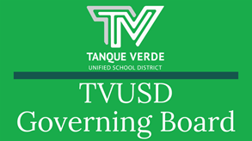
Governiing Board Meetiing Summary November 17, 2021

The Governing Board considered an action item to implement changes to the Safe Return to In-Person Learning (COVID Mitigation) Plan. There was also a detailed presentation and discussion of the K-6 ELACurriculum adoption process and the two curriculums being considered. Please review the presentation links and meeting summary below.

Revised Safe Return to In-Person Learning Plan

Superintendent, Dr. Scott Hagerman, reviewed the proposed changes to the Safe Return to In-Person Learning Plan, which were initially addressed at the November 9th meeting.

Face Masks are required for Grades PreK-6 through December 17, 2021. Whole School events are postponed until after January 31, 2022.
Visitors in K-6 schools are required to wear face coverings.

The board discussed these changes to the mitigation policy and voted to revise the plan as proposed. The presentation may be viewed here.

K-6 ELA Curriculum Adoption

Student Services Director, Mrs. Tiffany Hodge, and members of the Curriculum Review Committee discussed the ELA adoption process and gave an overview of the two curriculum adoption options being considered.

The K-6 ELA Curriculum Adoptionpresentation is available here.

The curriculum adoption is intended to work with the framework teachers have created through the PLC process.
ADE allows districts to choose a curriculum, with an eye to our district and our population, which meets the needs of our students. The district has the responsibility to ensure that all standards are covered.
The following selected curriculum options have been vetted by a committee of practitioners in the Tanque Verde School District. Members of the committee were present to discuss the options.


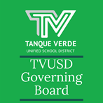
The ELA Adoption process includes a 60-day review process for textbooks of the English Language Arts materials for use in Kindergarten through 6th grade classrooms in the Tanque Verde and Agua Caliente Elementary Schools.

The district is proposing the adoption of the following curriculum materials for the 2022-23 school year:

● Collaborative Classroom’s Curriculum entitledCollaborative Literacy ● Scholastic’s curriculum entitled Scholastic Literacy

Before making a decision on the adoption, a board vote and a 60-day period of public review and comment are required. Hard copies of the curriculum materials are available for review Monday–Friday between the hours of 7:30 am - 4:00 pm at:

Tanque Verde Elementary School – Library 2600 N. Fennimore Ave., Tucson, AZ 85749

Or Online via:

Collaborative Literacy - Literacy Portal Collaborative Literacy - Program Overview

Scholastic Literacy - Literacy Portal Scholastic Literacy - Program Overview

Important Dates & Informatiion

Important Dates

November 24-26, 2021 - Thanksgiving Break/No School December 17, 2021 - Grading Day/No School December 20-31, 2021 - Winter Break/No School January 3, 2022 - Classes Resume

December Events Calendar

Next Governiing Board Meetiing Date:

The next Regular Meeting of the TVUSD Governing Board will be held on Wednesday, December 8th at 6:00 p.m. at the Tanque Verde Elementary School Library.

A Call to the Public will be held at the first meeting of each month. The Virtual Call to the Public Form is available from 5:00 p.m. on the Friday before the meeting and closes at 5:00 p.m. on Tuesday, unless otherwise noted.

Board Meeting Agendas and Minutes

TVUSD Board Meeting Livestream Link
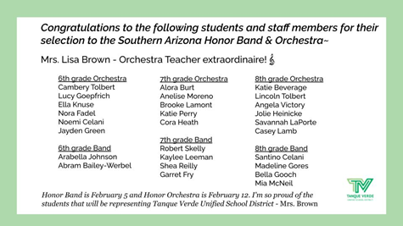
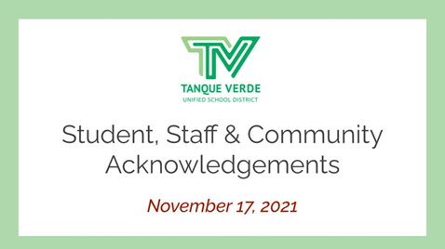
TVUSD Virtual Call to the Public Form

Student, Staff & Communiity Acknowlledgments
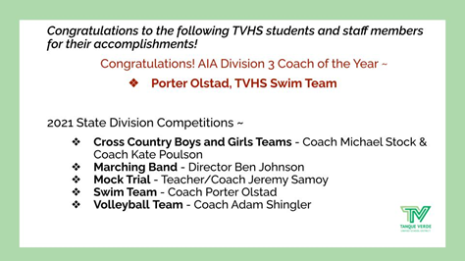
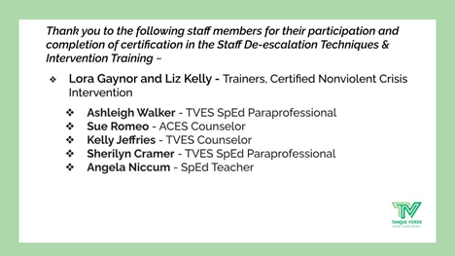
Connect wiith us
Visit our website

