Mrs. Daniel’s Messages
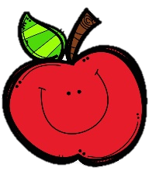
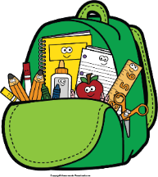
December 13-17, 2021
Reading Skills, Grammar (verbs: am, is, are, was, were),
Spelling (-er, -est), and Vocabulary Tests: Wednesday (multiple choice)
*Tests will be given for assessment purposes, but will not be recorded in the gradebook.

Please check folders and behavior logs daily.

Thursday, December 16: Wear pajamas
Friday, December 17: 2nd 9 Weeks ends
December 20-January 4: Christmas break
Monday, December 13: Dress like candy cane
Tuesday, December 14: Wear flannel shirt
Wednesday, December 15: Beanie, scarf, socks

Reading Story and Skills:  Story:  A Weed is a Flower  by Aliki  Phonics/Fluency:  comparative endings  -er, -est  Text-Based Comprehension:  fact and opinion, inferring  Grammar:  verbs (am, is, are  was, were) |  | Selection Vocabulary Words:  - greenhouse – a building with glass or plastic sides where plants are grown  - agriculture – the science or practice of farming  - college – a school of learning to attend after high school  - laboratory – a place where tests and experiments are done  Vocabulary Words  (these words will be tested each week):  - clothes – things that cover a body  - neighbor – someone who lives in the next  house or nearby  - taught – helped to learn  - hours – parts of time that are sixty minutes  - only – one and no more  - money – metal or paper used to buy and sell  things  - question – something asked in order to find out
Math  This week we will be  reviewing 2-digit  addition and subtraction. |  |  |  | Social Studies/Science  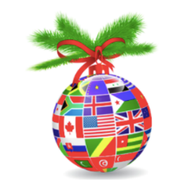  This week we will continue our  study of how Christmas around  the world is celebrated.
Spelling Words: Students who correctly spell the bonus words get a small prize.
- sooner  - soonest  - hotter | - hottest  - busier  - busiest |  | - happier  - happiest  - smaller |  | - fatter  - fattest  - smallest | ***BONUS***  13. heavier  14. widest  15. shinier

