Meningococcal Information

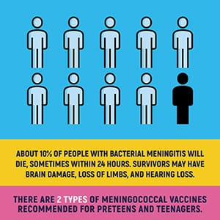

What is meningococcal disease?
- Meningococcal disease is any illness caused by the bacteria Neisseria meningitidis.
- It is the leading cause of bacterial meningitis in children 2-18 years of age in the U.S.
- Meningococcal disease can be very serious, even life-threatening in 48 hours or less.
- The two most severe and common illnesses caused by meningococcal bacteria include:
- Meningitis - an infection of the fluid and lining around the brain and spinal cord
- Septicemia - a bloodstream infection.

Symptoms
- Sudden onset of a high fever
- Headache
- Stiff neck
- Nausea
- Vomiting
- Increased sensitivity to light
- Rash
- Confusion
- Severe aches and pain in the muscles, joints, chest or belly

How does meningococcal disease spread?
- Meningococcal disease is spread person-to-person by sharing respiratory secretions, through kissing or coughing, close or lengthy contact, and among people who share a room or live in the same household.
- Anyone can get meningococcal disease, but teens and college freshmen who live in residence halls are at increased risk.
- Some people can "carry" meningococcal bacteria in their nose and throat without getting meningococcal disease, but can still infect other people.
- Most cases of meningococcal disease are spread by people who "carry" the bacteria with no symptoms, appear to be random, and not linked to other cases.
- Meningococcal outbreaks can occur in communities, schools, colleges, prisons, and in other high-risk populations.

Meningococcal Vaccine Information
- Meningococcal vaccine(s) is recommended for all preteens and teens.
- All 11 and 12 year olds should be vaccinated with serogroups A, C, W, and Y meningococcal conjugate vaccine (MCV4). A booster dose is recommended at age 16.
- Teens and young adults, 16 through 23 year olds, may also be vac
cinated with a serogroup B meningococcal vaccine (SBMV), preferably at 16 through 18 years old.
- Both MCV4 and SBMV can be given at the same time, talk to your provider.
- Teens with HIV should get three doses of MCV4.
- People 55 years of age and older should get Meningococcal polysaccharide vaccine (MPSV4).
- People at increased risk (ex: no spleen or poor spleen, autoimmune disease) during an outbreak, should be vaccinated.

For more information, visit https://www.alabamapublichealth.gov/immunization/meningococcal.html

