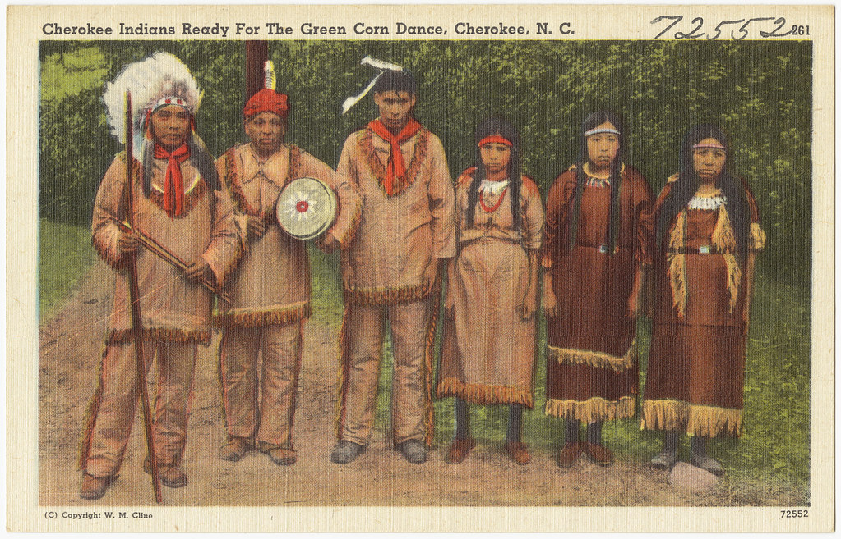
Reading News
Mrs. Williams’ Second Grade
November 10, 2025

Reading: The Cherokee People

Word Study: words spelled with by changing y to i

Vocabulary:
struggle – a very difficult task
village – a small group of homes and community spaces that is smaller than a town or city
settlers - people who move with a group of others to live in a new country or area
politician – a person who is chosen to speak up for their people and come up with ideas that help their people
descendant – someone who is a family member of a person or group who lived long ago

