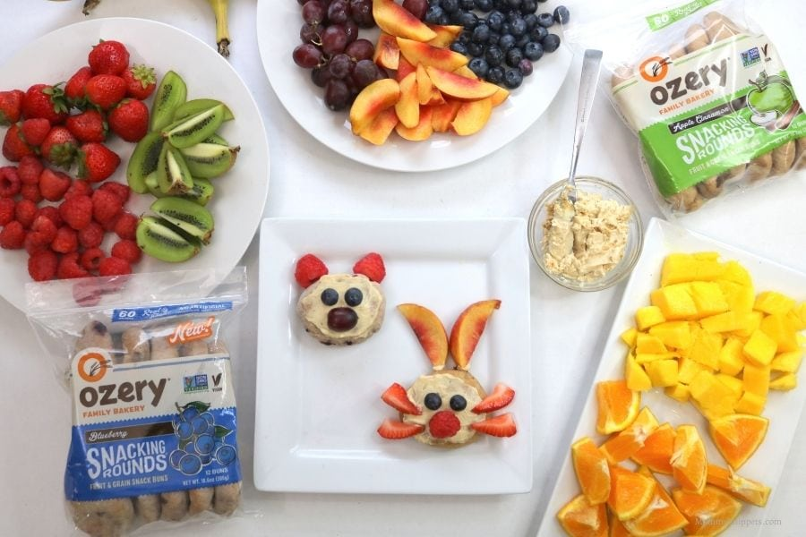

SNACK – 3:55PM -4:10 PM

Week1 | Monday | Tuesday | Wednesday | Thursday
Fruits/ Vegetables  100% Juice | Juice | Juice | Juice | Juice
Grains | Vanilla Gold Fish Grahams | Birthday Grahams | Cheez Its | Sun Chips
Milk is offered with every meal
- Fat – Free Flavored and Unflavored Milks
- Low Fat (1%) unflavored choices
- Lactose Intolerant Milks will be provided for those in need

SNACK – 3:55PM -4:10 PM

Week 2 | Monday | Tuesday | Wednesday | Thursday
Fruits/ Vegetables  100% Juice | 100% Juice | 100% Juice | 100% Juice | 100% Juice
Grains | Blueberry Muffins | Birthday Grahams | Cheez Its | Goldfish

Milk is offered with every meal
- Fat – Free Flavored and Unflavored Milks
- Low Fat (1%) unflavored choices
- Lactose Intolerant Milks will be provided for those in need

SNACK – 3:55PM -4:10 PM

Week 3 | Monday | Tuesday | Wednesday | Thursday
Fruits/ Vegetables  100% Juice | Juice | Juice | Juice | Juice
Grains | Emoji Graham | Blueberry Muffins | Cheez Its | Poptarts

Milk is offered with every meal
- Fat – Free Flavored and Unflavored Milks
- Low Fat (1%) unflavored choices
- Lactose Intolerant Milks will be provided for those in need

SNACK – 3:55PM -4:10 PM

Week 4 | Monday | Tuesday | Wednesday | Thursday
Fruits/ Vegetables  100% Juice | Juice | Juice | Juice | Juice
Grains | Birthday Grahamz | Animal Crackers | Cheez Its | Sun Chips

Milk is offered with every meal
- Fat – Free Flavored and Unflavored Milks
- Low Fat (1%) unflavored choices
- Lactose Intolerant Milks will be provided for those in need

SNACK – 3:55PM -4:10 PM

Week 5 | Monday | Tuesday | Wednesday | Thursday
Fruits/ Vegetables  100% Juice | Juice | Juice | Juice | Juice
Grains | Graham Bug Bites | Animal Crackers | Cheez Its | Goldfish Grahamz

Milk is offered with every meal
- Fat – Free Flavored and Unflavored Milks
- Low Fat (1%) unflavored choices
- Lactose Intolerant Milks will be provided for those in need

