SALARY SCHEDULE

2021 - 2022

Approved September 9, 2021

BESSMER CITY BOARD OF EDUCATION
1621 5th Avenue North
P. O. Box 1230, Bessemer, Alabama

TABLE OF CONTENTS

PAGE

Message from the Superintendent 4
Bessemer City Board of Education Members 4
Administration 4
Bessemer Salary Schedule
Introduction 5
Assumptions 5
The Effect of Fair Labor Standards Act 6
Employee Benefits
Insurance 6-7
Teacher Retirement 7
Leave Days 7-8
Definitions and Positions 9-12
Teachers Salary Schedule 13-14
Statements Defining Employees (9 mo. 10 mo., etc.) 15
Notes Relative to Teacher Salary Schedule 16
Principal Formulas
Tenure Principals Salary Schedule 17
Contract/Probationary Principals Salary Schedule 18
Assistant Principal Formulas
Assistant Principal Allocations 19
Assistant Principal Salary Schedules 20
Notes Relative to Assistant Principal 21
Central Office Formulas
Director Salary Schedule 22
Supervisor Salary Schedule 23
Coordinator Salary Schedules 24
Clerical Positions
Central Office Clerical Salary Schedules 25
School Clerical Staff Matrix 26
School Secretary Salary Schedules 27
Custodian
Custodian (10,11,12 month) Salary Schedules 28

Maintenance
Maintenance (IV, III, II, I) Salary Schedule 29

Transportation
Mechanic (II-I) Salary Schedule 30
Bus Driver, Bus Assistant Salary Schedule 31
Bus Supplements 31

Child Nutrition Program
CNP Manager, Assistant Manager Salary Schedules 32
CNP Worker Salary Schedule 33

Other Support Personnel
School Nurse (RN, LPN, Lead Nurse) Salary Schedules 34
Para Professional Salary Schedule 35
Job Coach and Security Guard Salary Schedules 36

Technology
Technology Salary Schedules (Senior, Certified, Tech Support) 37

Substitute and Part-Time Employment
Substitute Schedule 38
Supplements
Coaching and Band Supplements 39-40

A MESSAGE FROM THE SUPERINTENDENT.….
Each employee of the Bessemer City School System is a valuable member of a team of certified and classified personnel striving for excellence in education. Designing a system for equitable and fair remuneration for our employees is an important responsibility of the Bessemer City Board of Education. The development of this salary schedule is a positive step in establishing an equitable and fair compensation system.
By adopting this salary schedule, the Bessemer City Board of Education confirmed legally the importance of every employee in our system.

Dr. Autumm M. Jeter
Superintendent

BESSEMER CITY BOARD OF EDUCATION

Mr. Amos Rembert
Mrs. Vera Eades, Vice-President
Mrs. Renna’ Soles Scott, Mr. Sam Morris
Mr. Jerome Cook,
Mrs. Remeka Thompson, President
District 1
District 2
District 3
District 4
District 5
District 6

Mr. Lee Jones District 7

ADMINISTRATION

Dr. Autumm M. Jeter Superintendent

Pat Stewart Chief School Financial Officer

INTRODUCTION
SALARY SCHEDULE

FOR THE
BESSEMER CITY SCHOOL SYSTEM 2021 - 2022

The purpose of this salary schedule is to convey wage and salary information to the employees of the Bessemer City School System and the public. In adopting this revised schedule, the Bessemer City Board of Education anticipated that certain goals would be met by its use. These goals are as follows:

- To provide an ability to differentiate between different skill levels and seniority ranks in positions.
- To furnish an equitable means for the future adjustment of remuneration should funds become available.
- To meet the salary adjustments as required by Alabama Law.
- To meet Federal and State minimum wage mandates.

ASSUMPTIONS

In the preparation of any salary schedule, certain assumptions must be made, implicitly or explicitly. It is the opinion of the Board that maximum benefit will accrue when these assumptions are made explicit. The assumptions under which this salary schedule were prepared are as follows:
- Any new employees will begin employment under the salary guidelines in this schedule.
- Current employees compensated above this schedule will remain "grandfathered" at existing rates of pay or salary schedules until retirement, termination, or job change. Unless otherwise mandated by the State Legislature (i.e., State matrices), salary increases or raises will be made by applying an across-the-board percentage to this schedule of base salaries or wages for all employees and to previously existingschedule or salary bases for grandfathered employees.
- Wages will be increased in a step fashion up to a predetermined maximum to reflect an employee's increasing competence over the tenure of employment.
- Employees performing equivalent tasks will receive equivalent remuneration.
- All employees should be duly certified for their respective positions.
- A certified employee whose pay is based on the state minimum salary schedule is entitled to be paid for the highest recognized degree earned at an accredited institution. The pay will begin with the first pay period after the degree is recognized by the State Superintendent of Education.

THE EFFECT OF THE FAIR LABOR STANDARDS ACT

The case of Garcia vs. San Antonio reapplied the provisions of the Fair Labor Standards Act (FLSA) of 1938 and its amendments to certain employees in education, in particular the provision dealing with additional compensation for overtime work. As authorized by the Bessemer City Board of Education, the Superintendent should determine the need for overtime work, negotiate with employees the amount and timing of overtime work, and compensate the employees for that overtime work. This additional compensation is generally provided by paying the employee for additional hours worked over 40 hours in a work week. Compensatory time, in some cases, may be used in lieu of overtime pay within the system but must be approved in advanced. In accordance with Title 29, Part 541, of The Code of Federal Regulations, revised June 1983, most positions listed in this proposal are subject to the provisions of the FLSA (i.e., are nonexempt). Exempt positions are not entitled to overtime pay or compensatory release time. As outlined in the Code, exempt employees are those that meet one or more of the following criteria:
- Executive, administrative, and professional (certified) employees, including teachers, registered nurses and academic administrative positions (e.g., supervisor).
- Non-certified employees (a) whose primary duties consist of the management of the enterprise in which they are employed, (b) who customarily direct the work of two or more employees, (c) who have the authority to hire or fire or whose suggestions and recommendations as to the hiring, firing, or other change of status decisions for other employees will be given particular weight, and (d) who customarily and regularly exercise discretionary powers.

Employees not meeting one of the above criteria are subject to the provisions of the FLSA and are eligible for additional compensation for work performed in excess of forty hours per week.

EMPLOYEE BENEFITS

MEDICAL INSURANCE

Public Education Employee Health Insurance Program (PEEHIP) is available for all active full- time and permanent part-time employees. PEEHIP offers two (2) medical plans to choose from, Blue Cross Blue Shield of Alabama (PPO) and VIVA Health Plan (HMO). For each active employee, the district pays $800 per month towards their insurance premium. Depending on the enrollment (single/family) of the employee, the premium rates due for medical coverage can differ. The cost for each plan is listed below.

Single $30.00 Single w/child(ren) $207 Single w/spouse $282 Family $307

EMPLOYEE BENEFITS (continued)

If you are a tobacco user, a $50.00 monthly tobacco premium will be charged to each member enrolled in single or family coverage (covered spouse) for tobacco usage. Also, if you are covered under the Blue Cross Blue Shield medical plan, you are required to participate in the Wellness Program. Failure to do so can result to an additional $50.00 charge. Please contact PEEHIP on how to qualify for the $50.00 wellness premium waiver. TO make any changes, additions or terminations of PEEHIP coverages, log on to Member Online Services at https://mso.rsa-al.gov

SUPPLEMENTARY INSURANCE

Supplementary insurance is provided through PEEHIP, by Southland Benefit Solutions. All active employees (full-time or permanent part-time) are eligible for coverage.

Vision  Indemnity | $38 (single/family)  $38 | Cancer  Dental | $38  $38 (single)
 |  |  | $50 (family)

Additional pre-tax supplementary insurances can be acquired through other benefit carriers that have payroll slots available here in the district. Deadline for making any annual changes, additions or deletions with PEEHIP is August 31. Contact the Human Resources Department for any questions or a list of current vendors.

TEACHER RETIREMENT
All full time employees are required to participate in the Teachers Retirement Systems of Alabama (TRS) program. For more information on retirement and to set-up a Retirement consultation, please contact them at 877-517-0020 or www.rsa-al.gov.

LEAVE DAYS AND VACATION
Each full-time employee will accrue sick leave at the rate of one day per month of contract (the 12 month employee will earn 12 sick leave days per year; the 9-month employee will earn 9 days).
Effective August 1, 2001, full time employees will be allowed to accumulate an unlimited number of sick leave days. All accumulated sick leave days, not to exceed one day per month of employment, may be used for retirement purposes. Sick leave days must be taken in full day increments.

Each full-time employee will receive two (2) personal leave days funded by the state as authorized by Section 16-8-26, Code of Alabama 1975 and 1986 Cumulative Supplement. Certificated employees are entitled to three (3) additional unpaid personal leave days per year. For additional personal leave days beyond the two funded by the state, the cost of the substitute for these additional days shall be paid by the certificated employee. Part-time employees (i.e., those working less than twenty hours per week) are ineligible for these benefits. When the two (2) paid personal leave days are not used, the Systems employees may receive, upon written request, compensation at the same daily rate paid for their substitute. Otherwise, the two (2) unused paid personal leave days will be converted to sick leave days. Personal leave is non-cumulative and requires no justification from the employee.

All twelve-month personnel are entitled to paid vacation days, to come from public funds. Twelve-month employees who have been employed by the Board for less than fifteen (15) years are entitled to two (2) weeks’ vacation. Twelve-month employees who have been employed by the Board for fifteen (15) years or more are entitled to three (3) weeks’ vacation on July 1st of their 16th year of employment. Effective January 1, 2020, twelve-month employees receiving two (2) weeks’ vacation shall accrue .83 of a vacation day per month, and twelve-month employees receiving three weeks’ vacation shall accrue 1.25 vacation days per month. Any employee who plans to take a vacation shall schedule such in cooperation with his or her immediate supervisor.

Only twelve-month personnel shall earn vacation days. Vacation days will not be granted before they are earned, and all vacation days must be used by the employee prior to his or her effective retirement or resignation date. In the event the employee retires or is terminated, the System shall make cash payments for up to thirty (30) unused, earned vacation days. Effective July 1, 2020, a twelve-month employee shall accumulate no more than thirty (30) vacation days of any year. Effective July 1, 2020, any accrued vacation in excess of thirty (30) days of any year will be forfeited.

DEFINITIONS

POSITION, JOB, OR CLASSIFICATION
These three terms are used interchangeably in this document.

POSITIONS

The positions listed in this document are as follows:

Administrative Assistant/Special Education Administrative Assistant/Student Services Assistant Principal, Elem./Middle/High School Athletic Director Bus Driver
Bus Assistant
Central Office Accounting Assist. Central Office Receptionist Central Office Executive Secretary Central Office Payroll Officer
CNP Assistant Manager CNP Bookkeeper
CNP Manager Rank 3/Rank 4 CNP Secretary
CNP Worker
Coordinator of Parent Engagement Coordinator of Technology Counselor Crossing Guard Custodian
Director of Attendance and Security Director of Career Technical Education Director of Curriculum
Director of CNP
Director of Human Resources Director of Maintenance Director of Special Education Director of Student Services Job Coach
JROTC Instructor

Local School Accountant Library Media Specialist Maintenance I Maintenance II Maintenance III Maintenance IV Mechanic I
Mechanic II
Metal Detector Officer Para-Professional
Principal Elem./Middle/High Program Assistant Psychometrist
School Nurse (RN) Lead School Nurse (RN) School Nurse (LPN)
School Secretary Main/High School School Secretary/Attendance School Secretary/Financial
School Secretary-Career Tech Security Officer
Substitutes (Certified, Classified) Supervisor of Business Affairs Supervisor of Professional Development Supervisor of Transportation Supplements (Sports, Band)
Teacher
Teacher/Grandfathered

DEFINITIONS (continued)

TRANSFER

A transfer may be of two types: transfers initiated by the system for its purposes, and transfers initiated by individuals of their own volition. This distinction is important for the employees of the system who have been grandfathered at a pay rate higher than those included in this salary schedule. If a grandfathered employee is involuntarily transferred by the system within the same employment category, that employee would retain his/her current or grandfathered salary (e.g., a school aide involuntarily transferred from Bessemer City High to Bessemer City Middle School would retain his/her current or grandfathered salary). If a grandfathered employee is involuntarily transferred by the system to a higher employment category, that employee would retain his/her current or grandfathered salary or the salary specified in this document, whichever is higher (e.g., a principal involuntarily transferred from Charles F. Hard Elementary to Bessemer City High would retain his/her current or grandfathered salary or be eligible for the salary specified in this document).

All involuntary transfers to lower employment categories shall be in accordance with the provisions of the Students First Act.

Conversely, if a grandfathered employee seeks a transfer on his or her own volition and is approved for a transfer by the system, that employee would move to the salary specified in this document. A voluntary move from one type of position to another is regarded as an individual volition transfer; the grandfathered employee would move to this salary schedule (e.g., an assistant principal at Jonesboro Elementary who applies for and is appointed principal at Abrams Elementary would move to this salary schedule).

In instances in which support employees apply and are selected for a position that entails movement from a higher salary schedule to a lower salary schedule, said employees shall be moved to the lower salary schedule at the step closest to their actual years of experience in their current School System job position.

A transfer request form must be completed and a copy be given to the Human Resources Department, the employee’s present supervisor and the supervisor responsible for the job posting in order to be considered/interviewed for the job.

In an effort to protect the educational interest of students and established schedules, transfer requested by the employees normally will be made during the months of June, July, and August.

YEARS OF EXPERIENCE

Under normal circumstances, experience is defined as the number of years of service in a particular position, job, or classification within the Bessemer City School System, not the total years of service (e.g., a person with four years of experience as assistant principal at Bessemer City High and one year of service as principal at Greenwood Elementary would have five years of administrative experience, a school secretary with four years of experience as school secretary at Bessemer City Middle School and one year as school aide at Bessemer City High would have only four years of experience

For employees who are promoted to central office positions, initial placement on the salary schedule shall be based upon the following:

- An administrator coming into a central office Coordinator position will begiven experience at step 4 on the salary schedule or based upon that administrative experience attained from the local school, whichever is greater.
- An administrator coming into a central office Supervisor position will be given experience at step 4 on the salary schedule or based upon that administrative experience attained from the local school, whichever is greater.
- The Superintendent may place a new central office administrator at a higher step on the salary schedule in order to assure that the incoming salary reflects an increase from an administrator’s previous administrative position, based upon Board approval.

The number of years of acceptable experience for initial placement on the salary schedule for certified personnel shall be determined and agreed upon prior to employment. Job applicants must provide verification of all past job-related experience from their former employers, prior to placement on a personnel report. The determination of such credit shall be based on the following criteria:

- Full-time teaching/administrative experience in all kindergarten through post- secondary public schools (elementary, secondary, and post-secondary public college), in or out of state, shall be approved as credit for placement on the salaryschedule.
- A maximum of three (3) years of experience credit for placement on the salary schedule may be granted for service in the U.S. military.

- In determining experience for placement on the salary schedule, credit shall be given for full years of experience only. A full year of experience will be granted to an employee who worked a complete semester plus at least one day of the previous or following semester of an academic school year.

Under normal circumstances, the number of years of acceptable experience for initial placement on the salary schedule for non-certified personnel shall be determined and agreed upon prior to employment. For employment outside the System that is gained in the exact (no exceptions) employment position for which the job applicant seeks employment in the School System (i.e. secretarial experience applicable only to a secretarial position; bookkeeper experience applicable only to a bookkeeping position; bus driver experience applicable only to a bus driver position; custodial experience applicable only to a custodial position, etc.) some credit for experience may be given. The Bessemer City School system, through the Central Office, shall have sole responsibility for the determination of exactly what skills, etc., are exact and the amount of experience to be credited based upon the documentation provided. Work experience for classified employees outside the System will not be credited above the fourth experience level.

RETIRED TEACHER
Alabama law requires that school systems notify the Teacher Retirement System (TRS) of Alabama upon employment of a retired teacher. A TRS retiree who is employed full-time with a TRS member agency must have his or her retirement benefit suspended until he or she withdraws from service again. If the retiree is employed for a period of two years, he or she may petition the TRS Board of Control to permit the resumption of participation in the TRS. Upon approval, the member will pay the contributions over the non-contributing period plus interest and begin contributing on future compensation. Upon termination of service, the member’s retirement benefit would be recalculated to include service accrued since reemployment. The member will also be allowed to reselect a retirement option and beneficiary.

STATE TEACHERS SALARY SCHEDULE 2021 - 2022 FISCAL YEAR
9, 10, 11, & 12 MONTHS
Years of Experience | Classification (Months) | Bachelor's  Degree Rank II Type II &III | Master's  Degree Rank I Type I | Ed. Specialist  Degree/AA Certificate | Doctoral Degree
0-2 | 9 | 42,940 | 49,379 | 53,244 | 57,110
 | 10 | 46,383 | 53,341 | 57,516 | 61,692
 | 11 | 50,977 | 58,621 | 63,211 | 67,798
 | 12 | 55,111 | 63,376 | 68,335 | 73,298
3-5 | 9 | 47,231 | 54,316 | 58,566 | 62,821
 | 10 | 51,021 | 58,673 | 63,266 | 67,862
 | 11 | 56,072 | 64,483 | 69,529 | 74,576
 | 12 | 60,618 | 69,712 | 75,165 | 80,628
6-8 | 9 | 49,301 | 56,695 | 61,148 | 65,568
 | 10 | 53,256 | 61,242 | 66,051 | 70,829
 | 11 | 58,526 | 67,306 | 72,592 | 77,840
 | 12 | 63,271 | 72,764 | 78,479 | 84,153
9-11 | 9 | 50,289 | 57,827 | 62,373 | 66,879
 | 10 | 54,324 | 62,467 | 67,375 | 72,245
 | 11 | 59,701 | 68,652 | 74,046 | 79,396
 | 12 | 64,540 | 74,220 | 80,048 | 85,836
12-14 | 9 | 51,292 | 58,984 | 63,620 | 68,215
 | 10 | 55,407 | 63,717 | 68,725 | 73,685
 | 11 | 60,892 | 70,023 | 75,529 | 80,981
 | 12 | 65,828 | 75,702 | 81,655 | 87,550
15-17 | 9 | 52,320 | 60,162 | 64,889 | 69,582
 | 10 | 56,518 | 64,987 | 70,094 | 75,164
 | 11 | 62,112 | 71,421 | 77,034 | 82,608
 | 12 | 67,150 | 77,213 | 83,279 | 89,304
18-20 | 9 | 53,367 | 61,371 | 66,187 | 70,973
 | 10 | 57,722 | 66,295 | 71,497 | 76,667
 | 11 | 63,356 | 72,858 | 78,576 | 84,255
 | 12 | 68,494 | 78,764 | 84,948 | 91,090
21-23 | 9 | 54,431 | 62,596 | 67,513 | 72,394
 | 10 | 58,797 | 67,617 | 72,929 | 78,202
 | 11 | 64,617 | 74,314 | 80,150 | 85,942
 | 12 | 69,857 | 80,339 | 86,649 | 92,914
24-26 | 9 | 55,517 | 63,846 | 68,864 | 73,843
 | 10 | 59,919 | 68,917 | 74,355 | 79,768
 | 11 | 65,785 | 75,674 | 81,624 | 87,539
 | 12 | 71,067 | 81,758 | 88,195 | 94,774
27+ | 9 | 56,629 | 65,123 | 70,241 | 75,320
 | 10 | 60,992 | 70,240 | 75,767 | 81,362
 | 11 | 66,978 | 77,063 | 83,137 | 89,168
 | 12 | 72,302 | 83,206 | 89,770 | 96,667
Contract Days: | - Months - 187 Days  - Months - 202 Days |  | - Months -  - Months - | 222 Days  240 Days

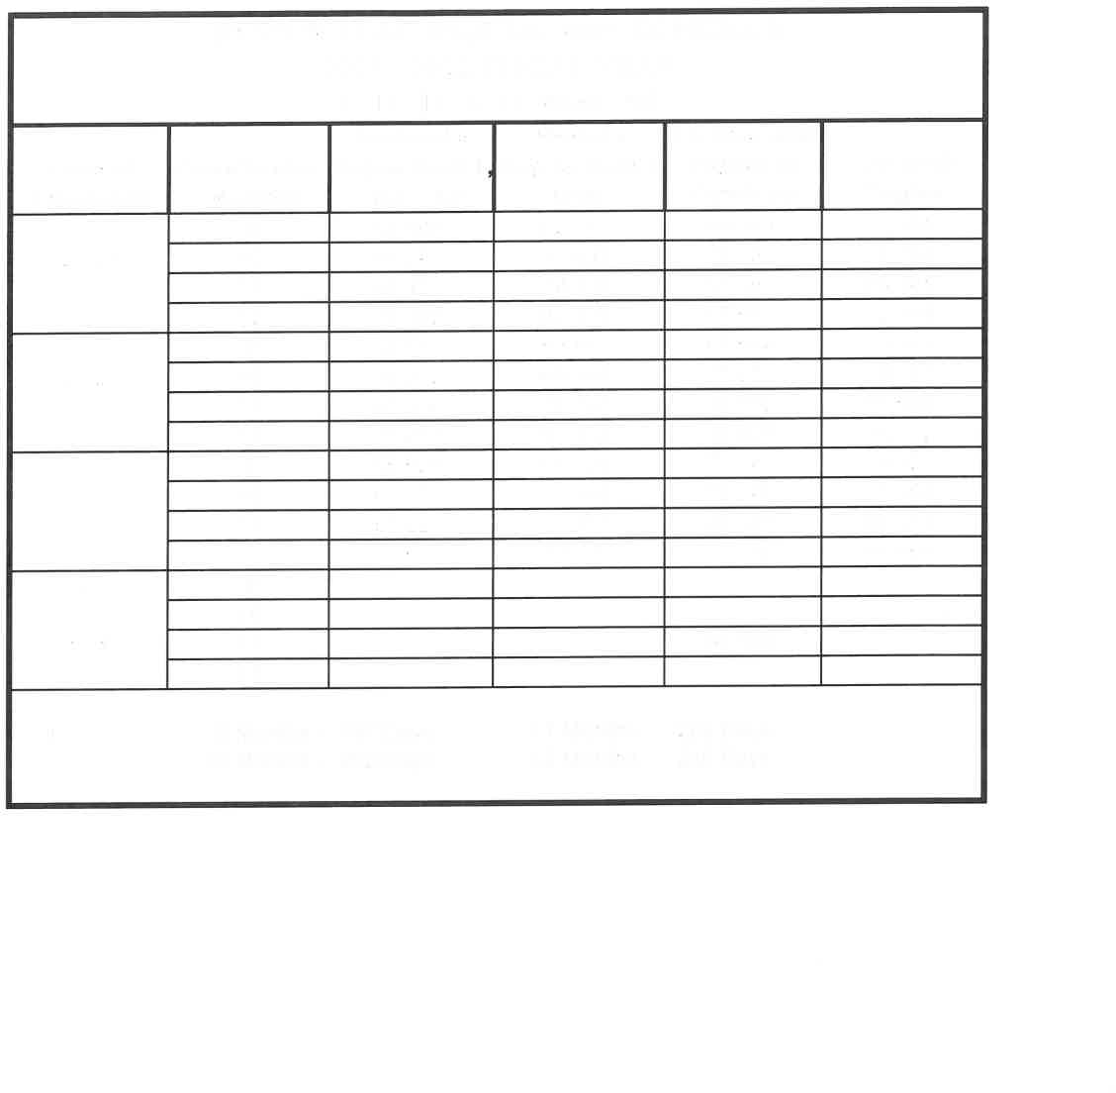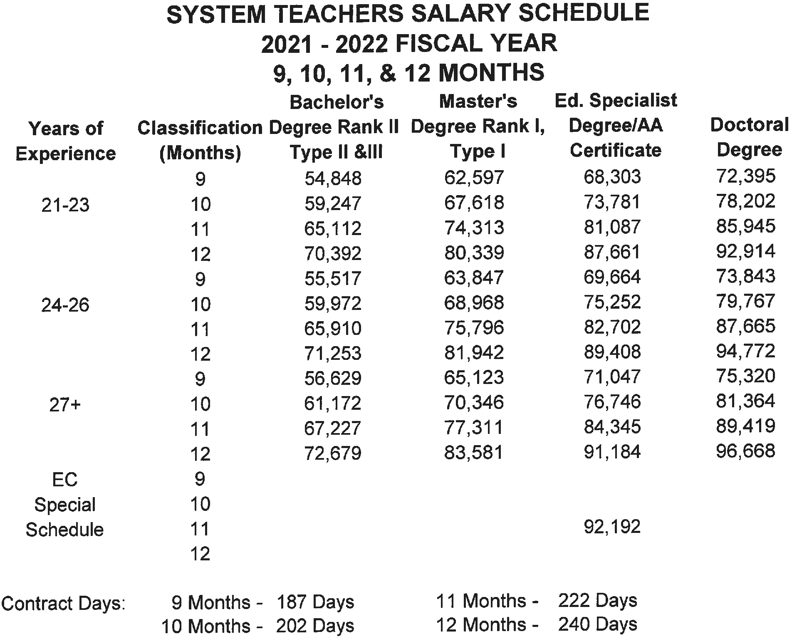

*The pay period for the contract year runs from September 2021 through August 2022.

Employees (9 Month) (180 Days)
The Crossing Guard and Security Officer annual salaries are calculated from the daily rate of pay at the appropriate experience level of the position. Multiply the daily rate of pay times 180 days.

Employees (9 Month) (183 Days)
The Instructional Assistant, Bus Drivers’, and Bus Assistants annual salaries are calculated from the daily rate of pay at the appropriate experience level of the position. Multiply the daily rate of pay times 182 days.

Employees (9 Month) (184 Days)
CNP Workers’ annual salary is calculated from the daily rate of pay for the position at the appropriate experience level. Multiply the daily rate of pay times 184 days.

Employees (9 Month) (187 Days)
Media Specialist, Counselor, and Psychometrist’s annual salaries are calculated from the Teacher’s Salary Schedule based on the degree and appropriate experience level.

Employees (9 Month) (192 Days)
CNP Assistant Managers annual salary is calculated from the daily rate of pay for the position at the appropriate experience level. Multiply the daily rate of pay times 192 days.

Employees (10 Month) (202 Days)
Teachers, Athletic Director, and the Lead Nurse annual salaries are calculated from the Teacher’s Salary Schedule by multiplying the daily rate of pay based on the degree and appropriate experience level by 202 days.

Employees (11 Month) (222 Days)
Eleven (11) month assistant principals’ and annual salaries are calculated from the Assistant Principals’ Salary Schedule. The Coordinators of Federal Programs, Parent Engagement, Special Education and Technology annual salaries are based on the Coordinators Salary Schedule.

Employees (11 Month) (222 Days)
The JROTC Instructor’s salary is the greater of two (2) times the federal salary reimbursement or the appropriate contract amount from the Teacher’s Salary Schedule based on the JROTC Instructor’s degrees and recognized years of teaching experience. An increase in either the Teacher’s Salary Schedule or the federal salary reimbursement requires a new calculation that could result in a change of salary. The salary increases only when the higher of the two calculated numbers increases. (This formula may result in more or less than 222 days.)

Employees (12 Month) (240 Days)
The salaries for the Central Office clerical staff, twelve (12) month Custodians, are calculated by multiplying the daily rate of pay at the appropriate experience level for the position by 240 days. Directors of Attendance and Safety, Curriculum, Child Nutrition Program, Federal Programs, Special Education Programs, and Human Resources annual salaries are based on the Directors’ Salary Schedule. Supervisors of Business Affairs, Maintenance, Transportation salaries are based on the Supervisor’s Salary Schedule.

Employees (12 Months) (240 Days)
Central Office Clerical Staff, Custodian- Annual salaries are calculated by multiplying the daily rate of pay at the appropriate experience level for the position by 240 days.
Supervisor of Maintenance and the Supervisor of Transportation- Annual salaries are based on the Classified Supervisor’s Salary Schedule.

Contract and Probationary Principals- Annual salaries are calculated from the Principal’s Salary Schedule.

Tenure Principals are calculated from the Tenured Principal’s Salary Schedule

NOTES RELATIVE TO TEACHER SALARY SCHEDULE

♦Experience credit will only be given for experience (in or out of state) K-post secondary public education.

♦Degree credit will be given to certificated personnel who earn advanced degrees from accredited institutions, with the approval of the degree by the State Department of Education.

♦Certified employees will be placed on the salary matrix considering the highest degree held and years of experience served in public education.

♦Certified employees will be paid for the advanced degree as soon as the degree is certified and recognized by the State Department of Education.

♦Upon receiving funds from the State, a supplement will be paid to teachers and counselors who meet the National Board for Professional Teaching/Counseling Standards requirements and receive certification from the National Board and in accordance with rules established by the Alabama State Department of Education.

♦Daily Rate – Equals 1/187 of the annual salary (9 months).

♦Current employees will be paid in 12 equal monthly installments, regardless of contract length (12, 11, 10, or 9 months).

♦Mentors will be paid in accordance with rules established by the Alabama State Department of Education.

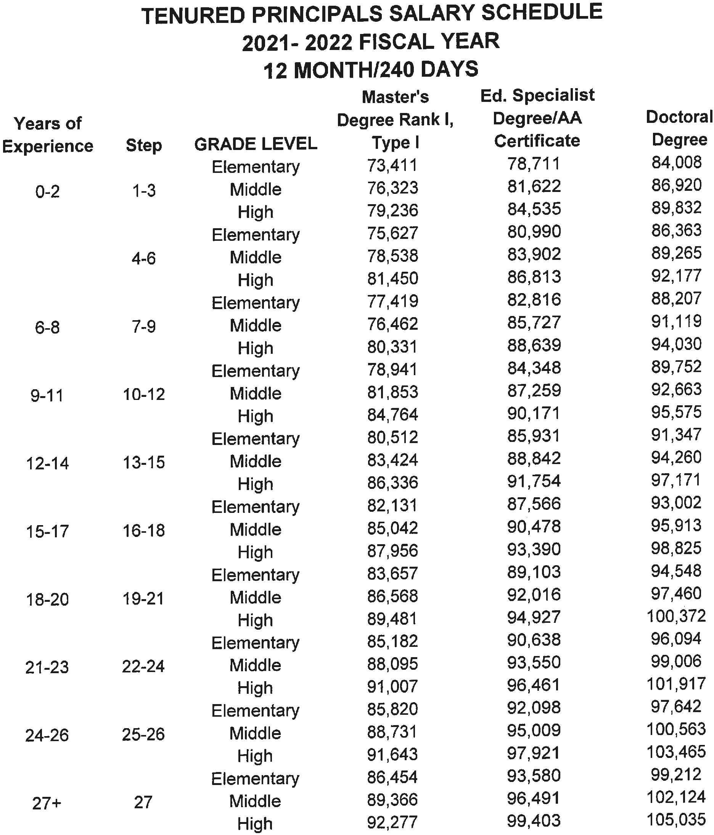
Note:
The principal must have a Class A (Master’s level) certificate in administration
or educational leadership to qualify for the base salary. Non-contract and non-probationary principals are paid based upon this salary schedule.

CONTRACT/PROBATIONARY PRINCIPAL SALARY SCHEDULE NEGOTIATION RANGE
2021 - 2022 FISCAL YEAR
12 MONTH/240 DAYS

Elementary School | From | 74,325 | To | 96,092
Middle School | From | 77,643 | To | 99,411
Alternative School | From | 77,643 | To | 99,411
High School | From | 80,963 | To | 106,306

Notes:

Principals are employed pursuant to individual contracts based upon qualification, experience, performance and other relative factors. Contract terms for probationary and contract principals including salary, length of contract and similar terms are subject to negotiation.

The position of principal is a 12 month assignment for elementary, middle and high school. A principal will be on call at all times, even while the school is closed for the holidays

ASSISTANT PRINCIPAL ALLOCATION

HIGH SCHOOLS
  - It is recommended that an 11-month assistant principal be allocated to each school and a second 11-month assistant principal be allocated to each school with enrollment of 950 or more.
School enrollment from 250-499 .5 Assistant Principal School enrollment from 500-749 1 Assistant Principal School enrollment from 750-999 1.5 Assistant Principals School enrollment from 1,000-1,249 2 Assistant Principals School enrollment from 1,250-UP 2.5 Assistant Principals

MIDDLE SCHOOLS
  - The middle school assistant principal for schools with an enrollment of 499 is an 11-month position.
  - The first middle school assistant principal for schools with an enrollment of more than 499 is an 11-month position.

ELEMENTARY SCHOOLS
    - The elementary school assistant principal is an 11-month position. It is recommended that an 11-month assistant be allocated to each elementary school with enrollment of 500 or more.

School enrollment from 500-749 .5 Assistant Principal School enrollment from 750-999 1 Assistant Principal School enrollment from 1,000-1,249 1.5 Assistant Principals School enrollment from 1,250-UP 2 Assistant Principals

ASSISTANT PRINCIPALS SALARY SCHEDULE 2021 - 2022 FISCAL YEAR
11 MONTH/222 DAYS

Years of Experience | Step | GRADE LEVEL | Master's  Degree Rank I, Type I | Ed. Specialist  Degree/AA Certificate | Doctoral Degree
0-2 | 1-3 | Elementary | 61,552 | 66,371 | 71,189
 |  | Middle | 63,312 | 68,266 | 73,224
 |  | High | 64,483 | 69,533 | 74,579
3-5 | 4-6 | Elementary | 67,708 | 73,006 | 78,305
 |  | Middle | 69,640 | 75,090 | 80,543
 |  | High | 70,931 | 76,483 | 82,032
6-8 | 7-9 | Elementary | 70,672 | 76,221 | 81,733
 |  | Middle | 72,691 | 78,401 | 84,067
 |  | High | 74,035 | 79,852 | 85,625
9-11 | 10-12 | Elementary | 71,621 | 77,225 | 82,829
 |  | Middle | 73,668 | 79,431 | 85,196
 |  | High | 75,033 | 80,901 | 86,775
12-14 | 13-15 | Elementary | 72,918 | 78,627 | 84,338
 |  | Middle | 75,003 | 80,873 | 86,746
 |  | High | 76,391 | 82,373 | 88,351
15-17 | 16-18 | Elementary | 74,583 | 80,420 | 86,256
 |  | Middle | 76,713 | 82,719 | 88,721
 |  | High | 78,137 | 84,249 | 90,362
18-20 | 19-21 | Elementary | 75,547 | 81,459 | 87,372
 |  | Middle | 77,705 | 83,788 | 89,868
 |  | High | 79,143 | 85,338 | 91,532
21-23 | 22-24 | Elementary | 76,513 | 82,500 | 88,487
 |  | Middle | 78,700 | 84,857 | 91,015
 |  | High | 80,156 | 86,427 | 92,702
24-26 | 25-26 | Elementary | 77,148 | 83,136 | 89,122
 |  | Middle | 79,336 | 85,495 | 91,015
 |  | High | 80,792 | 87,062 | 93,337
27+ | 27 | Elementary | 77,784 | 83,885 | 89,758
 |  | Middle | 79,972 | 86,127 | 92,287
 |  | High | 81,428 | 87,698 | 93,971

ASSISTANT PRINCIPAL NOTES

BASE SALARY
The assistant principal must have a Class A (Master’s level) certificate in administration or educational leadership to qualify for the base salary

GENERAL NOTES
♦Master’s Degree – (Class A) certificate must be in administration or educational leadership to qualify for this schedule.

♦Sixth Year – (Class AA) certificate or degree will be recognized for degree credit in or out of field. This remuneration is in effect for all assistant principals upon approval of the schedule.

♦During the time of his/her contract (11 months), an assistant principal will be considered to be on call at all times, even while the school is closed for holidays.

FORMULAS

CENTRAL OFFICE ADMINISTRATIVE POSITIONS

BASE SALARY-CERTIFIED SUPERVISORS, DIRECTORS AND CERTIFIED COORDINATORS
The Certified Director, Supervisor and Coordinator must have a Class A Master’s level certification in administration or in the area of employment to qualify for the base salary.

CENTRAL OFFICE ADMINISTRATION NOTES

A professional degree or completion of a credentialing program in the area of employment that requires a minimum of 30 hours of graduate work above the B.S. or B.A. degree.

**A professional degree or completion of a credentialing program in the area of employment that requires a minimum of 30 hours of graduate work above the M.S. or M.A. degree.

2021 - 2022 FISCAL YEAR DIRECTOR SALARY SCHEDULE
12 MONTHS/240 DAYS
Years of Experience |  | Classification (Months) | Master's Degree Rank I,  Type I | Ed. Specialist Degree/AA  Certificate | Doctoral Degree
0-2 |  | 12 | 76,568 | 84,051 | 85,258
3-5 |  | 12 | 79,328 | 87,037 | 88,568
6-8 |  | 12 | 81,673 | 89,577 | 91,405
9-11 |  | 12 | 83,754 | 91,831 | 93,947
12-14 |  | 12 | 85,882 | 94,134 | 96,539
15-17 |  | 12 | 88,057 | 96,488 | 99,184
18-20 |  | 12 | 90,140 | 98,747 | 101,728
21-23 |  | 12 | 92,226 | 101,004 | 104,270
24-26 |  | 12 | 92,850 | 101,629 | 104,880
27+ |  | 12 | 93,473 | 102,251 | 105,491

Contract 9 Months - 187 Days
10 Months - 202 Days
- Months -
- Months -
222 Days
240 Days

The following positions are funded under the Central Office Director Schedule:
12 month Director of Attendance and Security
12 month Director of Career Technical Education 12 month Director of Curriculum 12 month Director of Federal Programs
12 month Director of Human Resources 12 month Director of Maintenance
12 month Director of Special Education 12 month Director of Student Services

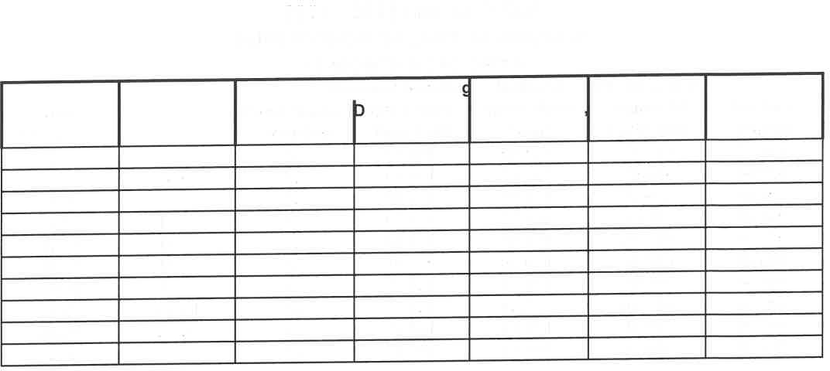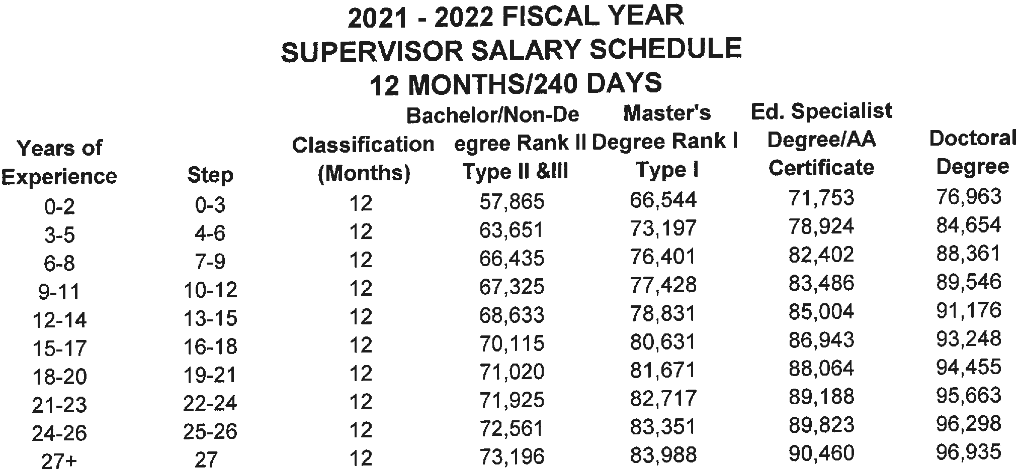

The following positions are funded under the Central Office Supervisor Schedule:
12 month Supervisor of Business Affairs
12 month Supervisor of Professional Development 12 month Supervisor of Transportation
NOTES:
- The Supervisor of Maintenance and Supervisor of Transportation are paid in this category. Each employee works 240 days, eight hours each day in a contract year.

- The Supervisor of Maintenance must be a skilled employee in at least one trade (carpentry, plumbing, electricity).

- The Supervisor of Transportation must be trained in school bus driving techniques by the State Department of Education and hold a valid School Bus Driver’s Certification and a valid Commercial Driver’s License issued by the Department of Public Safety.

COORDINATOR SALARY SCHEDULE 2021- 2022 FISCAL YEAR
10, 11, & 12 MONTHS
- Years of |  | Classification (Months) | Bachelor/Non-Degree Master's |  | Ed. Specialist Degree/AA  Certificate | Doctoral Degree
 |  |  | Degree Rank II,  Type II &Ill | Degree Rank I,  Type I
Experience
0-2 |  | 10 | 48,704 | 56,006 | 60,391 | 64,775
 |  | 11 | 53,526 | 61,552 | 66,371 | 71,189
 |  | 12 | 57,864 | 66,544 | 71,752 | 76,963
3-5 |  | 10 | 53,477 | 61,607 | 66,429 | 71,251
 |  | 11 | 58,771 | 67,708 | 73,006 | 78,305
 |  | 12 | 63,536 | 73,197 | 78,925 | 84,655
6-8 |  | 10 | 55,916 | 64,305 | 69,354 | 74,370
 |  | 11 | 61,453 | 70,672 | 76,221 | 81,733
 |  | 12 | 66,435 | 76,403 | 82,402 | 86,611
9-11 |  | 10 | 56,665 | 65,170 | 70,269 | 75,367
 |  | 11 | 62,276 | 71,621 | 77,225 | 82,829
 |  | 12 | 67,327 | 77,430 | 83,486 | 87,822
12-14 |  | 10 | 57,696 | 66,350 | 71,544 | 76,739
 |  | 11 | 63,408 | 72,918 | 78,627 | 84,338
 |  | 12 | 68,550 | 78,830 | 85,005 | 89,424
15-17 |  | 10 | 59,013 | 67,865 | 73,176 | 77,971
 |  | 11 | 64,856 I 74,583 |  | 80,420 | 85,691
 |  | 12 | 70,114 _J 80,632 |  | 86,372 | 91,458
18-20 |  | 10 | 59,776 | 68,742 | 74,119 | 78,485
 |  | 11 | 65,695 | 75,547 | 81,459 I | 86,255
 |  | 12 | 71,022 | 81,672 | 86,943 | 92,638
21-23 |  | 10 | 60,537 | 69,620 | 75,068 | 78,967
 |  | 11 | 66,532 | 76,513 | 82,500 | 86,786
 |  | 12 | 71,925 | 82,717 | 87,473 | 93,824
24-26 |  | 10 | 61,115 | 70,199 | 75,645 | 79,533
 |  | 11 | 67,167 | 77,149 | 83,136 | 87,409
 |  | 12 | 72,612 | 83,402 | 88,148 | 94,495
27+ |  | 10 | 61,695 | 70,776 | 76,224 | 80,101
 |  | 11 | 67,801 | 77,784 | 83,771 | 67,801
 |  | 12 | 73,300 | 84,090 | 88,821 | 95,170
Contract Days:  I |  | - Months -  - Months - | 187 Days  202 Days | - Months -  - Months - | 222 Days  240 Days

Central Office Secretary Salary Schedule 2021- 2022 Fiscal Year
10 Months/202 Days
12 Months/240 Days
Years of  Experienc E | Step | 10 Months  Rank2 | 12 Months  Rank3 | 12 Months  Rank4 | 12 Months  Rank 5 | 12 Months  Ranks | 12 Months  Rank7
0 | 1 | 27,818 | 31,824 | 31,887 | 34,315 | 37,287 | 40,264
1 | 2 | 27,818 | 31,824 | 31,887 | 34,315 | 37,287 | 40,264
2 | 3 | 28,334 | 32,353 | 32,794 | 35,556 | 38,529 | 41,503
3 | 4 | 28,847 | 32,884 | 33,705 | 36,793 | 39,772 | 42,747
4 | 5 | 29,360 | 33,414 | 34,617 | 38,034 | 41,009 | 43,989
5 | 6 | 29,872 | 33,942 | 35,525 | 39,278 | 42,254 | 45,230
6 | 7 | 30,387 | 34,471 | 36,434 | 40,516 | 43,493 | 45,961
7 | 8 | 30,896 | 35,000 | 37,348 | 41,760 | 44,733 | 47,712
8 | 9 | 31,412 | 35,533 | 38,256 | 43,001 | 45,973 | 48,953
9 | 10 | 31,924 | 36,060 | 39,166 | 44,244 | 47,217 | 50,194
10 | 11 | 32,436 | 36,590 | 40,077 | 45,484 | 48,458 | 51,437
11 | 12 | 32,947 | 37,127 | 40,990 | 46,725 | 49,698 | 52,676
12 | 13 | 33,463 | 37,649 | 41,896 | 47,964 | 50,941 | 53,917
13 | 14 | 33,973 | 38,180 | 42,806 | 49,207 | 52,177 | 55,159
14 | 15 | 34,488 | 38,710 | 43,714 | 50,448 | 53,420 | 56,401
15 | 16 | 35,037 | 39,241 | 44,625 | 51,687 | 54,664 | 57,639

Classifications: Rank 2 - 10 Month Secretary Rank 3 - Secretary/Receptionist Rank 4 - Senior Secretary Rank 5 - Accounting Assistant
Rank 6 - Executive Secretary/Payroll Officer/Accounts Payable
Rank 7 - Comptroller/Administrative Assistant/Local School Accountant

Note: Salaries of Secretaries working less than 240 days will be calculated by multiplying the daily rate of pay by the number of days approved.

SCHOOL CLERICAL EMPLOYEES

Clerical Staffing Matrix

Enrollment | Secretary Attendance | Secretary Financial | General Clerical
High Schools
0 - 499 | 1.00 | 1.00
500 – 749 | 1.00 | 1.00 | 1.00
Middle Schools
0 - 499 | 1.00 | 1.00
Elementary Schools
0 – 439* | 1.00 | 1.00 | 1.00
440 – 659 | 1.00 | 1.00 | 1.00

NOTES
- Each elementary and middle school shall have one (1) attendance secretary and (1) financial secretary. The attendance secretary will be a 222-day contract position and the financial secretary will be a 240-day contract position. All elementary school secretaries/bookkeepers must work 7½ hours each day. For reasons of financial exigency, all positions may not be filled.

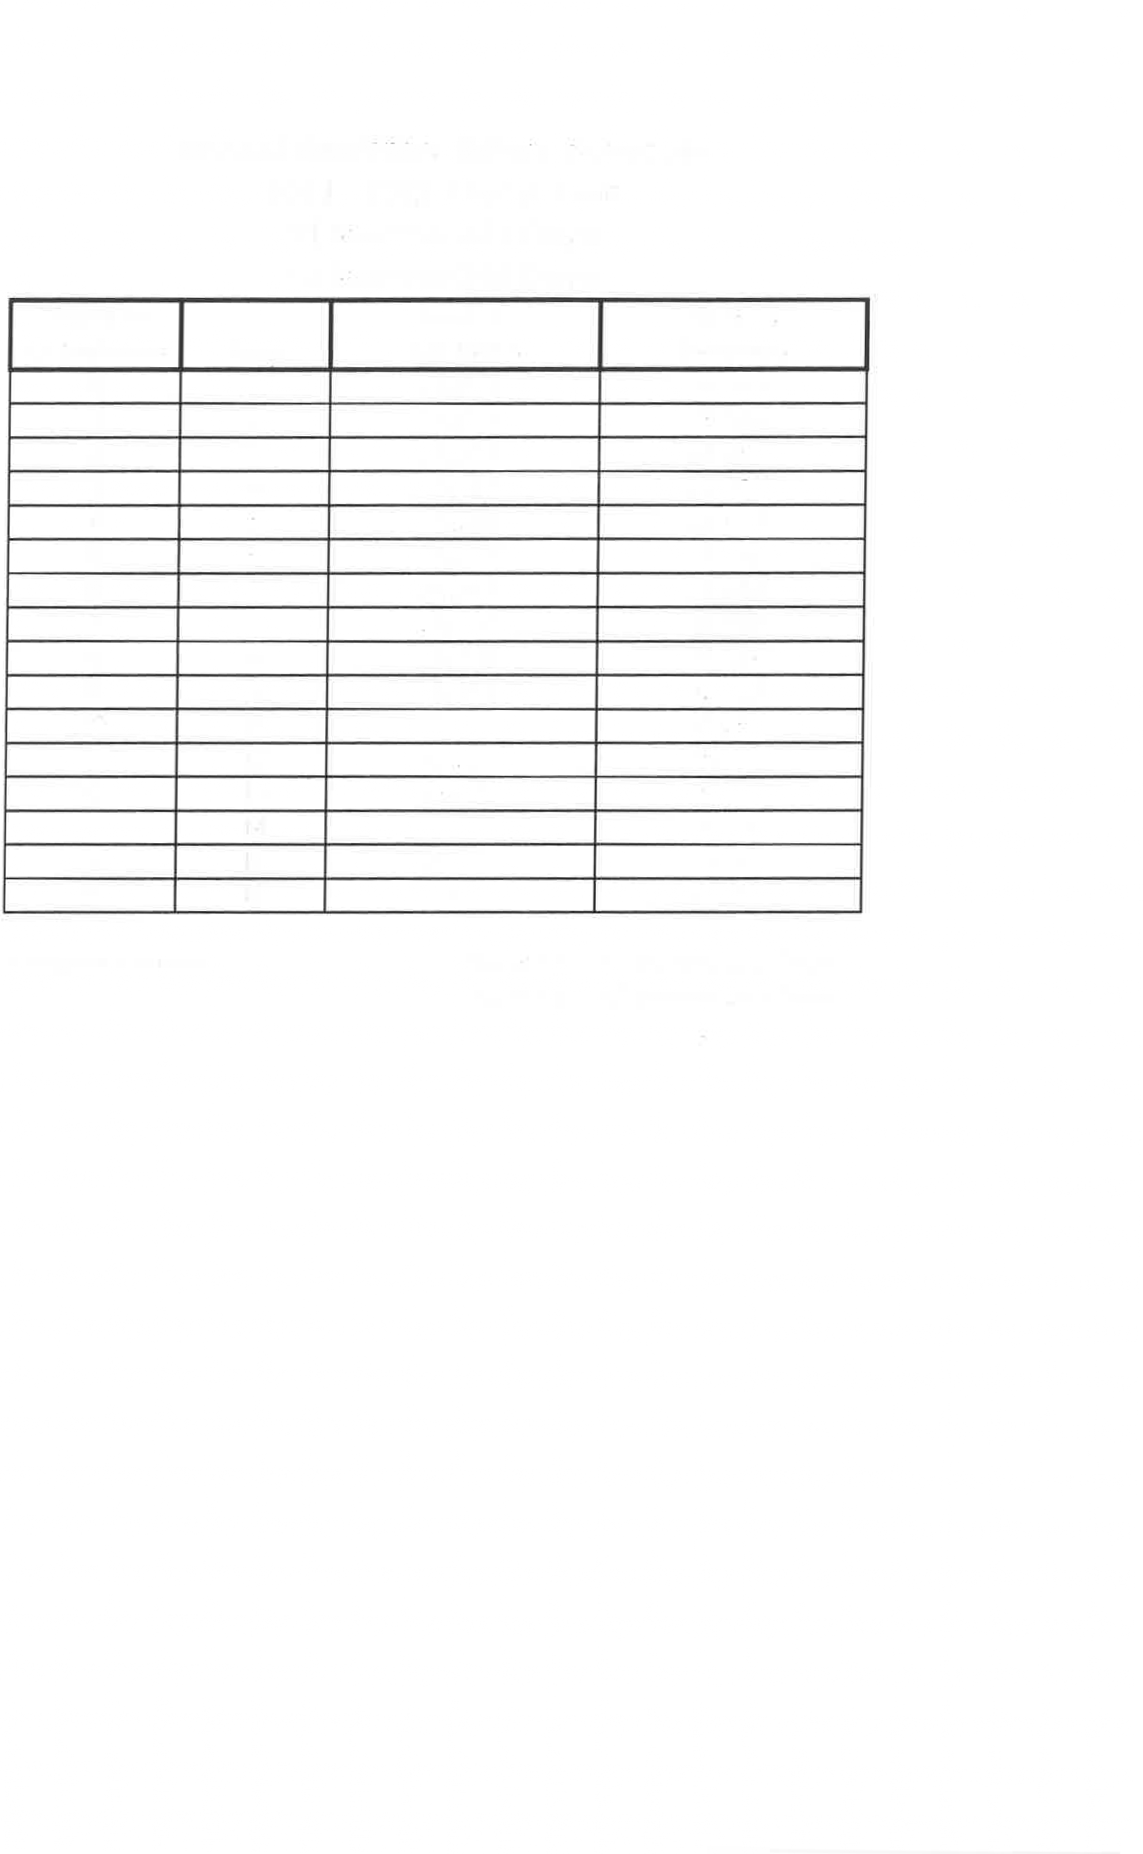
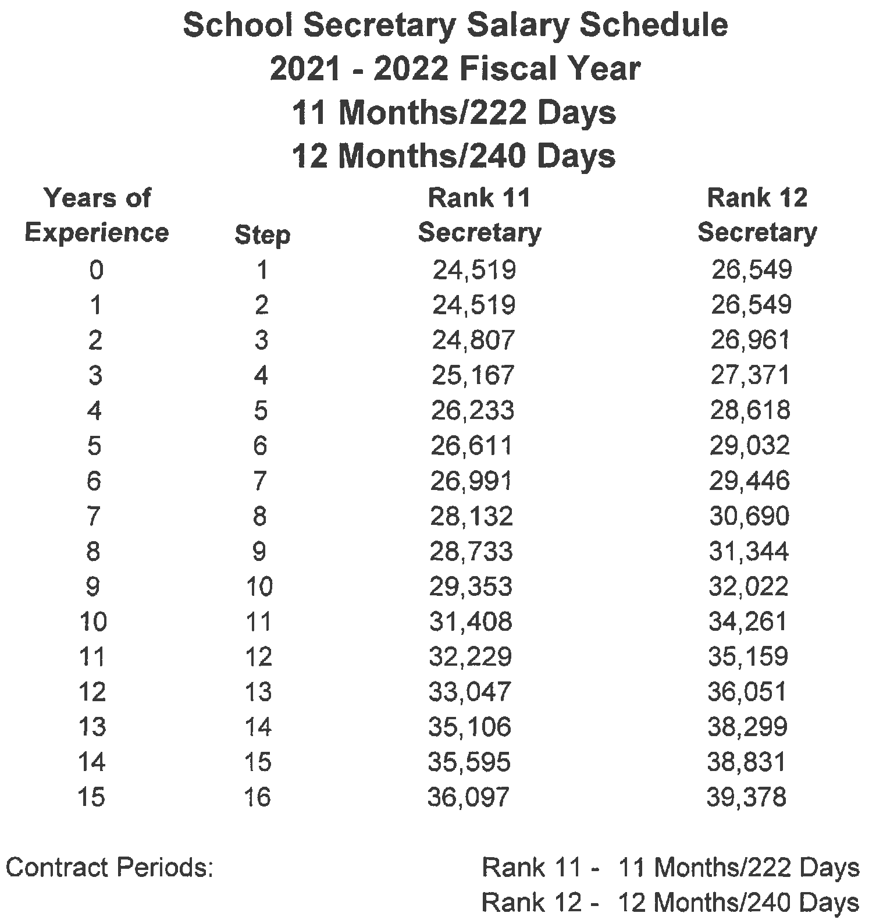

Page 27

Custodial Salary Schedule Fiscal Year
2021 - 2022
10, 11, & 12 MONTHS

Years of Experience | Step | Hours Per Day | 10 Month/202 Days  Custodian | 11 Month/222 Days Custodian | 12 Month/240 Days Custodian
0 | 1 | 6 | 15,754 | --
 |  | 8 | 20,353 | 22,241 | 23,943
1 | 2 | 6 | 15,754 | --
 |  | 8 | 20,353 | 22,241 | 23,943
2 | 3 | 6 | 16,005 | --
 |  | 8 | 20,707 | 22,632 | 24,365
3 | 4 | 6 | 16,225 | --
 |  | 8 | 21,024 | 23,994 | 24,365
4 | 5 | 6 | 16,478 | --
 |  | 8 | 21,391 | 23,384 | 24,756
5 | 6 | 6 | 16,730 | --
 |  | 8 | 21,744 | 23,772 | 25,597
6 | 7 | 6 | 16,964 | --
 |  | 8 | 22,076 | 24,132 | 25,989
7 | 8 | 6 | 17,201 | --
 |  | 8 | 22,428 | 24,532 | 26,409
8 | 9 | 6 | 17,468 | --
 |  | 8 | 22,808 | 24,941 | 26,868
9 | 10 | 6 | 17,735 | --
 |  | 8 | 23,188 | 25,361 | 27,343
10 | 11 | 6 | 17,987 | --
 |  | 8 | 23,542 | 25,747 | 27,783
11 | 12 | 6 | 18,252 | --
 |  | 8 | 23,923 | 26,168 | 28,259
12 | 13 | 6 | 18,546 | --
 |  | 8 | 24,303 | 26,583 | 28,730
13 | 14 | 6 | 18,815 | --
 |  | 8 | 24,655 | 26,985 | 29,174
14 | 15 | 6 | 19,101 | --
 |  | 8 | 25,037 | 27,439 | 29,645
15 | 16 | 6 | 19,389 | --
 |  | 8 | 25,377 | 27,862 | 30,122
16 | 17 | 6 | 19,674 | --
 |  | 8 | 25,795 | 28,294 | 30,594
17 | 18 | 6 | 19,942 | --
 |  | 8 | 26,173 | 28,739 | 31,067
18 | 19 | 6 | 20,210 | --
 |  | 8 | 26,529 | 29,147 | 31,510
19 | 20 | 6 | 20,581 | --
 |  | 8 | 27,024 | 29,698 | 32,108
20 | 21 | 6 | 20,869 | --
 |  | 8 | 27,425 | 30,139 | 32,583

Maintenance Salary Schedule 2021 - 2022 Fiscal Year
12 Months/240 Days
Years of  Experience | Step | Classification  M-IV | Classification  M-111 | Classification  M-11 | Classification  M-1 | Classification  M-V
0 | 1 | 23,943 | 24,361 | 32,250 | 37,298 | 52,414
1 | 2 | 23,943 | 24,361 | 32,250 | 37,940 | 53,539
2 | 3 | 24,365 | 24,798 | 32,479 | 38,623 | 54,664
3 | 4 | 24,759 | 25,229 | 32,705 | 39,343 | 55,789
4 | 5 | 25,176 | 25,700 | 32,969 | 40,025 | 56,915
5 | 6 | 25,597 | 26,132 | 33,199 | 40,645 | 58,040
6 | 7 | 25,989 | 26,567 | 33,428 | 41,434 | 59,165
7 | 8 | 26,409 | 27,016 | 33,655 | 42,156 | 60,292
8 | 9 | 26,868 | 27,468 | 33,879 | 42,836 | 61,417
9 | 10 | 27,343 | 27,964 | 34,147 | 43,558 | 62,543
10 | 11 | 27,783 | 28,419 | 34,378 | 44,242 | 63,668
11 | 12 | 28,259 | 28,873 | 34,604 | 44,925 | 63,668
12 | 13 | 28,730 | 29,330 | 34,831 | 45,646 | 63,668
13 | 14 | 29,174 | 29,784 | 35,058 | 46,329 | 63,668
14 | 15 | 29,645 | 30,238 | 35,324 | 47,049 | 63,668
15 | 16 | 30,122 | 30,735 | 35,555 | 47,732 | 63,668
16 | 17 | 30,594 | 31,188 | 35,779 | 48,454 | 63,668
17 | 18 | 31,067 | 31,644 | 36,005 | 49,135 | 63,668
18 | 19 | 31,510 | 32,099 | 36,236 | 49,819 | 63,668
19 | 20 | 32,108 | 32,554 | 36,499 | 50,538 | 63,668
20 | 21 | 32,583 | 33,047 | 36,725 | 51,232 | 63,668

- The Maintenance Workers I, II, III and IV are employed eight hours per day in a contract year. It is recommended that Worker IV be skilled in a trade.

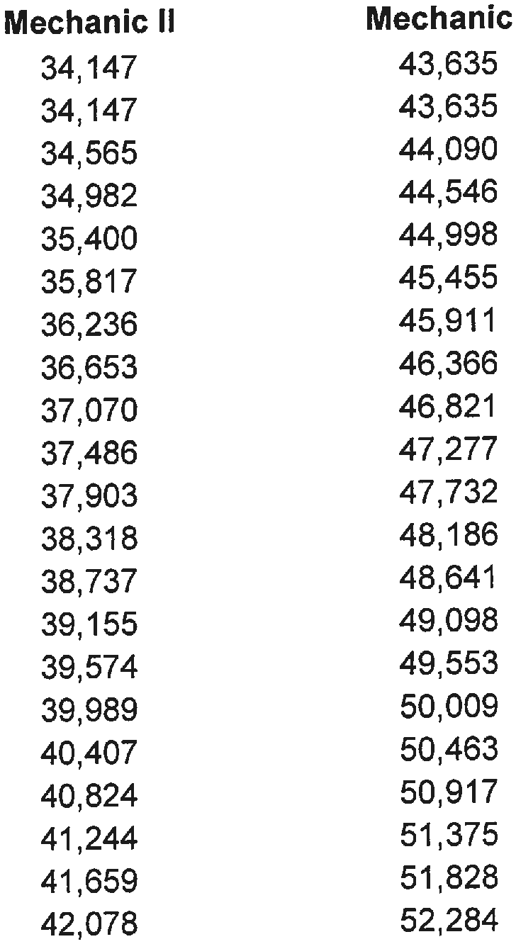

  - The Mechanic I and II are state certified skilled mechanic positions.

Page 30

Bus Driver Salary Schedule 2021 - 2022 Fiscal Year
9 Months/183 Days
Years of  Experience | Step | Salary
0 | 1 | 15,228
1 | 2 | 15,228
2 | 3 | 15,734
3 | 4 | 15,987
4 | 5 | 16,239
5 | 6 | 16,491

Bus Assistant Salary Schedule 2021 - 2022 Fiscal Year
9 Months/183 Days
Years of  Experience | Step | Salary
0 | 1 | 12,767
1 | 2 | 12,767
2 | 3 | 13,107
3 | 4 | 13,396
4 | 5 | 14.076
5 | 6 | 14,417

BUS SUPPLEMENTS (Extra Runs)

Bus supplements are for one year only and are not included when base salary is computed. The Supervisor of Transportation must recommend a particular individual for a specific supplement each school year. No continuing services status in the supplemental position is implied or should be assumed by the individual receiving the supplement.

A run is defined as driving to and from a specific destination.

Page 31

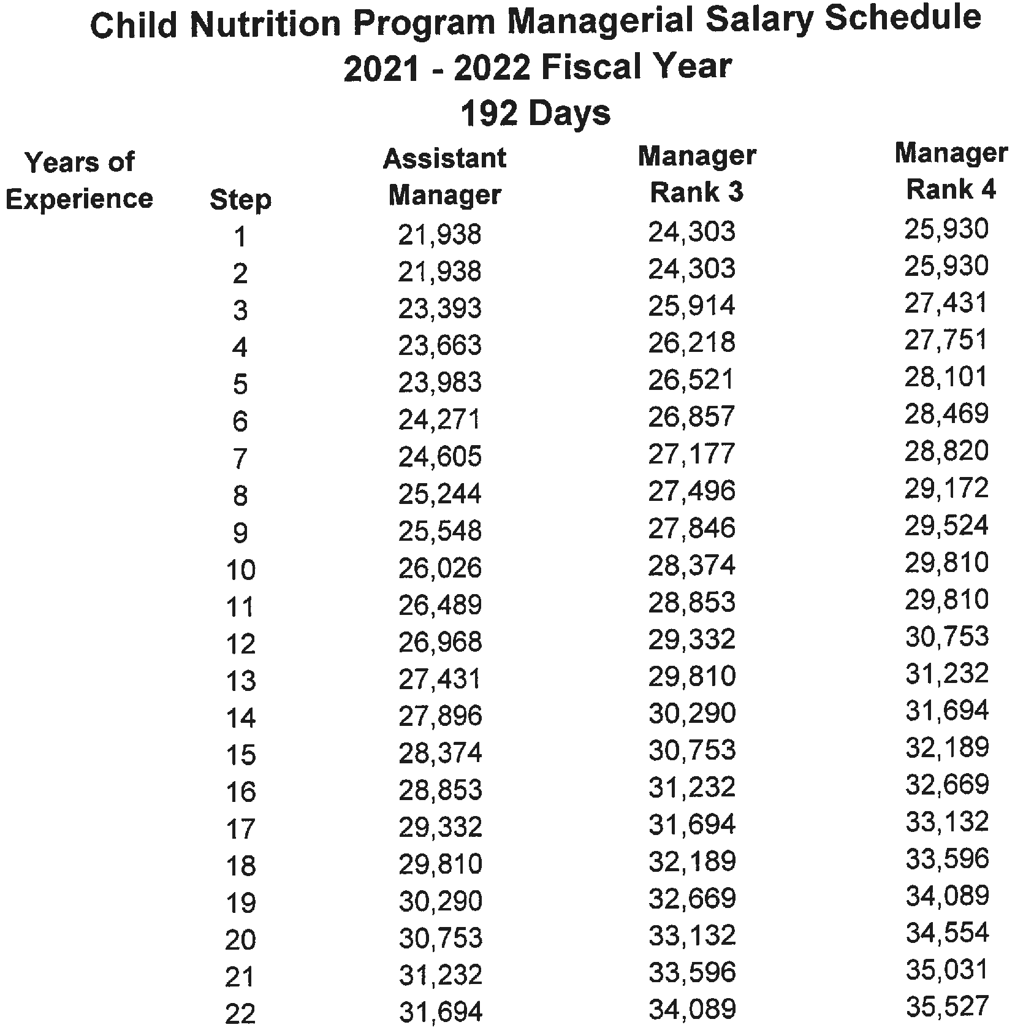

The CNP Manager works 7 hours each day during the contract year.

Page 32

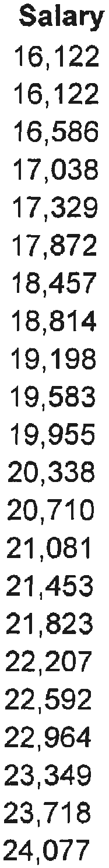

Page 33

Nurse Salary Schedule 2021- 2022 Fiscal Year
9 Months/182 Days, 10 Months/202 Days
Years of Experience | Step | Licensed Practical Nurse - LPN  182 Days | Registered Nurse -  RN (BS)  182 Days | Registered Nurse -  RN (MS)  182 Days | Lead Nurse 202 Days
0-2 | 1-3 | 21,968 | 41,791 | 48,063 | 54,361
 |  | 21,968 | 41,791 | 48,063 | 54,361
 |  | 21,968 | 41,791 | 48,063 | 54,361
3-5 | 4-6 | 24,143 | 45,969 | 52,858 | 55,049
 |  | 24,143 | 45,969 | 52,858 | 60,147
 |  | 24,143 | 45,969 | 52,858 | 60,147
6-8 | 7-9 | 25,183 | 47,982 | 55,179 | 60,147
 |  | 25,183 | 47,982 | 55,179 | 62,931
 |  | 25,183 | 47,982 | 55,179 | 62,931
9-11 | 10-12 | 25,509 | 48,623 | 55,918 | 62,931
 |  | 25,509 | 48,623 | 55,918 | 62,931
 |  | 25,509 | 48,623 | 55,918 | 62,931
12-14 | 13-15 | 25,970 | 49,509 | 56,932 | 62,931
 |  | 25,970 | 49,509 | 56,932 | 62,931
 |  | 25,970 | 49,509 | 56,932 | 62,931
15-17 | 16-18 | 26,539 | 50,637 | 58,235 | 62,931
 |  | 26,539 | 50,637 | 58,235 | 62,931
 |  | 26,539 | 50,637 | 58,235 | 62,931
18-20 | 19-21 | 26,859 | 51,292 | 58,984 | 62,931
 |  | 26,859 | 51,292 | 58,984 | 62,931
 |  | 26,859 | 51,292 | 58,984 | 62,931
21-23 | 22-24 | 27,180 | 51,946 | 59,740 | 62,931
 |  | 27,180 | 51,946 | 59,740 | 62,931
 |  | 27,180 | 51,946 | 59,740 | 62,931
24-26 | 25-27 | 27,758 | 52,564 | 60,358 | 62,931
 |  | 27,758 | 52,564 | 60,358 | 62,931
 |  | 27,758 | 52,564 | 60,358 | 62,931
27 | 28 | 28,337 | 53,184 | 60,977 | 62,931

Page 34

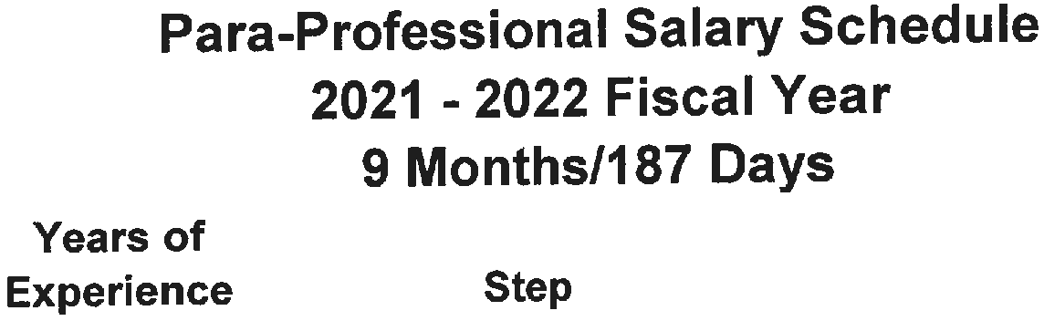
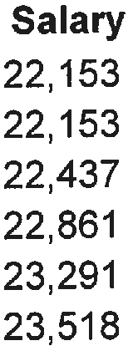

The Para-Professional works seven hours each day.

Page 35

Job Coach Salary Schedule 2021 - 2022 Fiscal Year
9 Months/187 Days
Years of  Experience | Step | Salary
0 | 1 | 27,666
1 | 2 | 28,097
2 | 3 | 28,511
3 | 4 | 28,929
4 | 5 | 29,336
5 | 6 | 29,747
6 | 7 | 30,161
7 | 8 | 30,573
8 | 9 | 30,985
9 | 10 | 31,397
10 | 11 | 31,808
11 | 12 | 32,221
12 | 13 | 32,632
13 | 14 | 33,044
14 | 15 | 33,455
15 | 16 | 33,867

Crossing Guard Salary Schedule Metal Detector Officer Salary Schedule
Security Officer Salary Schedule 2021 - 2022 Fiscal Year
180 Days/2 Hours Per Day
Position | Hourly Rate | Length of Contract
Crossing Guard | 10.00 | Part-time
Metal Detector Officer | 15.00 | Part-time
Security Officer | 20.00 | Part-time

Note: Positions on this Salary Schedule are part-time with no benefits.

Technology Salary Schedule 2021 - 2022 Fiscal Year
12 Months/240 Days
Years of  Experience | Step | Tech  Support | Certified  Tech Support | Senior  Tech Support
0 | 1 | 41,465 | 43,589 | 52,820
1 | 2 | 42,240 | 44,364 | 53,595
2 | 3 | 43,016 | 45,140 | 54,371
3 | 4 | 43,790 | 45,914 | 55,148
4 | 5 | 44,564 | 46,687 | 56,182
5 | 6 | 45,340 | 47,464 | 57,212
6 | 7 | 46,113 | 48,236 | 58,251
7 | 8 | 46,888 | 49,011 | 59,281
8 | 9 | 47,665 | 49,787 | 60,315
9 | 10 | 48,438 | 50,560 | 61,351
10 | 11 | 49,215 | 51,336 | 62,383

SUBSTITUTE AND PART-TIME EMPLOYMENT

SUBSTITUTE EMPLOYMENT
TEACHING PERSONNEL |  | SUPPORT PERSONNEL
CLASSIFICATION | DAILY RATE | CLASSIFICATION | DAILY RATE
Substitute | $80.00 | **CNP Substitute | $9.36 per hour
*Extended Certified Substitute | $125.00 | Bus Driver Substitute | $55.00
 |  | Extended Bus Driver Substitute (After 10 days) | $60.00
 |  | Custodian | $60.00
 |  | Instructional/Clerical Assistant | $60.00
 |  | School Secretary/ Bookkeeper | $60.00
 |  | LPN *** | $8.50 per hour
 |  | Extended LPN **** | $10.00 per hour

NOTES

** CNP Substitutes will be compensated on an hourly rate basis instead of a daily rate.

*** Must hold a current License as an LPN.

**** Retroactive pay to equal $10.00 per hour for Extended LPN Substitutes will be given for continuous long-term employment exceeding 20 consecutive full-day assignments in a single school. The nurse must hold a current License as an LPN.

SALARY SUPPLEMENT SCHEDULE
Supplements are for one year only, approved by the Board annually, and are not included when base salary is computed. The principal must recommend a particular individual for a specific supplement each school year or athletic season. No continuing service status in the supplement position is implied or should be assumed by the individual receiving a supplement.

SUPPLEMENTS
FISCAL YEAR 2021 - 2022

HIGH SCHOOL
POSITION | SUPPLEMENT
Athletic Director | $3,000
Head Football Coach, Varsity | $6,500
Head Football Coach, Varsity - Extra Days | Additional Days
Assistant Football, Varsity (5) | $2,500
Head Football Coach, Freshman (2) | $2,000
Assistant Football, Freshman | $1,500
Defensive Coordinator | $750
Offensive Coordinator | $750
Basketball, Head Varsity (Boys) | $5,000
Basketball, Head Varsity (Boys) - Extra Days
Assistant Basketball, Varsity (Boys) (1) | $2,500
Basketball, Head, Freshman (Boys) | $1,000
Basketball Head Coach (Girls) | $5,000
Basketball Head Coach (Girls) - Extra Days
Basketball Assistant Coach (Girls) (1) | $2,500
Basketball Head Freshman (Girls) | $1,000
Baseball, Head Coach, Varsity | $2,000
Baseball, Assistant, Varsity (1) | $1,000
Softball Head Coach | $2,000
Softball Assistant Coach (1) | $1,000
Track Head Coach, Boys/Girls | $1,500
Track Assistant, Boys/Girls | $1,500
Volleyball Head Coach | $1,500
Volleyball Assistant Coach (1) | $1,000
Golf - Girls | $2,000
Golf - Boys | $2,000
Soccer, Boys | $2,500
Soccer, Girls | $2,500
Strength Coach | $1,200
Band Director | $5,000
Cheerleader Coach | $2,000
Cheerleader Coach, Freshman/Junior | $1,500
Majorette, Drill, Dance & Flag Corp | $1,000
Athletic Nurse | $1,000
Equipment Manager | $750

SUPPLEMENTS FISCAL YEAR 2021 - 2022

MIDDLE SCHOOL
POSITION | SUPPLEMENT
Athletic Director | $2,000
Baseball - Head Coach | $1,000
Basketball - Head Coach (8th Grade Boys) | $2,500
Basketball - Head Coach (Girls) | $2,500
Football Head Coach | $3,200
Football Assistant Coach (2) | $1,500
Soccer Head Coach (Boys & Girls) | $1,000
Softball Head Coach | $1,000
Volleyball Head Coach | $1,000
Athletic Nurse | $1,000
Cheerleader Coach | $1,000

PLAY OFF & STATE CHAMPIONSHIP SUPPLEMENTS FISCAL YEAR 2021 - 2022

POSITION | SUPPLEMENT
Play Off Games:
Head Coach | $200/Game
Assistant Coach | $100/Game
Cheerleader Coach/Sponsor (includes state championship) | $200/Game
State Championship Games:
Head Coach | $5,000
Assistant Coach | $1,000

NOTES
- All assistant varsity football coaches must coach an additional sport.
- All coaches will be paid for EACH sport they coach.
- One coach should not earn two supplements during the same season except within the samesport.
- Coaching supplements and extended contracts will be prorated accordingly with resignations and terminations before the end of the contract season.
- The supplemental salary schedule becomes effective for coaches employed after the 2018- 2019 school year.

