PHONICS/READING | GRAMMAR/WRITING | MATH | SCIENCE/SOCIAL STUDIES
- Review r-controlled vowels, contractions, plurals, & vowel patterns  - Review cause/effect, author’s purpose, facts/details, & compare/contrast | - Review nouns, proper nouns, singular & plural nouns, plural nouns that change spelling, & possessive nouns.  - Practice Cursive Handwriting | - Fluently Add Within 100  - Practice Addition & Subtraction Facts for Weekly Quiz | - Landforms  - Matter: Solids, Liquids, & Gases
Mrs. Sharpe’s Class •Keisha.Sharpe@acboe.net
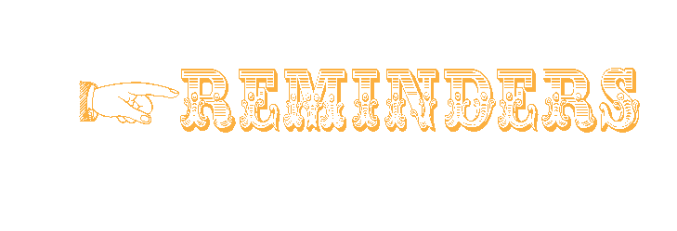

Spelling Words
If your child is a car rider in the mornings, be sure to get him/her to school before 7:45 to ensure he/she has time to eat breakfast before 8:00. Please send a bottle of water to school with your child daily. Also, allow your child to read for at least 20 minutes each night. Homework is due on Fridays.
Our school website is: pinelevelelem.com

Ladies & Gentlemen!

- 11.4: Reading & Grammar Tests
- 11.5: Spelling & Vocabulary Tests
- 11.5: Weekly Math Test
- 11.8: Progress Reports
- 11.11: Veteran’s Day/No School
- 11.12: E-Learning Day

No spelling words or test this week.

BONUS WORDS Small treat given for correctly spelled bonus words.
No bonus words this week.
Look at what we are learning!

Every Journey Has a Great Story!

Review Unit 2
High Frequency Vocabulary Words

November 1 , 2021

