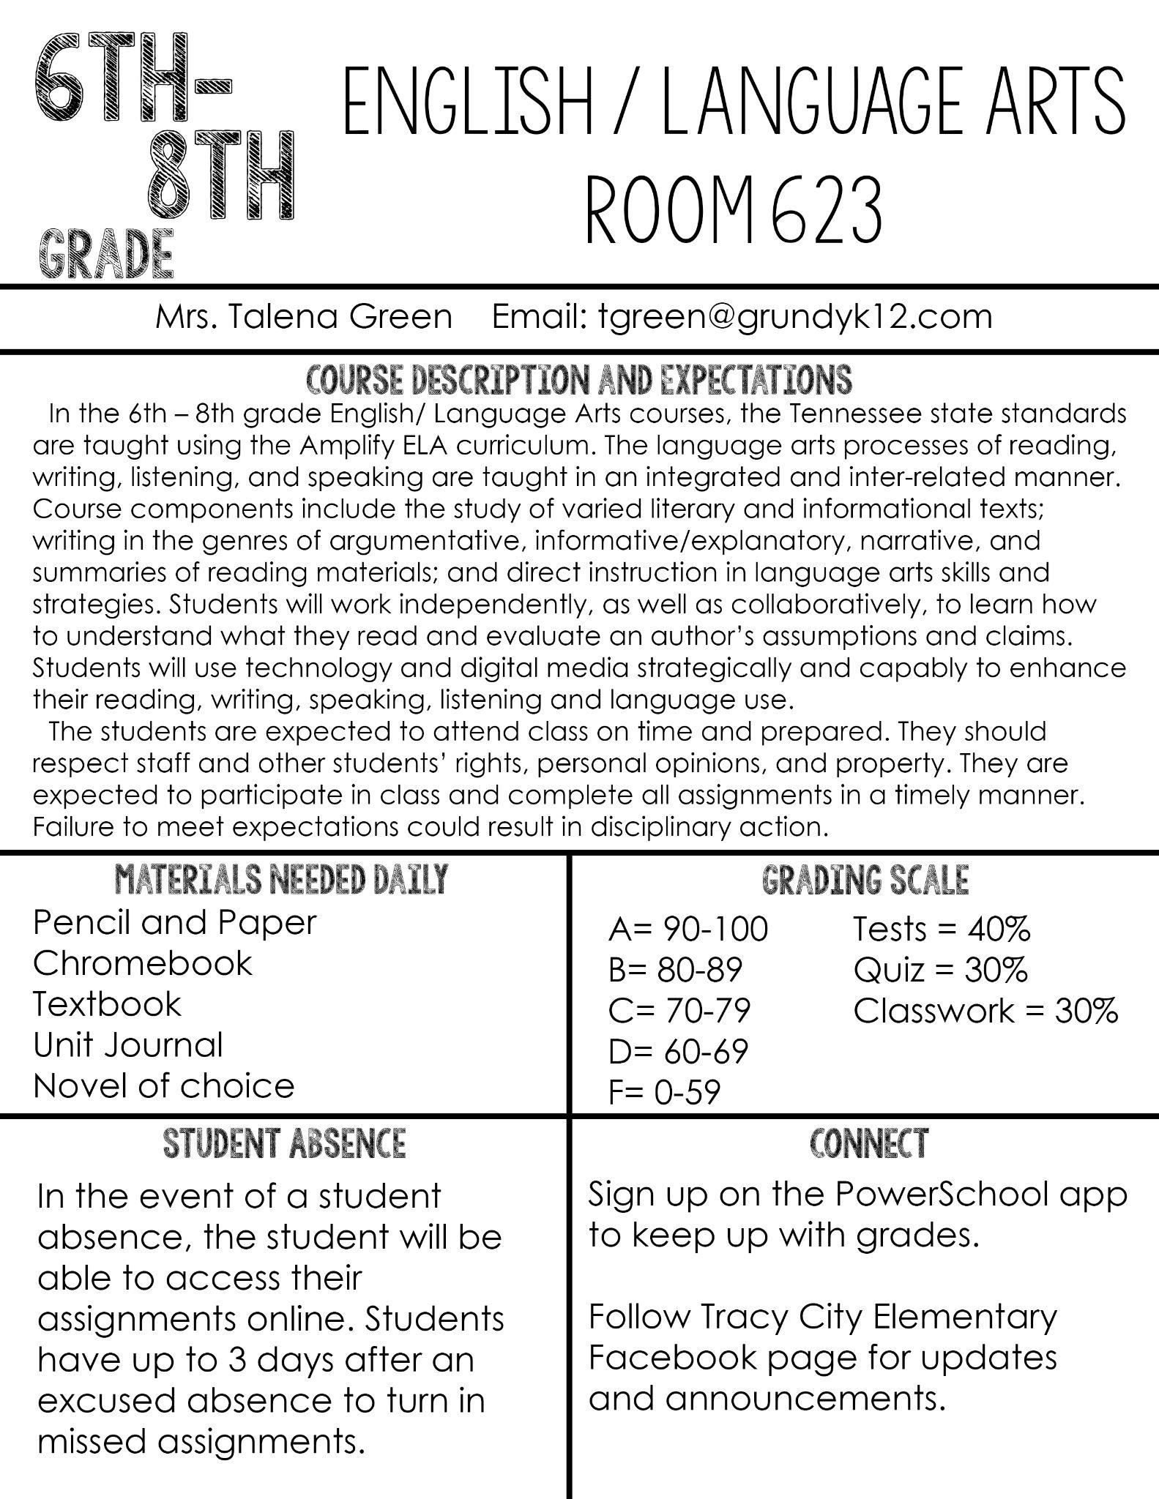

ELA Classroom Expectations

- Respect personal space, rights, and property of others.
- Be on time to class.
Arrive prepared. Have materials needed. Use the restroom during class change.
- Take initiative.
(example: Do not raise your hand to tell me you do not have a pencil. Instead, find a pencil. Get the pencil. Use the pencil. Become the pencil.)
- Be accountable.
Apologize when you make a mistake. (I will do the same.)
- Be kind to one another.
Zero tolerance for unkind words or actions. Don’t be the reason someone dreads coming to school. Unkind treatment of others will be addressed immediately.
- Be respectful and civil in class discussions.
Differences of opinions make life interesting. You will not always agree with everyone in classroom discussions but you are expected to respect differences of opinions that are expressed. Open and civil dialogue with classmates is a huge part of ELA class.
I have read, discussed, and understand the classroom expectations.

Student signature: ________________________
Date: ___________

