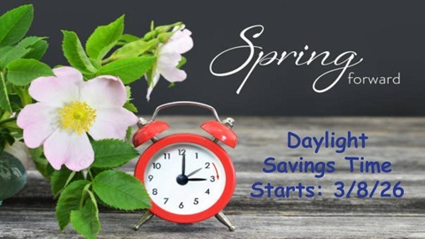

Class News
Mrs. Williams’ Second Grade
March 9, 2026

Math: finish unit/test unit on telling time

Science/Social Studies: wrap up unit on economics
-Test on Friday

Upcoming Events:
March 26 – Bunny Bash Family Engagement Night 5:30 – 7:30
March 27 – Report Cards go home
March 30 - April 3 – Spring Break!
April 6 – No school for students – Professional Development

