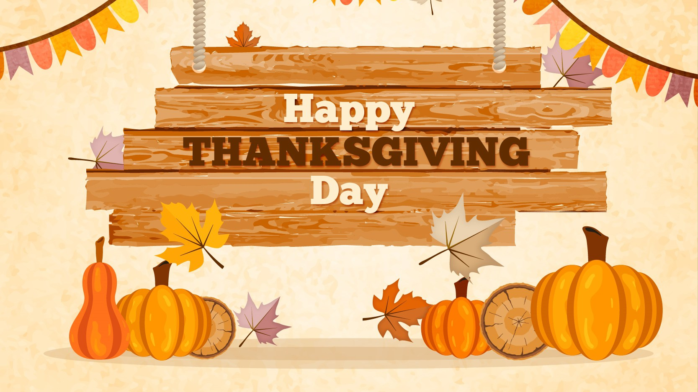

Class News
Mrs. Williams’ Second Grade
November 28, 2022

Reading: narrative elements, cause/effect, sequencing

Language: verbs

Spelling: change y to i and add -es

Math: check subtractracion using addition

Science/Social Studies: American symbols and holidays

