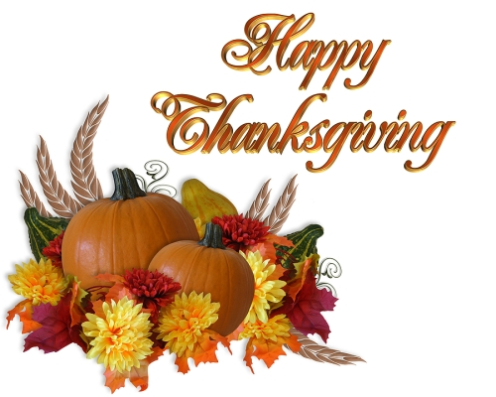

CLASS NEWS
Mrs. Williams
Date: November 18, 2024

Math: create, extend, and transfer number patterns

Science/Social Studies:
-American symbols; Pledge of Allegiance

Upcoming Events:
November 25 - 29 - Thanksgiving Break

