High Impact Instruction: Learning Maps
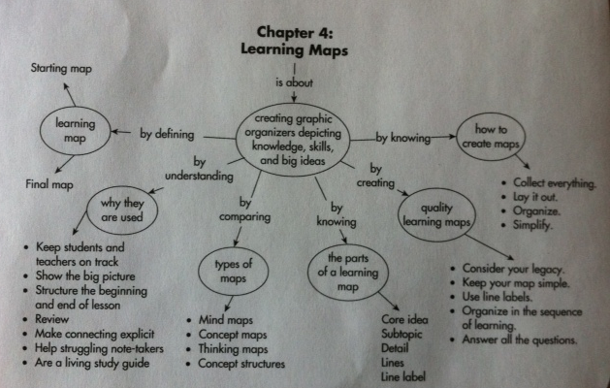
Too many students get lost in schools. They look up from what they are learning and don’t know where they are. As a result, they may give up.
A learning map is a graphic organizer that highlights the knowledge, skills, and big ideas that students should get from a lesson, unit, or course. It can be a living study guide that student and teachers complete after each new learning.
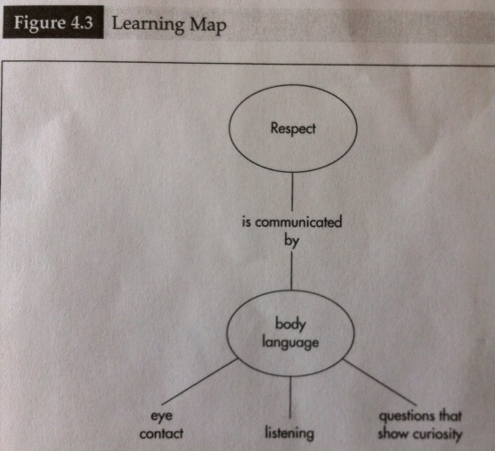
Learning maps are two-dimensional depictions of information that include:
- A core idea (often name of the unit) along with a paraphrase
- Subtopics
- Details
- Lines that show the relationship between the different parts of the map
- Line labels that explain the relationship between the core idea and subtopics

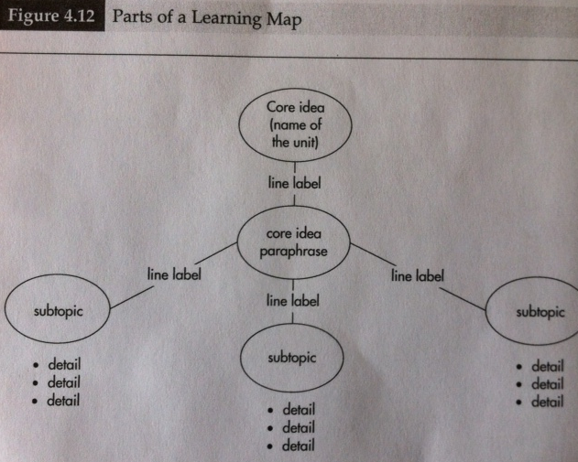
Starting maps only include the core idea, paraphrase and supporting details. Figure 4.1. Introduced on the first day of the unit.
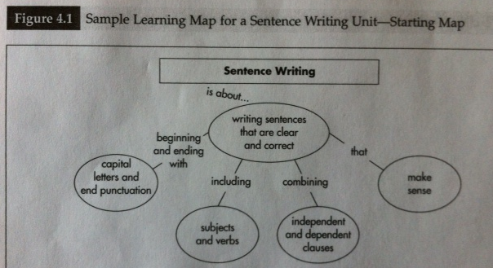
Ending maps which are constructed throughout the unit as details are added and finished when the unit is complete. Should be kept to one page, if more than one page perhaps you have slipped into more of covering content than on learning. A one-page map forces deep thinking.
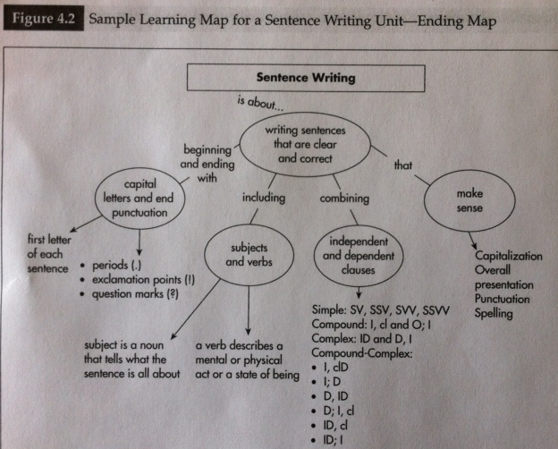
* Teachers should create a complete ending map before they begin teaching. This helps to estimate how much time is needed to spend on each unit component, as well, as review for differentiation instructional needs.
Video 4.1: www.corwin/com/highimpactinstruction
Why are learning maps important?
Seeing supports learning. Put simply, the more visual the input becomes, the more likely it is to be recognized—and recalled.
They show the Big Picture. Teachers who have used learning maps report that seeing the entire unit laid out on one page helps them make decisions about how to differentiate learning by pinpointing where to modify instruction for specific content. Students can see what has been learned and what remains to be learned. Having an advanced and post organizer for each day’s lesson helps as a visual reference point too for students.
They Structure the Beginning and Ending of lessons. Studies have been conducted to show that the first and last information we experience is the easiest to remember. In the classroom, this means that the first few minutes and the last few minutes of a class are extremely important for introducing and reinforcing student learning. Learning maps provide a picture of the unit that teachers can use to begin and end lessons in a way that best supports student learning.
They Serve as a Mechanism for Repeated Review. When teachers begin and end each day’s lesson by discussing the learning map, students are able to take stock of how well they understand what is being learned. Learners benefit by reviewing the learning depicted on the map.
They Make Connections Explicit. Many students do not see connections between knowledge, skills, and big ideas they are learning. A learning map is designed to show how everything being learned is connected.
They Help Struggling Note-Takers. Students who are at risk for failing often have not mastered the complex task of taking notes. Also distinguishing between important and unimportant information is a daunting task. Slow note-takers present another significant challenge within the classroom. If a teacher allows enough time for all students to keep up with the notes, intensity will be lost, and some students who are quicker will become bored or off task. Learning maps accommodate learner needs by providing a scaffold for note taking. A LM does not replace notes, it does provide a format for all students to record information about what they are learning, and with teacher guidance, students can be sure they are recording the most important information. In diverse classrooms, teachers can create a fill-in-the-blanks form of the learning map so that every student can complete the map quickly.
Three Types of maps:

- Mind maps- are webs of words or shapes filled with words that flow out from the center of the page. Figure 4.4

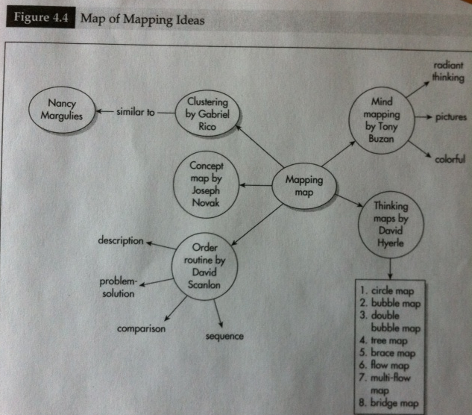
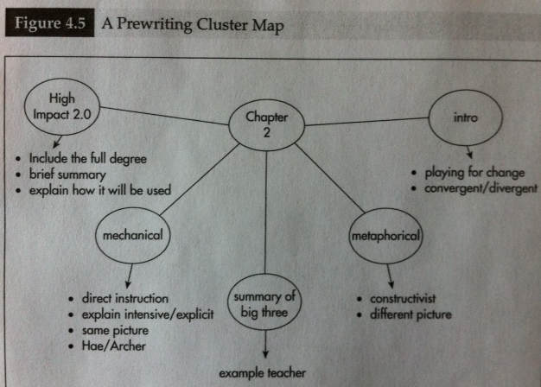

- Concept maps- are hierarchically organized maps of concepts where the relationship between concepts is communicated through line labels. Figure 4.6
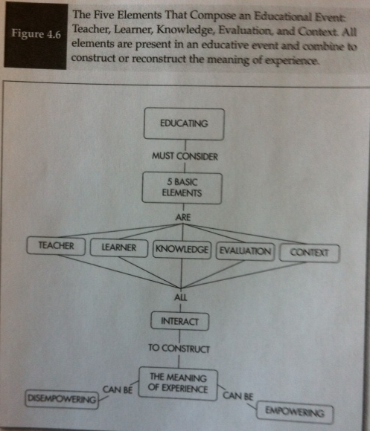
- Thinking maps- are depictions of cognitive processes designed to enhance people’s ability to think in ways that are universal. Figure 4.7
- Circle map
- Bubble map
- Double-Bubble map
- Tree map
- Brace map
- Flow map
- Multi-Flow map
- Bridge map

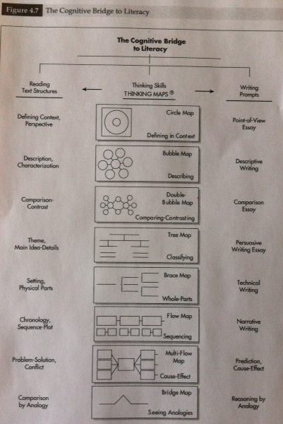
Order routine is a way student can identify important information and organize it in one of four graphic organizers: Sequential (Fig. 4.8), Compare and Contrast (Fig. 4.9), Problem-Solution (Fig. 4.10), and Descriptive (Fig. 4.11).
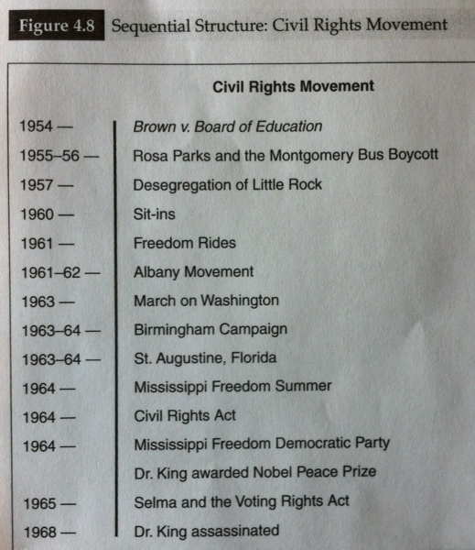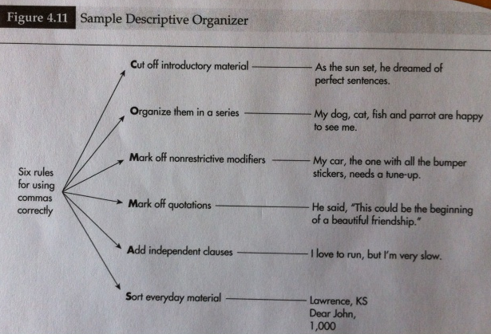
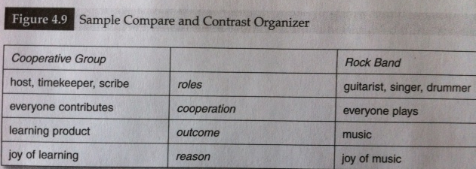
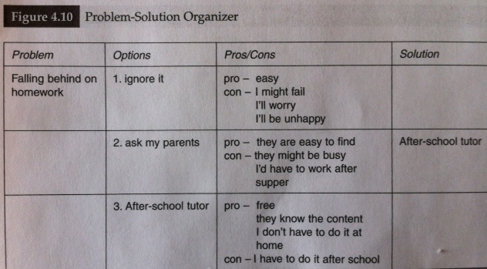
After creating a learning map (starting and ending), the next planning progression should lead toward guiding questions creation and formative assessment designing. One strategy for teachers would be to have students write their guiding questions on the opposite side of the learning map paper. The map then becomes a point of departure for learning that takes place throughout the unit.
Teachers need to create learning maps that provide excellent answers to the guiding questions. First, think about what knowledge, skill, and big ideas that students need to learn. Second, think about the specific proficiencies desired for each guiding question (A specific proficiency is determining all the components of the answers that you think need to be assessed) Option: Use sticky notes to answer the guiding questions and then move the notes around when you develop your maps to make sure your maps help students to answer all guiding quest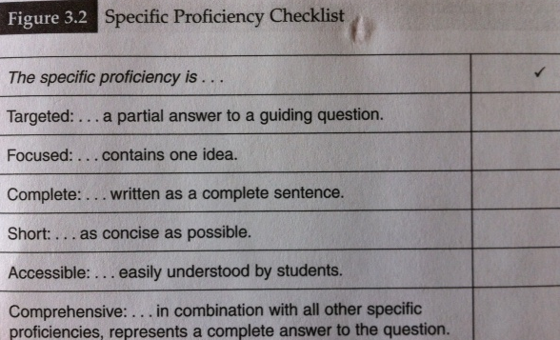ions.
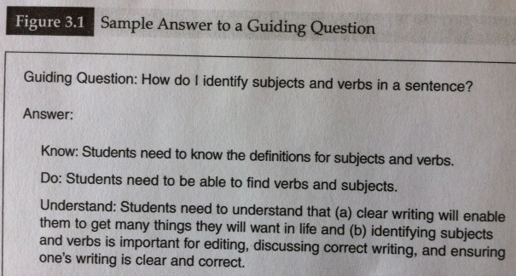

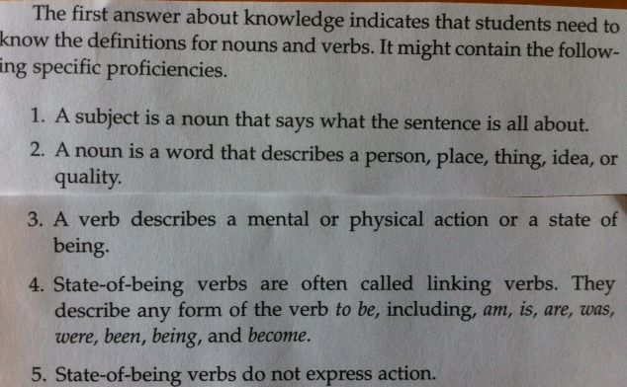
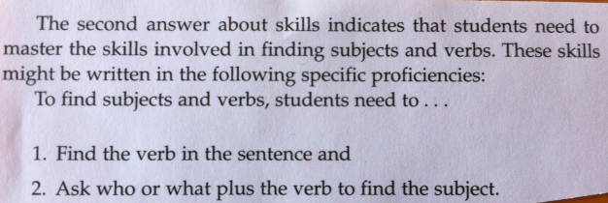
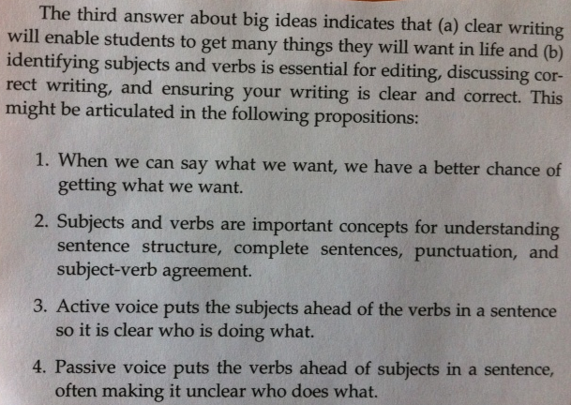
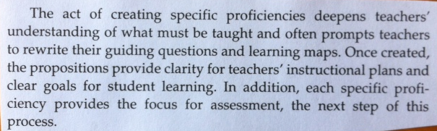
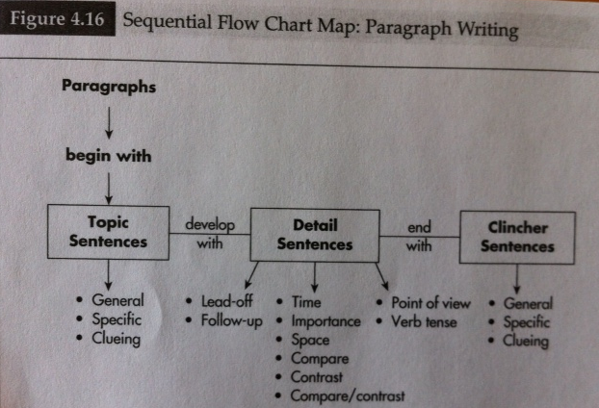
Line labels are used to link concepts with one or two words. The linking word should define the relationship between the two concepts.
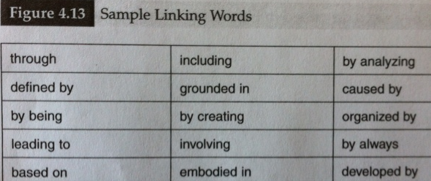
There may also be an advantage to organizing the map in the sequence that learning should occur.
How to create learning maps:
The entire planning process involves developing guiding questions, learning maps, and formative assessments. Each aspect of planning informs the other aspects.
- Identify Knowledge, Skills, and Big Ideas. The goal is to look at everything that might inform instruction before pinning down the details of the learning map.
- Display everything. Use sticky notes. Every fact, skill, concept, and theme should be individually noted on a separate sticky note. Movement and regrouping becomes easy to complete. Before you design your presentation, you must see the big picture and identify your core messages.
- Organize. Sort the ideas into groups, consider the hierarchy of content. Think about what kind of map to use.
- Connect. Label the lines with one or a few linking words. Should define the relationship between the two concepts.
- Refine. After the entire map has been created, the final step is to add, subtract, or contract information. The map points toward a complete answer for each guiding question. Second, consider if any information can be removed without diminishing the answer to a question. Finally, can information be combined or contracted.
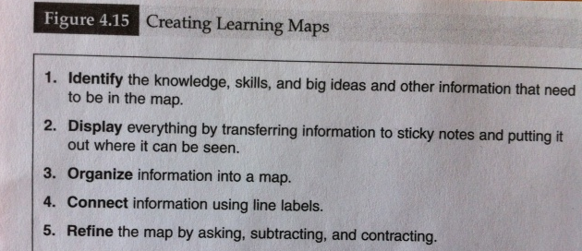
Sharing learning maps with students:
Teachers should develop rituals referred to as highly specific routines that integrate learning maps into learning. Teachers should employ a ritual of use for the start of a unit, during the daily lesson, and at the end of the unit.
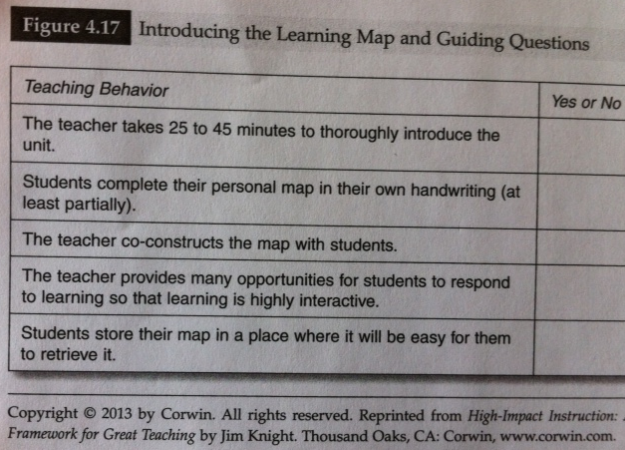
Rituals for Introducing Learning Maps
Day 1—Introduces the guiding questions and learning map to give student a clear outline of what they will be learning in the unit. Figure 4.18 This class is an opportunity to light students’ desire to learn all about something new, to engage their curiosity, and to lay out the exciting possibilities for the upcoming unit. A passionate teacher inspires passionate students.
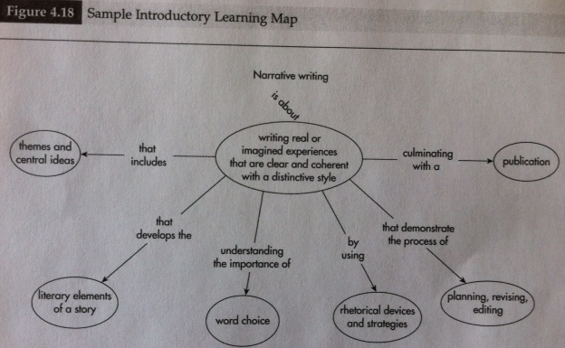
Students construct their personal map (or at least part of the map)—students need to interact with and own the map. Figure 4.19
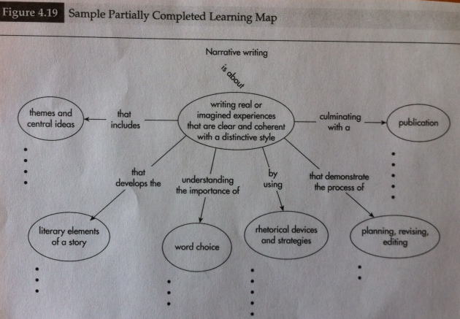
The teacher co-constructs the learning map with students. (Teachers need to create their own complete are being constructed in the moment.
Students store their map in an easy to retrieve location.
Rituals for Daily Use
Learning maps have their greatest impact on student learning when they are routinely used by teachers and students in the classroom. Many teachers begin their classes by focusing on the learning map, which is an optimum time. Advanced organizers-- Using the map as a visual aid and asking many questions, teachers guide students to see what they will learn, why it is important, what the need to do to learn, and how the day’s lesson fits with what they have already learned. Post organizers—reinforce student learning by prompting students to add newly learned content to their map. Teachers can simply ensure that every class ends with a post organizer where the teacher guides students through questions, to discuss what was learned today, how it fits with the bigger ideas being learned in the unit, and what will be learned the next day. (Fig. 4.21)
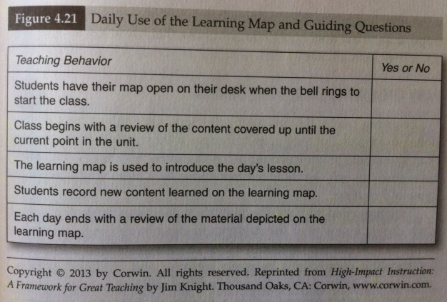
Students need to be guided to the habit of having their map out on their desk before the lesson begins. The use of the map helps the teacher to ask the following daily: what students have learned, what they will be learning today, why it is important, what they have to do in class, and how today’s learning fits with other learning they have done in the unit. Teachers can make a game/incentive to tell students that you want to do these 5 things daily and that you need their help to remember to complete all 5 at the start of class. * You could even say there would be some penalty you, the teacher, obtains if you don’t hit all 5 items at the start of a lesson and if students catch you (fine- dollar in a jar and money donated to charity at end of year, push ups, wear something funny).
Vary the Way Maps are Shared
Learning maps and guiding questions are high-impact instructional strategies, but they aren’t effective if they put students to sleep. If teachers share learning maps the same way every day, pretty soon, students will let their teacher know they’re getting tired of the same old routine. Teachers need to vary their use of maps with students so that learning will remain fresh and alive. Showing connections between learning and students’ personal experiences, using the element of surprise, varying formative assessment practices can all assess how well students are learning.
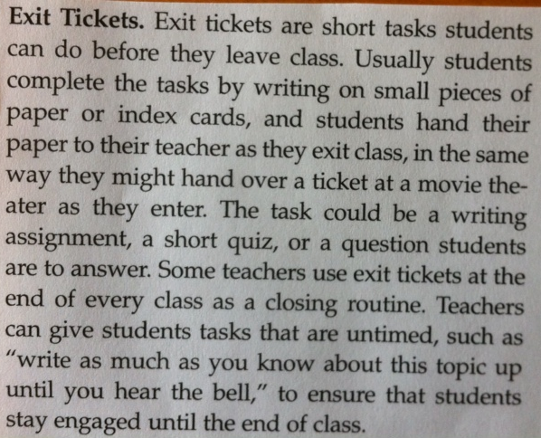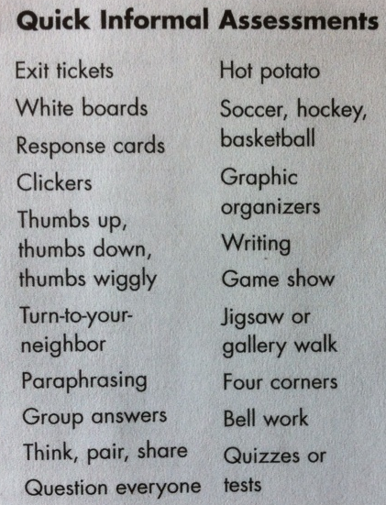
Thinking prompts such as a highly persuasive television commercial may be shown to students to introduce the idea of persuasive writing. Teachers can mix things up by trying a different strategy daily/weekly, such as they can use response cards, work with a partner, take part in a game show review or use white boards. What matters is that the start of class does not become a boring routine. If a teacher shares his/her passion for the unit to be learned and if students are excited about what they are going to learn, they are much less likely to complain of being bored.
End of Unit Review
By the end of the unit, teachers and students will have created a highly useful study guide for the learning that has occurred as everyone progress through the unit. This study guide is one that students have helped create and interacted with throughout the unit. Also, it will have been reviewed so many times that it should be as familiar as an old friend.
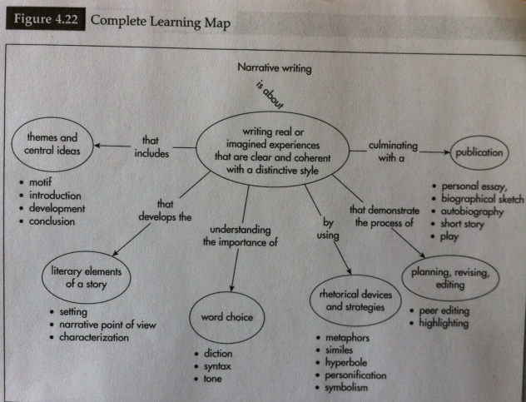
Suggestion: Teachers can integrate learning maps and guiding questions into their end-of-the unit review by dividing students into cooperative learning groups and giving each group one guiding question to answer. Students should be prompted to create a learning map that summarizes their answer. First they identify what kind of map is most appropriate for their answer (sequence, description, problem-solution, compare-contrast, or cause and effect. Then, start the process of creating a map and summarizing their answer. It may be helpful to have students write key information on small pieces of paper or sticky notes and then arrange them into the organizer and then draw the map on chart paper.
Turning Ideas in Action
Students:
Power sharing and construction of knowledge can be used by learners to enhance their learning. The more we use both systems of representation (linguistic and nonlinguistic) the better we are able to think about and recall knowledge.
Teachers should discuss with their students why they are using learning maps and ask students for their feedback on what works and doesn’t work for them. They can give feedback on how they like to interact with the map and suggest way in which exploration of the map can be made more meaningful, useful, or fun.
Teachers:
Teachers can experiment with maps for all kinds of task and see what works and doesn’t work for them. Cluster maps can be used as a pre-writing strategy. Concept maps can be used to clarify understanding of new curricula. Mind maps can be used to take notes during a workshop.
Learning maps are used to plan lesson and units and at first teachers may feel uncomfortable sharing the map with students and this is a good starting point for teachers. However, ultimately, the power of the learning map is revealed in sharing it with students as a living document.
It takes four to five days of sustained, reflective practice for teacher teams to write guiding questions, learning maps, and formative assessments for an entire course if the group is organized, well-functioning, and motivated. Teachers working alone will need more time to create maps, so working collaboratively has a better turn-around time.
What we know about knowledge work and motivation suggests that such a strategy (learning maps) does not change teaching practice because professionals need to be part of the thinking if they are going to embrace something as comprehensive as new plans for guiding questions, learning maps, and assessments for a unit, so THESE items shouldn’t be created and handed to teachers without involving teachers in the process.
What it looks Like:
Learning maps will only make a difference if students see them and use them. The quality map checklist can be used during the writing of learning maps and to review how learning maps have been constructed.
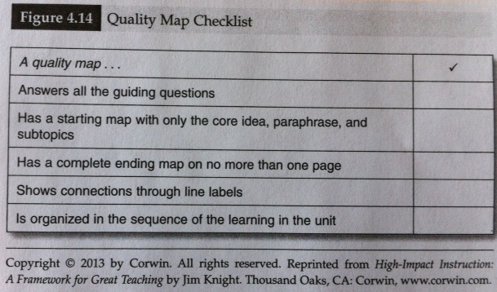
Learning maps …
- Are visual depictions of knowledge, skills, and big ideas students will learn in a unit
- Can be included as an element of most parts of learning in a unit
- Enhance student learning by being visual, keeping students and teachers on track, making connections explicit, and being a living study guide
- Combine aspects of mind maps, concept maps, thinking maps, content structures, and nonlinguistic representations
- Include…… a. core idea (main idea of unit) b. sub topics (usually surrounded by a geographical shape such as an oval, rectangle, star) c. details d. lines e. line labels
- Are most effective if they are simple, answer all the guiding questions, and make connections explicit

