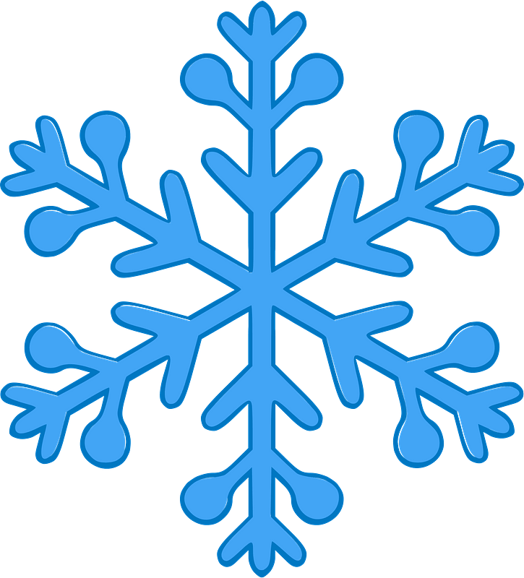Holiday Spirit Week 12/18-12/22

Monday 12/18 | Tuesday 12/19 | Wednesday 12/20 | Thursday 12/21 | Friday 12/22
Merry Monday:  Wear your favorite festive shirt!  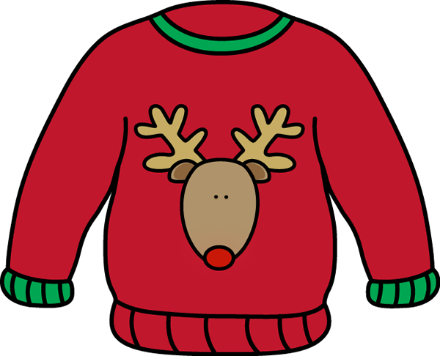 | Tinsled Tuesday:  Wear your favorite holiday accessories  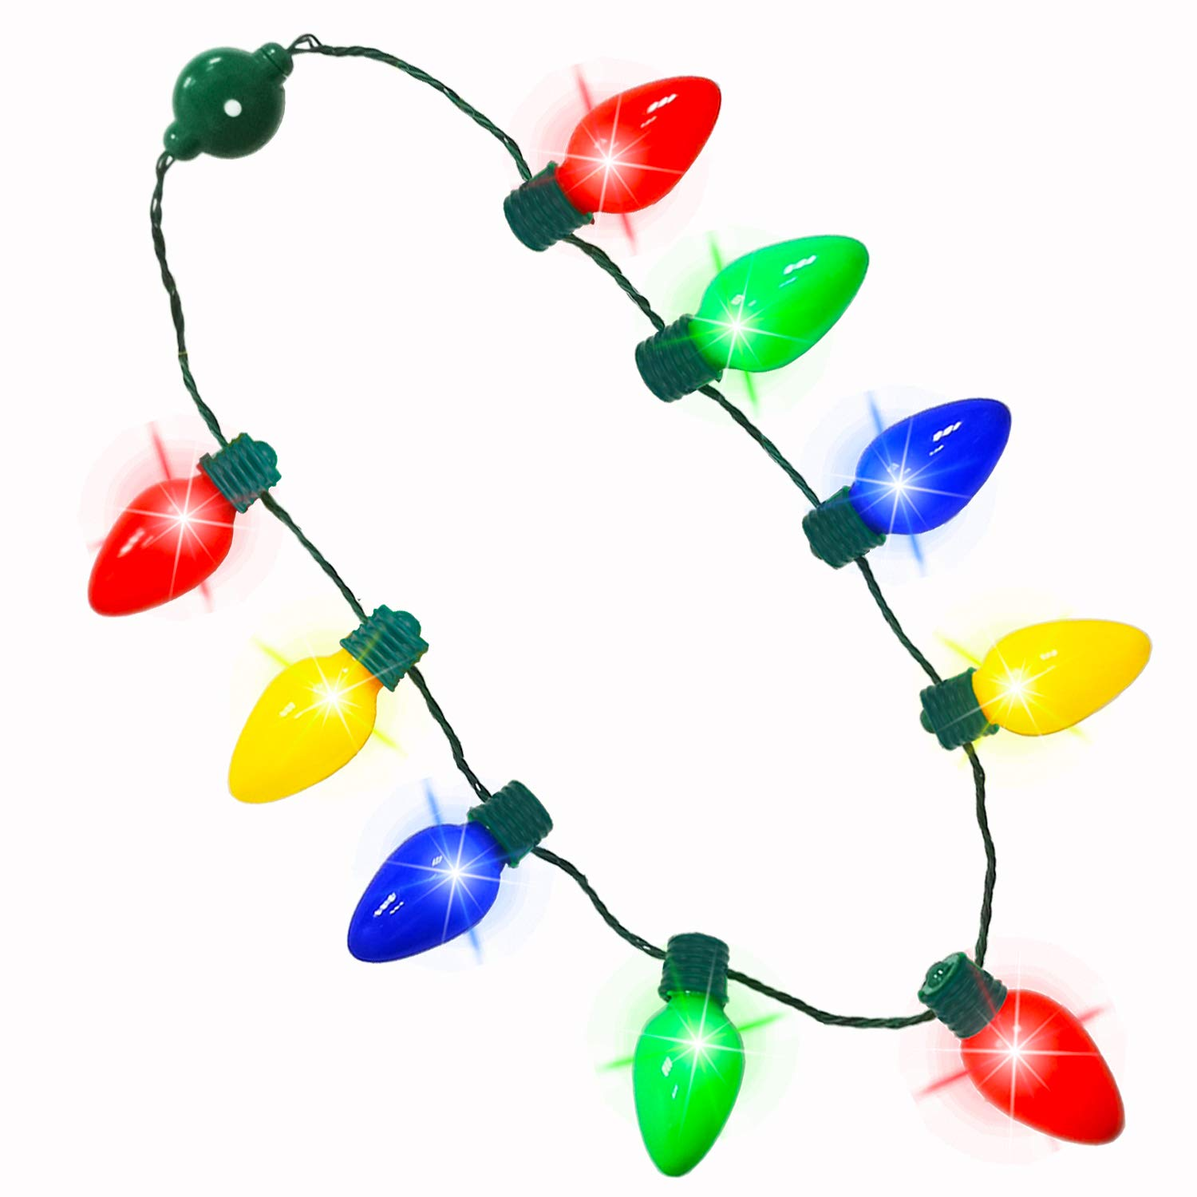 | Whoville Wednesday:  Wear your Grinch gear (or other Holiday Character gear)  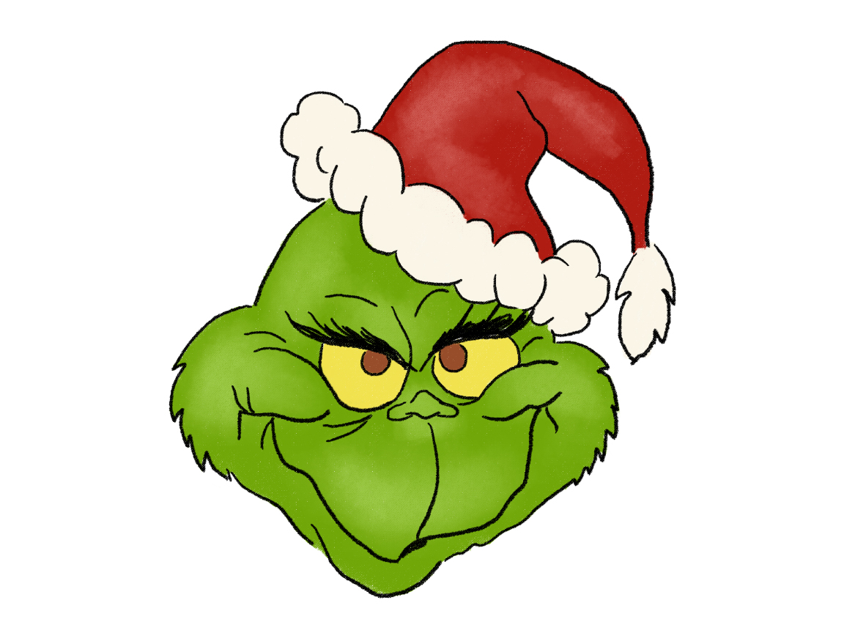 | ‘Twas the Night Thursday:  Wear your favorite “winter’s Cap” (Holiday Hat) | Festive Friday:  Students wear red, Staff wear green  