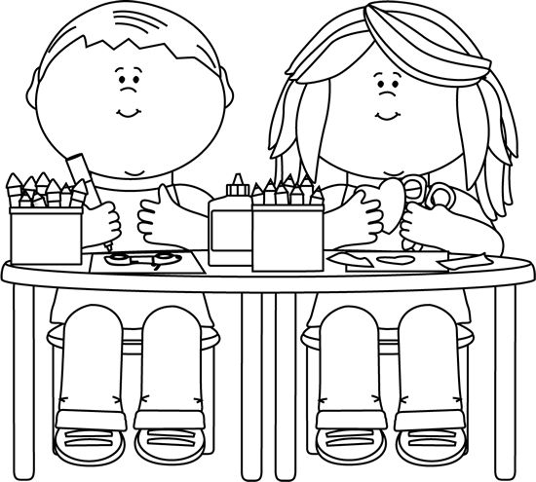


Franklin County Preschool
Application Process

WHERE: School you wish your child to attend
during the 2025-2026 school year IF ACCEPTED.

WHEN: April 3, 2025

TIME: 1:00 p.m. – 5:00 p.m.

Child must be 4 years old by August 15, 2025 to apply for
Preschool for the 2025-2026 school year.

Documents Required:
•Certified Birth Certificate
•Immunization Record & Current Physical Report
(on TN Dept. of Health form)
•Proof of Residence (utility bill, rent receipt, etc.)
•Proof of Income Required for Eligibility:
(2024 W-2’s or tax return preferred, or
last 3 consecutive pay stubs showing GROSS income,
or Letter of Food Stamp, SNAP, or Families First Proof)

For more information contact Patti Limbaugh at: 931-967-0626

